Analytic Geometry Final Study Guide Name ___________________
Due 5/22/14

Identify the choice that best completes the statement or answers the question. Show your work!

____ 1. Points H, G, and J are collinear, and G is between H and J. If , , and , what is HJ?

____ 2. Draw . What is the name of one of the sides of ?
F |  | H | 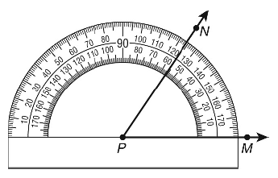
G |  | J

____ 3. What is ?

____ 4. What is the measure of if ?
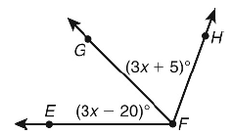

____ 5. If , what property justifies ?

____ 6. Given: If a child is at least 4 feet tall, then he or she can ride the roller coaster. If a child can reach the red bar, then the child is at least 4 feet tall. Which conjecture is valid by the Law of Syllogism?
F | If a child can reach the red bar, then the child can ride the roller coaster.
G | If a child is at least 4 feet tall, then the child can reach the red bar.
H | If a child can ride the roller coaster, then the child is at least 4 feet tall.
J | If a child can ride the roller coaster, then the child can reach the red bar.

____ 7. Which biconditional is false?
A | A person is eligible to attend the club meetings if and only if that person is a member of the club.
B | A person can practice medicine in the United States if and only if that person has a valid medical license.
C | A person can legally drive a car if and only if the person holds a valid driver? ’s license.
D | A student participates on the football team if and only if the student maintains at least a B average.

____ 8. For which conditional statement is its converse false?
F | If a fruit has seeds inside, then it is an orange.
G | If Meg lives in Egypt, then she lives in Africa.
H | If the day is between Monday and Wednesday, then it is Tuesday.
J | If the car will not start, then it is out of gas.

____ 9. For which conditional statement is its inverse false?
A | If a point is a midpoint of a segment, then it divides the segment into two congruent segments.
B | If Mike does not become an airplane pilot, then he will not learn how to fly a plane.
C | If you see a zebra, then you must be in a zoo.
D | If the biggest holiday of the month is Thanksgiving, then the month is November.

____ 10. The graph of which line is perpendicular to the graph of ?
F |  | H
G | 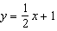 | J | 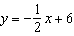

____ 11. The measures of two angles of a triangle are 18° and 62°. Which type of triangle is it?

____ 12. Which best describes the triangle?
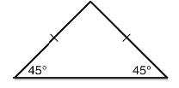

____ 13. If , which angle is congruent to ?

____ 14. What information would allow you to prove by SAS?
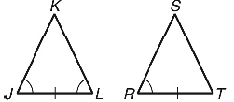

____ 15. Which information would you need for the shortest proof that by ASA?
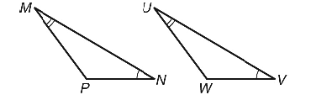
A |  | C
B |  | D

____ 16. Given the figure, why is ?
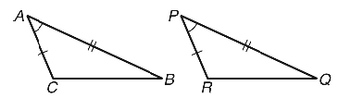

____ 17. For a coordinate proof concerning an isosceles triangle, which coordinates might be easiest to use?
A
B
C
D

____ 18. Which completes the statement? The point of concurrency of the perpendicular bisectors of a right triangle is on the ________ of the triangle.
F | inside | H | outside
G | right angle | J | hypotenuse

____ 19. The hypotenuse of an isosceles right triangle is 6. What is its area?

____ 20. If , which need NOT be true?
F |  | H
G |  | J

____ 21. is an equilateral triangle. Its medians intersect at W. If , what is the length of the median that is on?
A |  | C
B |  | D

____ 22. What is the value of x?
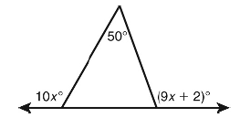

____ 23. The area of a parallelogram is 60 square inches. What is the area of the parallelogram if the
base is multiplied by ?
A | 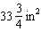 | C
B |  | D | 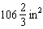

____ 24. Using as a guide. What is the transformation that yields ?
F | vertical stretch of 2, shift 4 units left and 3 units down
G | shift 8 units left and 3 units down
H | vertical stretch of 2, shift 4 units right and 3 units down
J | shift 8 units right and 3 units down

____ 25. What is the minimum or maximum of ?
A | minimum: 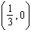
B | maximum:
C | minimum:
D | maximum:

____ 26. What are the zeros of the trinomial ?
F | 1, 5
G | , 1
H
J | 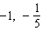

____ 27. What is a quadratic function in standard form having zeros of 9 and ?
A
B
C
D

____ 28. What is the simplified version of ?
F |  | H | 13
G |  | J

____ 29. Use the quadratic formula to solve .
A | 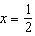
B
C | 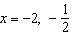
D | 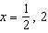

____ 30. For the discriminant , what is the number of solutions and their types?
F | 1 real solution
G | 2 imaginary solutions
H | 1 imaginary solution
J | 2 real solutions

____ 31. Simplify .

____ 32. Factor completely.
F
G
H
J

____ 33. Find the zeros of by factoring.
A | and 2 | C | and 6
B | and 3 | D | and 12

____ 34. Which of the following is a factorization of the polynomial ?

