Coordinate Algebra Final Study Guide Name ___________________
Due 5/22/14

Identify the choice that best completes the statement or answers the question. Show your work!

____ 1. Molly jogged at a rate of 6 miles per hour. What was her speed in feet per second?

____ 2. A model of a boat is 13.2 inches long. The scale of the model to the original is 2 inches:5 feet. How long is the boat?

____ 3. In horse racing, different horses are often assigned different weights to carry. In a particular race, the standard weight carried is 53 kg. The weight carried by each horse cannot differ by more than 4 kg from the standard. What are the maximum and minimum acceptable weights for a horse to carry in this race?

____ 4. Solve 0.4x – 0.2 = 1.

____ 5. Solve 3x – 7 = 5x + 3.

____ 6. The area of the rectangle shown is more than 72 square inches. Which inequality can be used to find x?
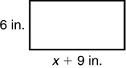
F | 12 + 2(x + 9) > 72 | H | 6(x + 9) > 72
G |  | J

____ 7. What compound inequality is shown by the graph below?
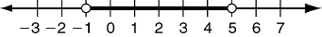

____ 8. Solve the compound inequality 8f < 24 OR f – 11 > –5.

____ 9. The park charges $20 plus $5 per hour to rent a boat. Which function gives the total amount charged?

____ 10. Which ordered pair does NOT lie on the graph of h(x) = –2x + 7?
F | (–2, 3) | H | (3, 1)
G | (–1, 9) | J | (4, –1)

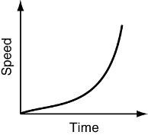
____ 11. What are the next three terms in the arithmetic sequence 2.2, 3.7, 5.2, ...?

____ 12. Which situation is best represented by the graph shown at the right?

F | A mountain biker bikes up a hill. | H | A mountain biker bikes up and down several hills, all of similar height.
G | A mountain biker bikes down a hill. | J | A mountain biker bikes up and down several small hills, and then up one large hill.

____ 13. What is the domain of the following relation?
x | y
0 | 1
3 | 1
3 | 2
6 | 4
____ 14. A line has a slope of 3 and contains the point (4, 6). Which is the equation of the line?

____ 15. Which of these describes the transformation in terms of f(x)? Horizontal translation 3 units left.
A | f(x) – 3 | C | f(x + 3)
B | –3f(x) | D | f(x – 3)

____ 16. Which transformation of the parent function does the function represent?

____ 17. Which is the average rate of change over the interval [0, 10]?
Equation A
X | 0 | 5 | 10 | 15
Y | 0 | 5 | 0 | –20

Equation B
f(x) = 15x + 13

____ 18. What are the y-intercepts of the graphs of the functions?

Function A
X | 0 | 5 | 10 | 15
Y | 0 | 5 | 0 | –20

Function B
f(x) = 15x + 13

F | A: 0, B: 13 | H | A: 10, B: 0
G | A: 10, B: 13 | J | A: 13, B: 0

____ 19. Which of the following graphs is NOT quadratic?
A | 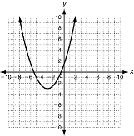 | B | 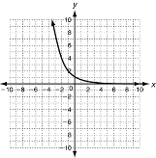 | C | 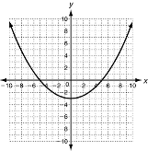 | D | 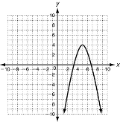

____ 20. Which type of model best fits this data: 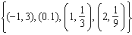?

____ 21. What is the 10th term of the arithmetic sequence below?
–13, –7, –1, 5...

____ 22. Which type of graph would be best for displaying this data?
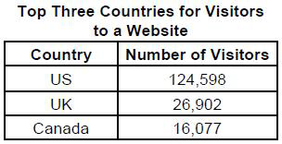
F | bar graph | H | histogram
G | circle graph | J | line graph

____ 23. The fuel economy in miles per gallon (mi/gal) of several vehicles is given below.
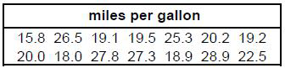
Which frequency table reflects the data?
A | 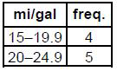 | C | 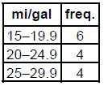
B | 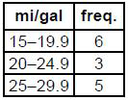 | D | 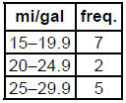

____ 24. The fuel economy in miles per gallon (mi/gal) of several vehicles is given below.
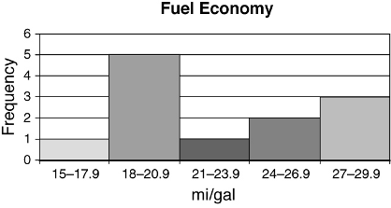

What is wrong with this histogram?

F | The bar for 15–17.9 is too short and the bar for 18–20.9 is too tall. | H | The bar for 21–23.9 is too short and the bar for 24–26.9 is too tall.
G | The bar for 18–20.9 is too short. | J | The bar for 27–29.9 is too tall.

____ 25. The fuel economy in miles per gallon (mi/gal) of several vehicles is given below.

What, if anything, is wrong with this box-and-whisker plot?

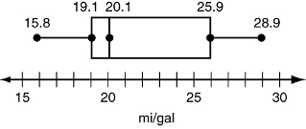
A | The value of Q1 is incorrect. | C | The value of Q3 is incorrect.
B | The value of the median is incorrect. | D | The boxplot is correct.

____ 26. A company is testing a new method of manufacturing a part for their machines. They tested parts using the old and new methods.
Parts Performance by Age
 | New | Old
Passed | 5 | 23
Failed | 2 | 30

What is the approximate probability that a part chosen at random from this group is new and passed the test?

____ 27. Which function is graphed for the domain {–2, –1, 0, 1, 2}?
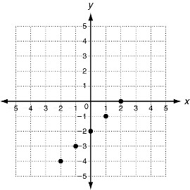
A | f(x) = x – 2 | C | f(x) = 2 – x
B | f(x) = x + 2 | D | f(x) = 2 + x

____ 28. A triangle has vertices A(–3, 6), B(1, 5), and C(2, –4). After a transformation, the image of the triangle has vertices A’(–3, –6), B’(1, –5), and C’(2, 4). Identify the transformation.
F | reflection across the x-axis | H | rotation
G | reflection across the y-axis | J | translation

____ 29. A quadrilateral with vertices (–3, 3), (–3, 0), (3, 0), and (3, 3) is reflected across the y-axis. Which is NOT a vertex of the image?
A | (–3, 3) | C | (3, 0)
B | (–3, 0) | D | Not here

____ 30. A fabric designer is mapping out a new design. Part of the pattern is formed by a repeating polygon. The initial polygon has vertices (–7, 3), (–4, 6), (–1, 3), and (–4, 0). The next polygon is a translation of the first along the vector . Which is NOT a vertex of the vector?
F | (–1, –3) | H | (3, 0)
G | (–4, 0) | J | (–1, 3)

____ 31. What is the angle of rotation if a rotation about the origin maps (4, –2) to (2, 4)?
A | 45° | C | 180°
B | 90° | D | Not here

____ 32. Given the function , which is the equation of the image when the graph is translated 2 units up?
F |  | H
G |  | J

____ 33. Which mapping represents a rotation of 270° clockwise about the origin?
A |  | C
B |  | D

