`sd
Goals, College, & Rates
Standard: SWABAT interpret parts of an expression, such as terms, factors, and coefficients. (MCC912.A.SSE.1a)

Name: ___________________________________ Mr. Murphey’s Analytical Geometry
Date: 1/9/2014 Block: 2


Inbox Task - Complete the letter to self activity found on the whiteboard

Big Goals
Our big number is ______________
1. _____________________- ________________________________________________________________
2. _____________________- ________________________________________________________________
3. _____________________- ________________________________________________________________
College
What are three advantages of college compared to high school? _____________________________________
__________________________________________________________________________________________
__________________________________________________________________________________________

The more you_____________ the more you _____________



Wanting to go to college is different than being _____________________
College to do list
- ____________________________
- ____________________________
- ____________________________
- ____________________________

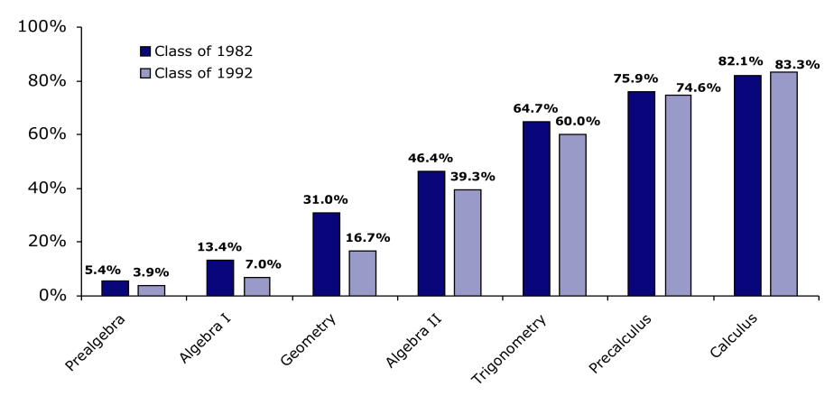
%
%
%
%
%
%
%

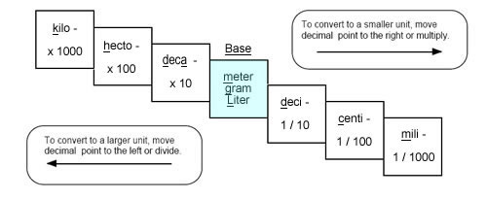
Unit Conversion Chart

Distance: Weight: Volume (liquids):


1 mile = 5,280 feet 1 ton = 2,000 pounds 1 gallon = 4 quarts
1 yard = 3 feet 1 pound = 16 ounces 1 quart = 2 pints
1 foot = 12 inches 1 pint = 2 cups
1 cup = 8 ounces
To Convert Between English and Metric:
1 inch = 2.54 cm.
1 quart = 946 mL
1 pound = 454 grams

Unit Conversion Practice

- 1.347 L = ____ mL

- 52 qt = ____ ga

- 1760 yd = ____mi

- 2750 lb = ____ oz

- 3.2 mi = ____ yd

- 2750 lb = ____ kg

- 940 mm = ____ cm

- 267 mg = ____ g

- 876 mL = ____ L

- 5675 ft = ____ mi

- 2750 lb = ____ ton

- 3.2 mi = ____ in

Word Problems

- Convert 760 minutes to days

- A building is 1,275 feet tall. How many yards tall is this building?
- Convert 3.725 kilometers to meters.

- If 1 inch = 2.54 centimeters, how tall is Marty, to the nearest centimeter, if he is 6 feet tall?

- You’re traveling in Canada and a sign says the temperature 25º Celsius (C). What is it in degrees Fahrenheit (F)? ( 1.6º C = 1º F)

