Intelligence and Goals

Standard: SWABAT Interpret parts of an expression, such as terms, factors, and coefficients. (MCC912.A.SSE.1a)

Name: ___________________________________ Mr. Murphey’s Coordinate Algebra
Date: 8/14/2013 Block: 2




Inbox Task
- In your own words, what is a goal?
_________________________________________________________________________________________________
- Why do you think setting goals are important?
__________________________________________________________________________________________________________________________________________________________
- Have you ever set a goal? Where you able to achieve it?
_____________________________________________________________________________
_____________________________________________________________________________
- What are our goals as a class? ______________________________________________________________
- What are the “pillars of professionalism”? ___________, _____________, ___________, and ___________

College
What are three advantages of college compared to college? _________________________________________
__________________________________________________________________________________________
__________________________________________________________________________________________
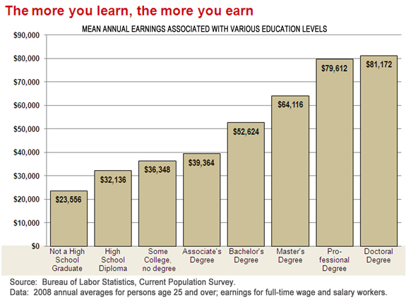
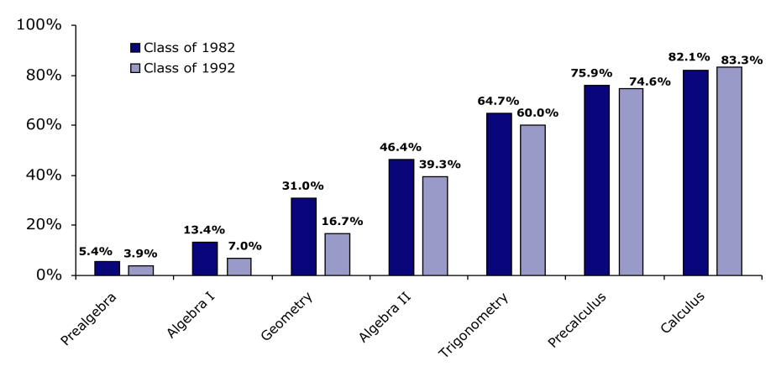
The more you_____________ the more you _____________

%
%
%
%
%
%
%

Wanting to go to college is different than being _____________________
College to do list
- ____________________________
- ____________________________
- ____________________________
- ____________________________

Procedures
____________________
_________________________________________________________________________________________________________________________________________________________________________________________________________________________________________________________________________________________________________________________________________________________________________________________________

____________________
_________________________________________________________________________________________________________________________________________________________________________________________________________________________________________________________________________________________________________________________________________________________________________________________________

____________________
_________________________________________________________________________________________________________________________________________________________________________________________________________________________________________________________________________________________________________________________________________________________________________________________________

____________________
_________________________________________________________________________________________________________________________________________________________________________________________________________________________________________________________________________________________________________________________________________________________________________________________________

____________________
_________________________________________________________________________________________________________________________________________________________________________________________________________________________________________________________________________________________________________________________________________________________________________________________________

Order of Operation Review

P - ___________________
E - ___________________
M - ___________________
D - ___________________
A - ___________________
S - ___________________

Like terms: ____________________________________
_____________________________________________

Examples:
- $3 + 4 × 2=$

- $6 + 7 ×8=$

- $16 ÷ 8 - 2=$

- $9 - 5 ÷ \left(8 - 3\right)× 2 + 6 =$

- $3+ 2 × \left(5- 3\right)+ 1 ×3 =$

- $2^{2}-\left(2 ×2\right)+ 4 ÷2 =$

- $14x + 5+6 \left(2x + 3\right)=$

- $6x+ 3\left(8 – 3x\right)+10 ÷ 5=$

- $\left( 3 × 4x\right)2+ 6^{2} - 7x=$

Practice

Circle the equations that equal the number in the box.
For every answer more than one is correct
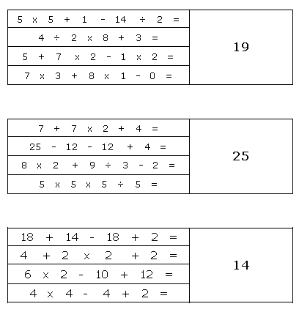

- $3 (4x + 3) =$

- $( 3 × 4 - 6^{2} ) + 7$

- $5 ( 2x -4 ) + 6 ( -x + 3 ) =$

- $x ( -3 - 5) + y (4) – 5y +x + 2 (4 + x )$

- $(86 - {6 }^{2} ) ÷( 8 - 3 )$

Solving Equations

When you solve an equation you are trying to get the __________________ by _______________.

Whatever you do to an equation, do the ___________ thing to ___________ sides of that equation!
- $26 = 8 + v$

- $m + 4 = -12$

- $3 + p = 8$

- $10n = 40$

- $7b = -56$

- $-5= \frac{a}{2}$

- $2d-4=8$

- $2\left(n+5\right)=-2$

- $-9x+1=-80$

- $-4=\frac{r}{20}-5$

- $-6+\frac{x}{4}=-5$

- $-6=\frac{n}{2}-10$

- $-20=-4x - 6x$

- $14= -(p-8)$

- $5\left(2x-2\right)=3\left(x-1\right)+7$

- $5x+3+x=3-6$

- $3\left(x+1\right)=6$

- $2\left(3x-3\right)=6$

