Exploring Transformations pg. 82
A translation moves a point, figure, or function right, left, up, or down.
Horizontal Translation (right or left) | Vertical Translation (up or down)
The x-coordinate changes.  (x, y) → (x + h, y) | The y-coordinate changes.  (x, y) → (x, y + k)

Translate the function y = f (x) left 2 units.
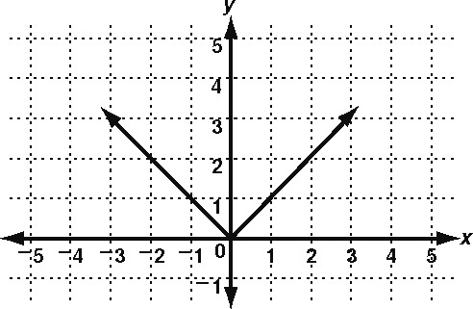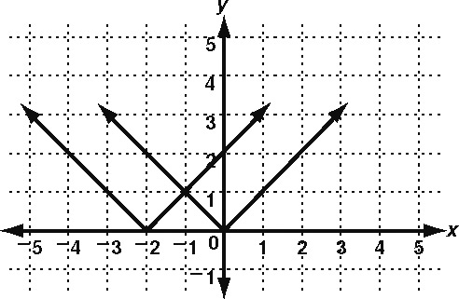
Move each point 2 units left. Connect the points. (x, y ) → (x − 2, y)
A reflection flips a point, figure, or function across a line.
Reflection Across y-axis | Reflection Across x-axis
The x-coordinate changes.  (x, y ) → (−x, y) | The y-coordinate changes.  (x, y ) → (x, −y)

Reflect the function y = f (x) across the x-axis.
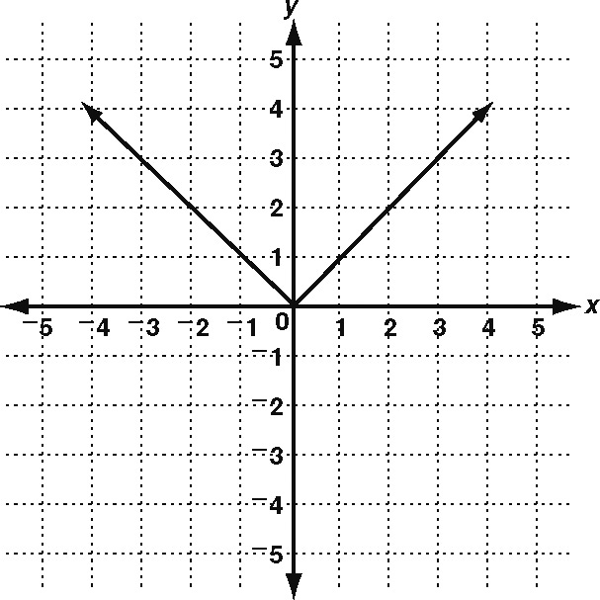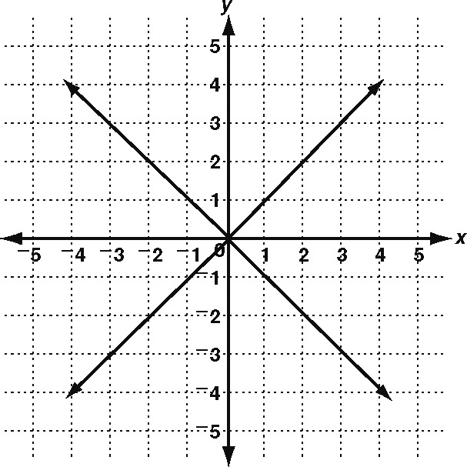
Flip each point across the axis. Connect the points. (x, y ) → (x, −y)
Perform each transformation of y = f (x).
1. translation up 2 units 2. reflection across x-axis
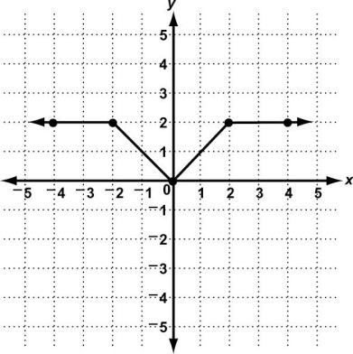
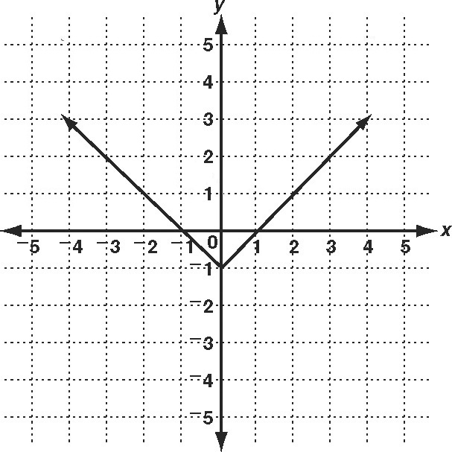
Exploring Transformations (continued)
In a stretch or a compression, the new figure has a different shape than the original.
Horizontal Stretch  (away from y-axis) | The x-coordinate changes.  (x, y) → (bx, y); | b | > 1
Vertical Stretch  (away from x-axis) | The y-coordinate changes.  (x, y) → (x, ay); | a | > 1
Horizontal Compression  (toward the y-axis) | The x-coordinate changes.  (x, y) → (bx, y); 0 < | b | < 1
Vertical Compression  (toward the x-axis) | The y-coordinate changes.  (x, y) → (x, ay); 0 < | a | < 1

Perform a vertical stretch of the function y = f (x) by a factor of 2.
In a vertical stretch (x, y) → (x, ay). In this case, a = 2.
Original Figure  (solid line) | x | 2y | Stretched Figure  (dashed line)
(−3, 3) | −3 | 6 | (−3, 6)
(−1, 1) | −1 | 2 | (−1, 2)
(0, 2) | 0 | 4 | (0, 4)
(1, 1) | 1 | 2 | (1, 2)
(3, 3) | 3 | 6 | (3, 6)

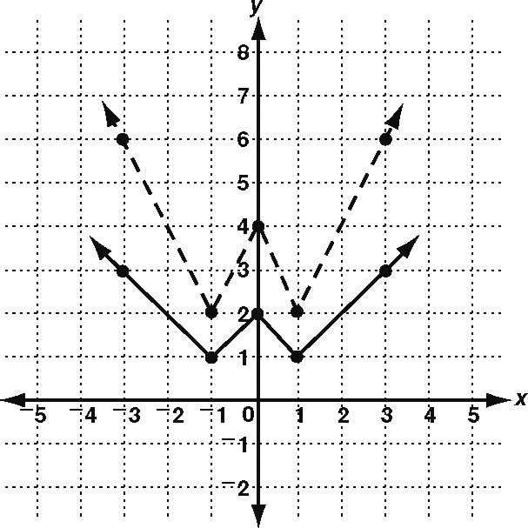

Perform each transformation of y = f (x).
3. horizontal stretch by a factor of 2 4. vertical compression by a factor of
