Linear Functions & Intercercepts
Standard: SWABAT Understand that the graph of an equation in two variables is the set of all its solutions plotted (MCC912.A.REI.10)

Name: ___________________________________ Mr. Murphey’s Coordinate Algebra
Date: 3/11/2014 Block: 1 4
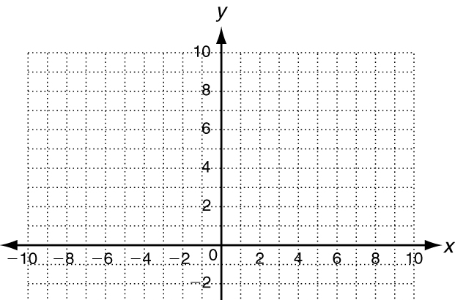



Inbox Task – Plot each point.

- Solve 2x – 3y = 12 for y
- Graph $y=\frac{1}{5}x+1$ for D: {–10, –5, 0, 5, 10}
Solve each equation.

- 5x + 0 = –10

- 33 = 0 + 3y

- $\frac{4}{5}x+\frac{1}{10}=\frac{9}{10}$

- 2x + 14 = –3x + 4

- –5y – 1 = 7y + 5

Identifying Linear Functions
Identify whether each graph represents a function. Explain. If the graph does represent a function, is it linear?
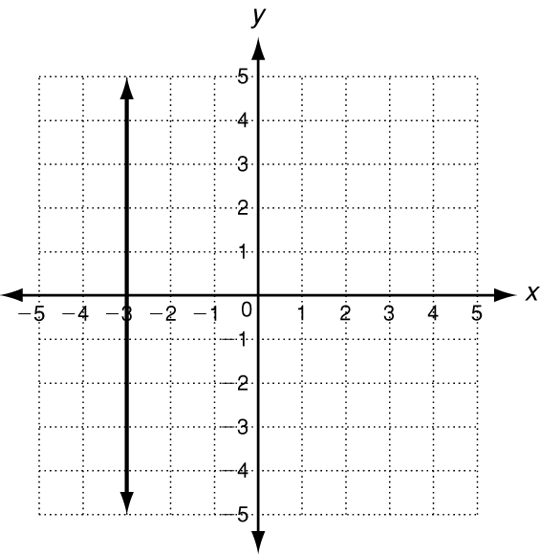
1.

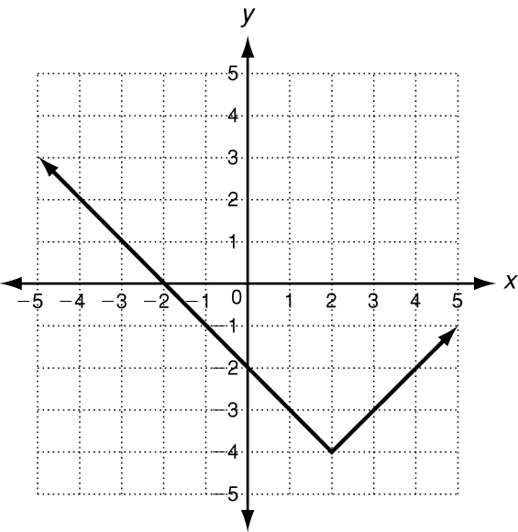

2. ____________________________________________
____________________________________________
____________________________________________

3. Which of the sets of ordered pairs satisfies a linear function? Explain.
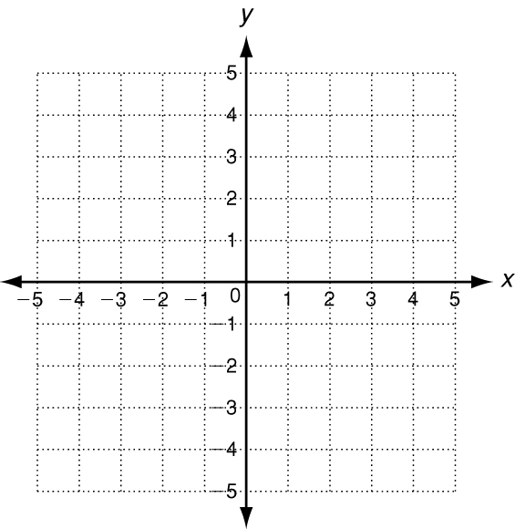
Set A: {(−10, 3), (−9.9, 4.5), (−9.8, 6), (−9.7, 7.5)} Set B: {(1, 5), (2, 10), (4, 15), (8, 20), (16, 25)} _____________________________________

4. Write y = −x + 3 in standard form. Then graph the function.

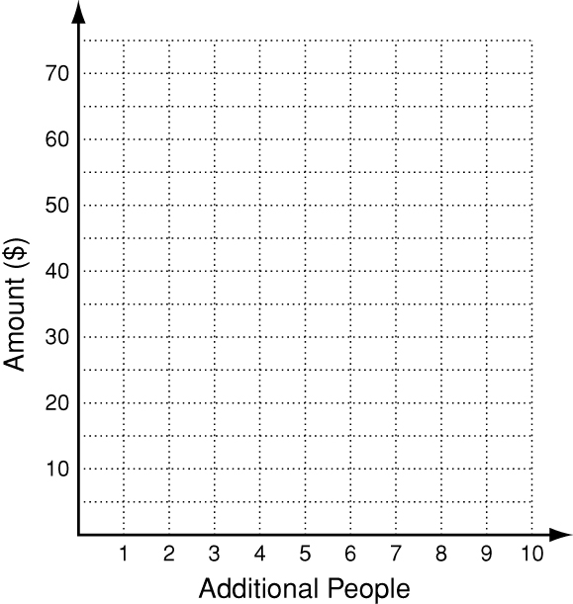
5. A campground charges $30 for 2 people plus $4 for
each additional person. The total amount owed is given
by f(x) = 30 + 4x where x is the number of additional
people. Graph this function and give its domain
and range.

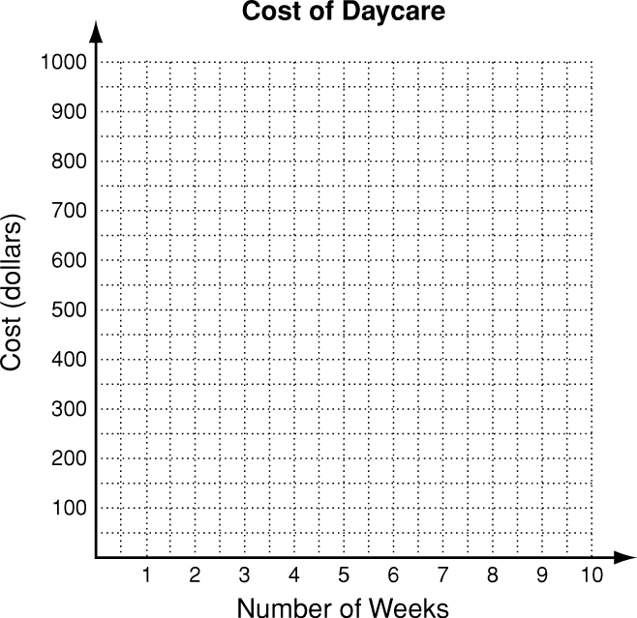
Write the correct answer.
6. A daycare center charges a $75 enrollment fee
plus $100 per week. The function f(x) = 100x + 75
gives the cost of daycare for x weeks. Graph this
function and give its domain and range.

Using Intercepts
Find the x- and y-intercepts.
1. 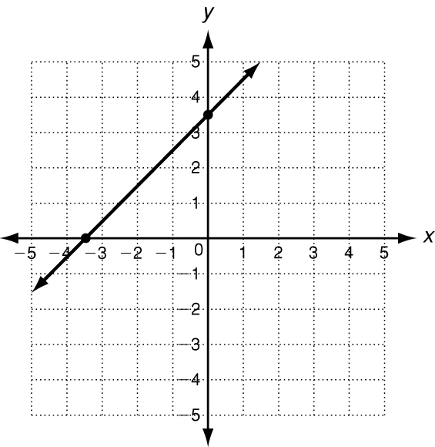 2. 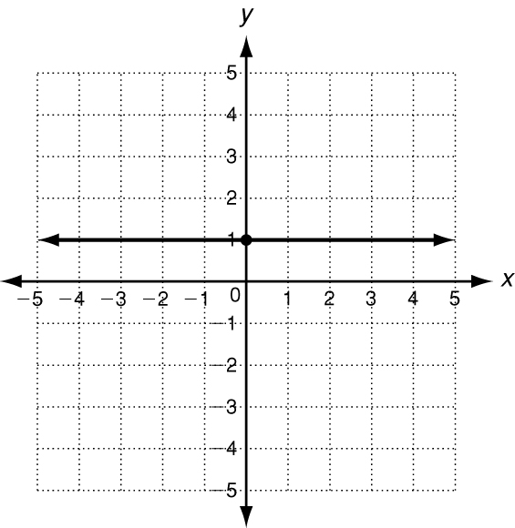 3. 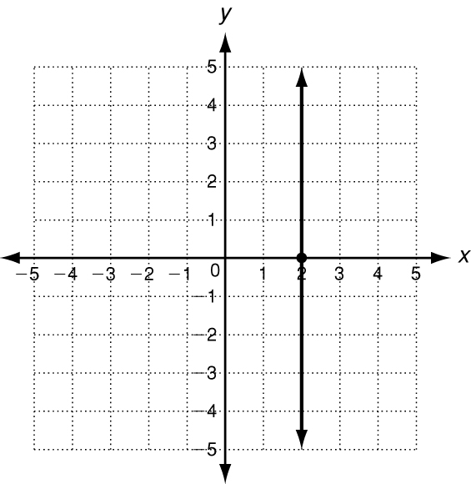

Use intercepts to graph the line described by each equation.
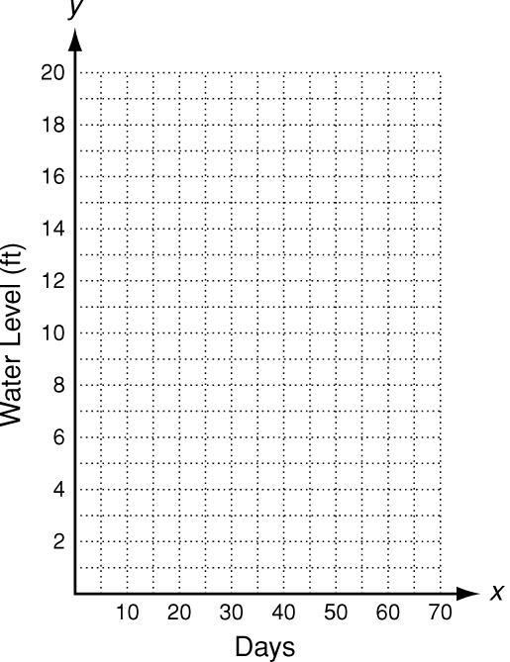
4. y = 0.25x − 1 5. $\frac{1}{3}x$+ y = 1
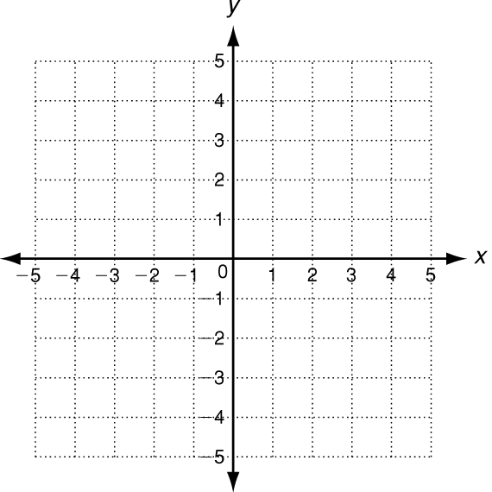
6. The change in water level of one portion of the Mississippi River isabout −0.3 ft per day. If the water level starts at 17 feet and falls forx days, the level is represented by the function f (x) = 17 − 0.3x.
a. Find the intercepts and graph the function.
b. What does each intercept represent?
Write the correct answer.

1. Naima has $40 to spend on refreshments for herself and her friends at the movie theater. The equation 5x + 2y = 40 describes the number of large popcorns x and small drinks y she can buy. Graph this function and find its intercepts.
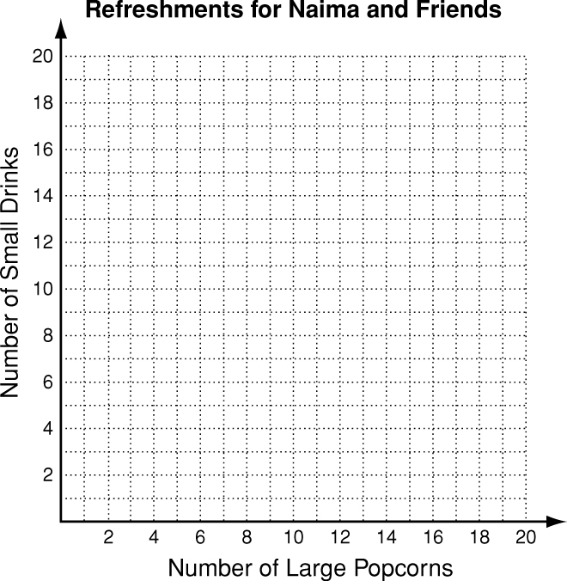

2. Turner is reading a 400-page book. He reads 4 pages every 5 minutes. The number of pages Turner has left to read after x minutes is represented by the function f( x) = 400 − $\frac{4}{5}x$ Graph this function and find its intercepts.

