ROC and Slope Formula
Standard: SWABAT Understand that the graph of an equation in two variables is the set of all its solutions plotted (MCC912.A.REI.10)

Name: ___________________________________ Mr. Murphey’s Coordinate Algebra
Date: 3/12/2014 Block: 1 4


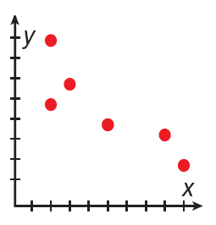

Inbox Task
- Find the x- and y-intercepts of 2x – 5y = 20.
- Describe the correlation shown by the scatter plot.
Find the x- and y-intercepts.

- x + 2y = 8
- 3x + 5y = –15

Rate of Change and Slope
Find the slope of each line.
1. 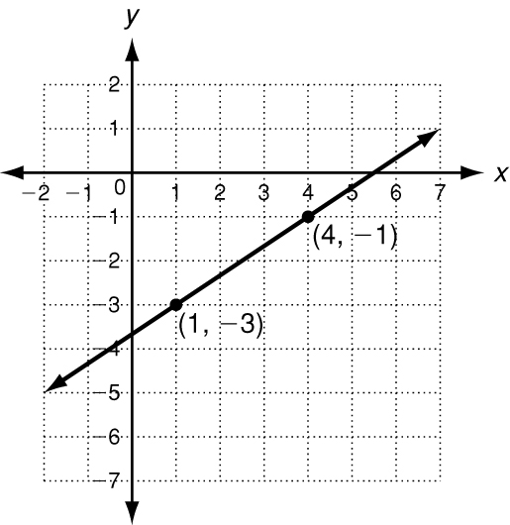 2. 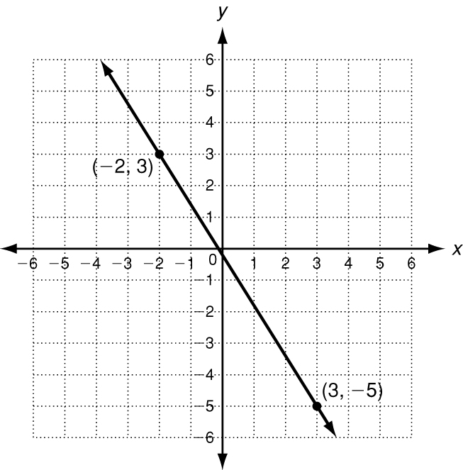 3. 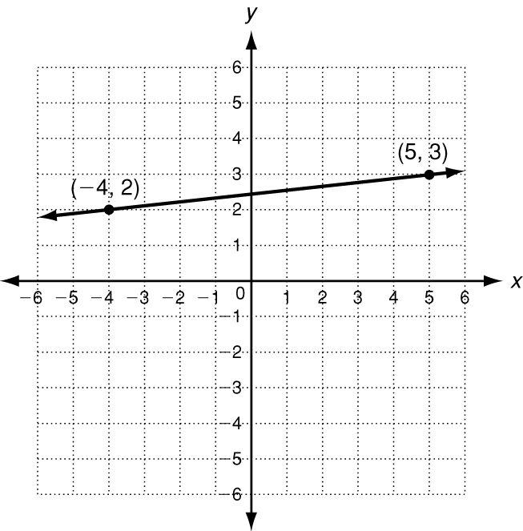
slope = _______________ slope = _______________ slope = _______________
4. 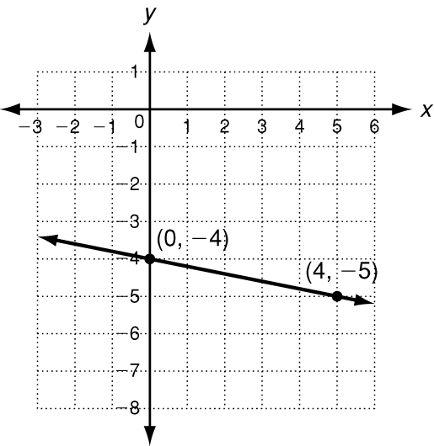 5. 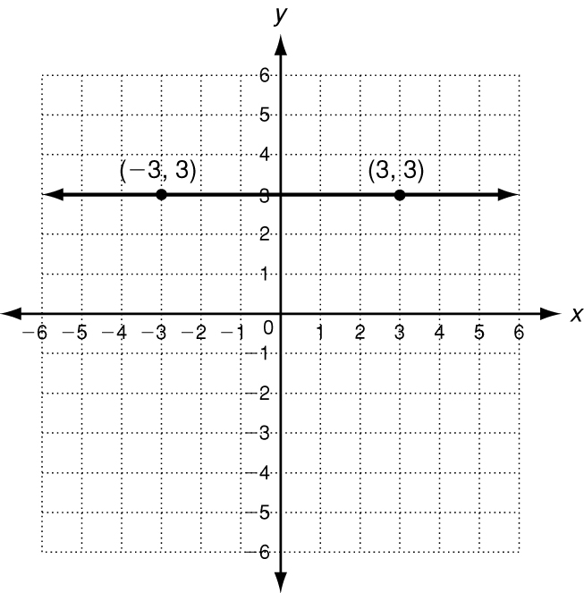 6. 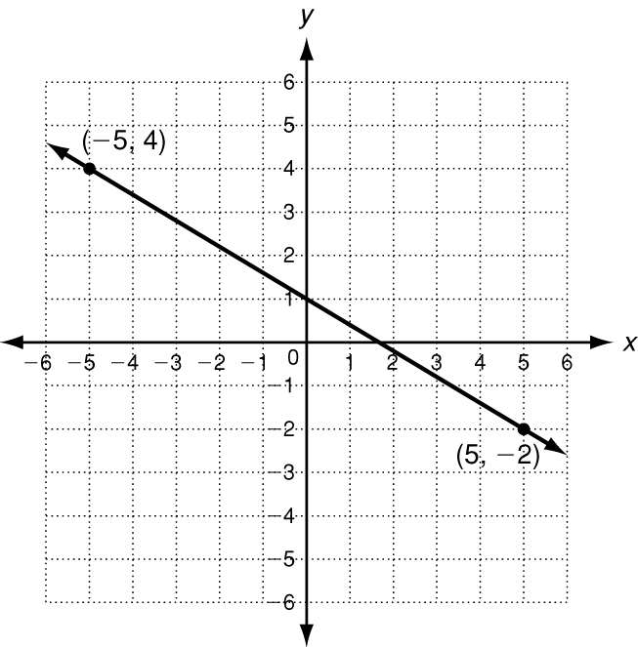
slope = _______________ slope = _______________ slope = _______________
Tell whether the slope of each line is positive, negative, zero, or undefined.
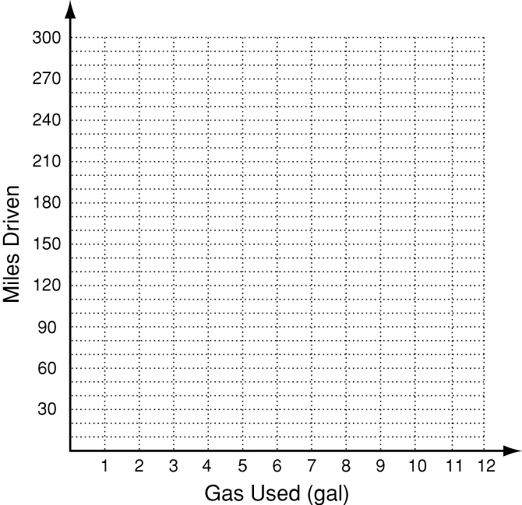
7. 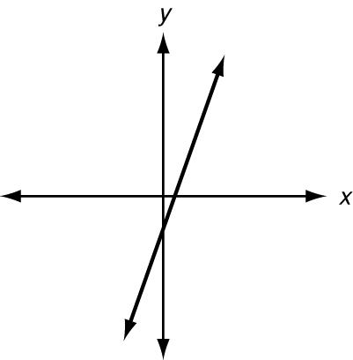 8. 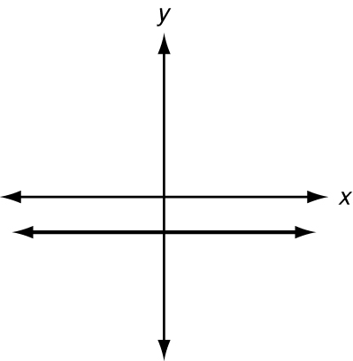 9. 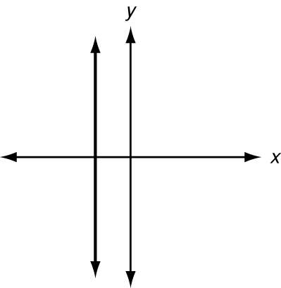

10. The table shows the distance a car drove on one tank of gasoline.
Miles driven | 0 | 60 | 150 | 170 | 230 | 260
Gas Used (gal) | 0 | 2 | 5 | 6 | 9 | 11
a. Graph the data and show the rates of change.
b. The rate of change represents the gas mileage in miles
per gallon. Between which two measurements was the
car’s gas mileage least?
The Slope Formula
Find the slope of the line that contains each pair of points.
1. (2, −5) and (4, 3) 2. (0, −4) and (7, 1) 3. (6, 2) and (−9, −1)
m = ______________ m = ______________ m = ______________
4. (8, 8) and (2, −10) 5. (0, −1) and (−3, −1) 6. (6, 1) and (5, −2)
m = ______________ m = ______________ m = ______________
Each graph or table shows a linear relationship. Find the slope.
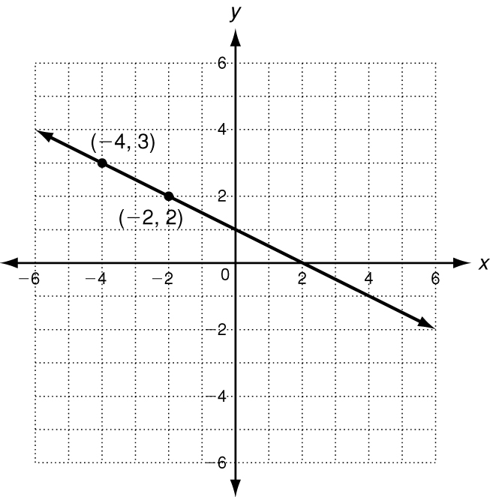
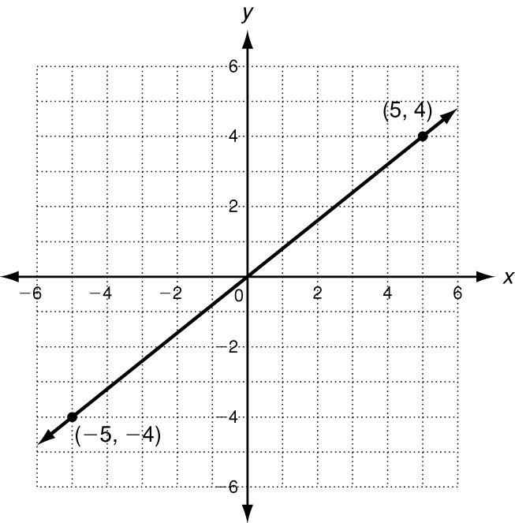
7. 8. 9.
x | y
10 | −28
20 | −24
30 | −20
40 | −16
50 | −12

Find the slope of each line. Then tell what the slope represents.
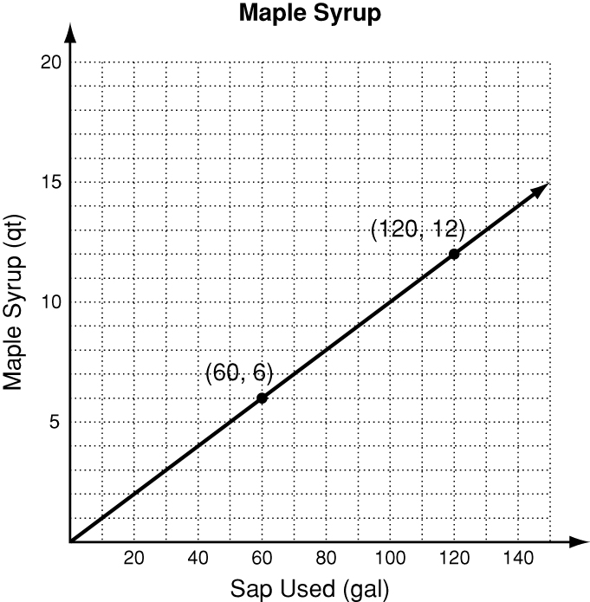
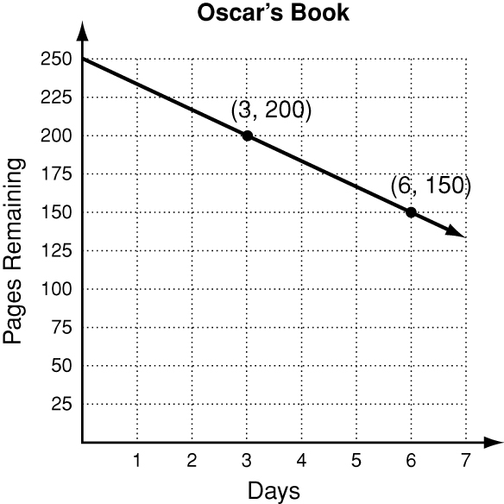
10. 11.

Find the slope of the line described by each equation.
12. 7x − 6y = 42 13. 5x + 2y = 20 14. −2x + 8y = 24

15. 64 − 4y = −16x 16. 8x = 4y − 1 17. y = 6x − 10

Write the correct answer.

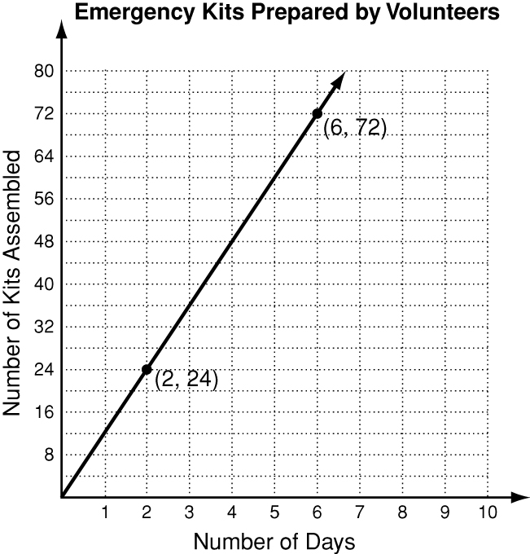
18. The graph shows the number of emergency kits assembled by volunteers over a period of days. Find the slope of the line. Then tell what the slope represents.
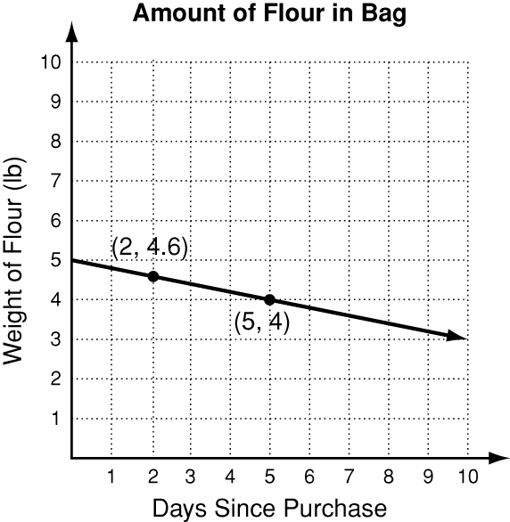
19. The graph shows how much flour is in a bag at different times. Find the slope of the line. Then tell what the slope represents.

20. The function 20x − y = 250 describes the profit y Bridget can make from selling x pairs of earrings.The graph of this function is a line. Find its slope.

