

Name: ___________________________________ Mr. Murphey’s Analytical Geometry
Date: 3/14/2014 Block: 2
Standard: SWABAT Represent transformations in the plan compare transformations that preserve distance (MCC912. G.CO.2)
Unit 1B Review

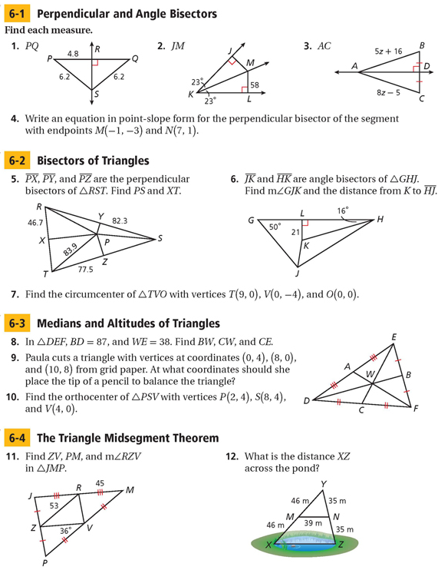
Inbox Task

