Linear Functions & Intercepts
Standard: SWABAT understand that the graph of an equation in is the set of all its solutions plotted in the coordinate plane (MCC912.A.REI.10)

Name: ___________________________________ Mr. Murphey’s Coordinate Algebra Support
Date: 10/15/2013 Block: 1 4


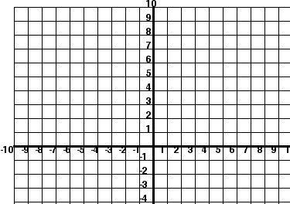

Inbox Task –

1. Solve $2x -3y= 12$ for y . 2. Graph $y=\frac{1}{5}x-1$ for D: { -10,- 5, 0, 5, 10 } .

Identifying Linear Functions
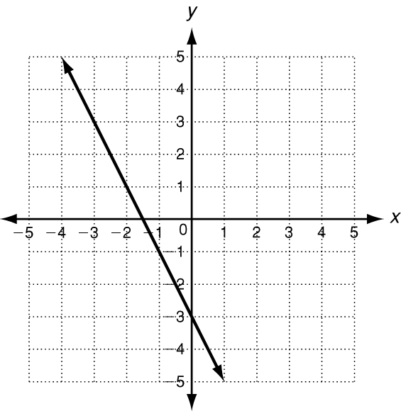
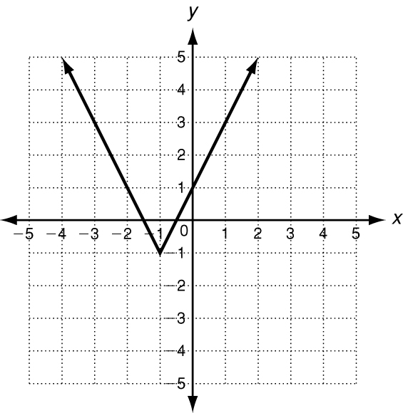
Tell whether each graph, set of ordered pairs, or equation represents a linear function. Write yes or no.
1. 2. 3.
x | y
−9 | 5
−5 | 10
−1 | 15

4. {(−3, 5), (−2, 8), (−1, 12)} 5. 2y = −3x ² 6. y = 4x − 7

Give the domain and range for the graphs below.
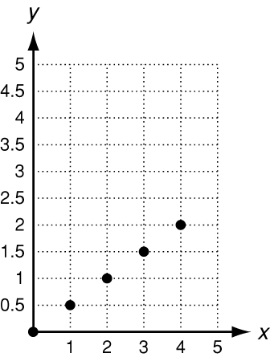
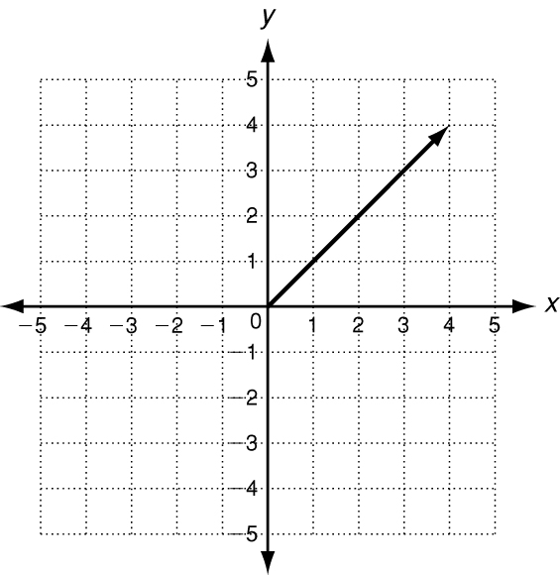
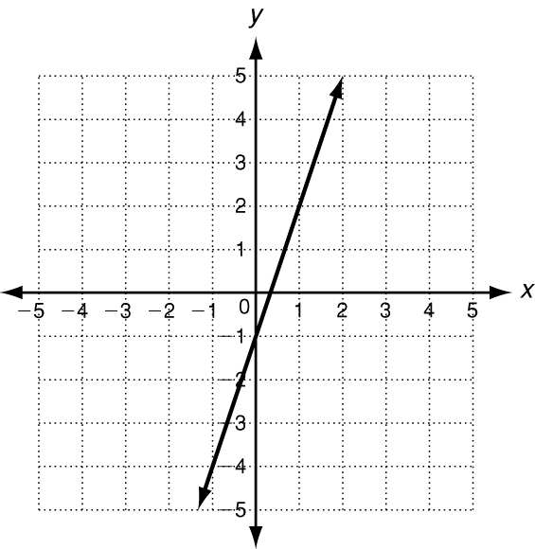
7. 8. 9.

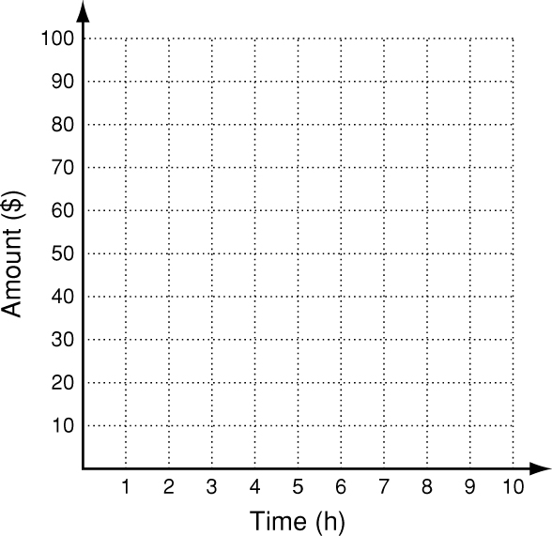

10. Tyler makes $10 per hour at his job. The function f(x) = 10x
gives the amount of money Tyler makes after x hours.
Graph this function and give its domain and range.

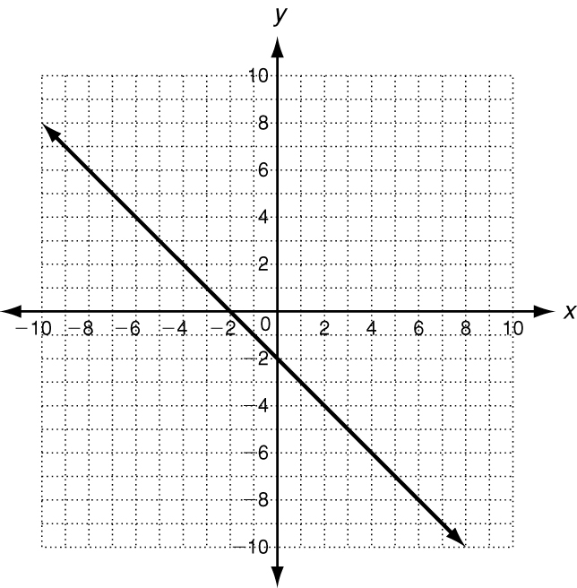
Use the graph for 1–3.
1. Is this graph a function?
2. Explain how you know it is a function.

3. If this graph is a function, is it also
a linear function?

Use the set {(1, 8), (2, 6), (3, 4), (4, 2), (5, 0)} for 4–5.
4. Does the set of ordered pairs satisfy a linear function?
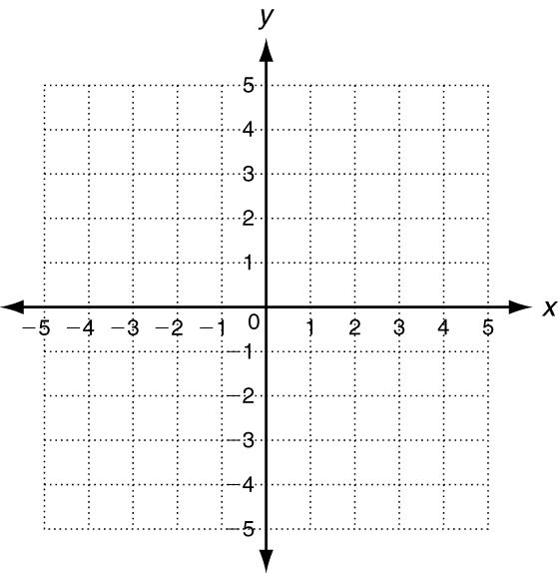
5. Explain how you decided.

6. Write the equation y = x − 4 in standard
form (Ax + By = C).

7. Is y = x − 4 a linear function?
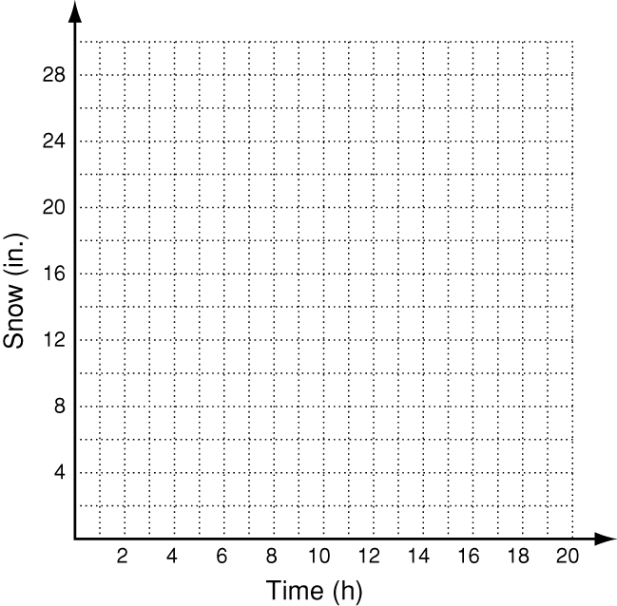
8. Graph y = x − 4 to check.
9. In 2005, a storm in Milwaukee, WI was dropping 2.5
inches of snow every hour. The total amount of snow
is given by f(x) = 2.5x, where x is the number of hours.
Graph this function and give its domain and range.

Find the x- and y-intercepts.
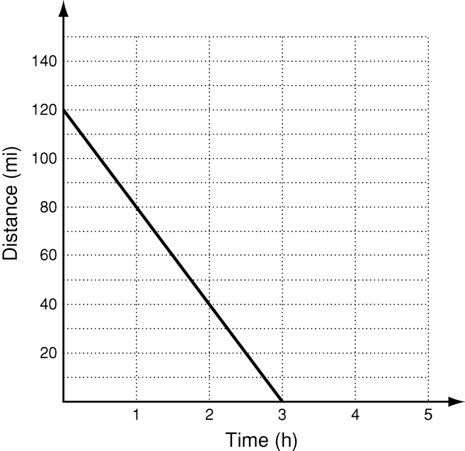
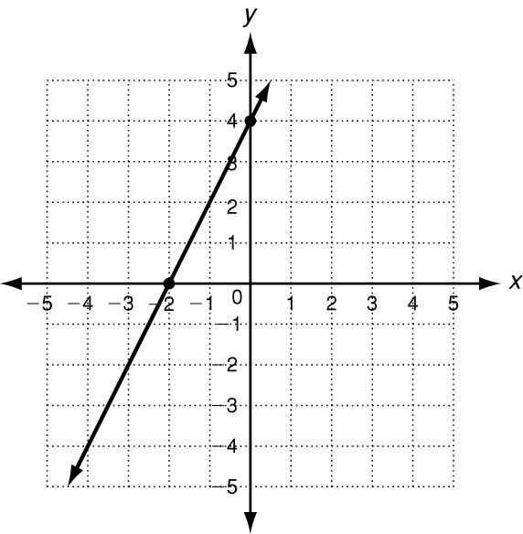
1. 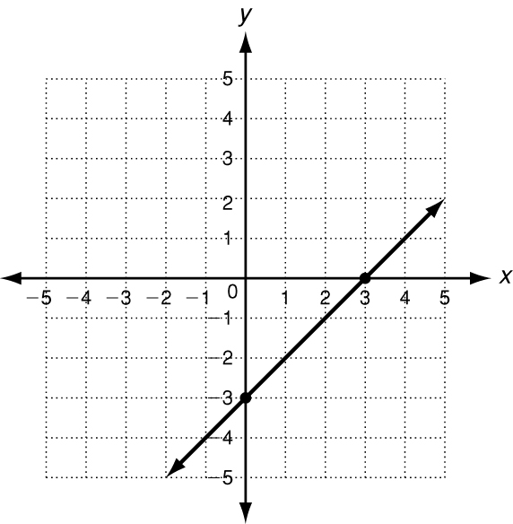 2. 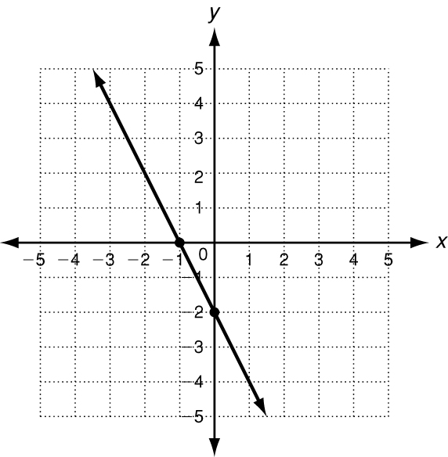 3.
4. The volleyball team is traveling to a game 120 miles away.
Their average speed is 40 mi/h. The graphed line describes
the distance left to travel at any time during the trip. Find the
intercepts. What does each intercept represent?
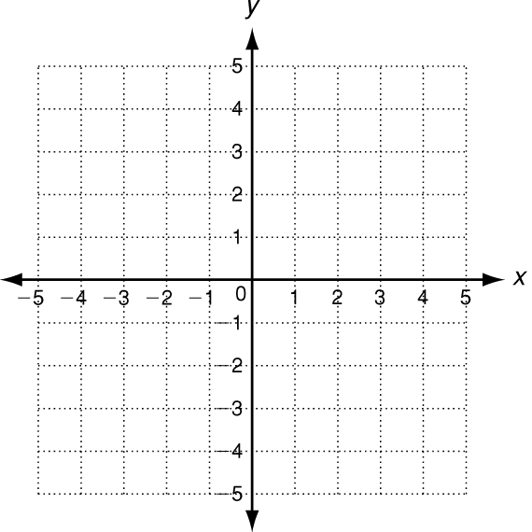
5. Find the intercepts of 2x + 3y = 6 by following the steps below.
a. Substitute y = 0 into the equation. Solve for x.

b. The x-intercept is: ________________________
c. Substitute x = 0 into the equation. Solve for y.

d. The y-intercept is: ________________________
e. Use the intercepts to graph the line described by the equation.
Use intercepts to graph the line described by each equation.
6. 3x + 9y = 9 7. 4x + 6y = −12 8. 2x − y = 4

