Linear Function Form
Standard: SWABAT Create equations in two or more variables to represent relationships between quantities; graph. (MCC912.A.CED.2)

Name: ___________________________________ Mr. Murphey’s Coordinate Algebra
Date: 3/17/2014 Block: 1 4



Inbox Task – Find each y-intercept.

- y = 3x + 2
- 5x – 3y = 12

Find each slope
- $y=\frac{2}{3}x$
- 6x + 2y = 6

Solve each equation for y.

- 4x + 2y = 10
- 3x + 2 = 6y
Find the slope of the line containing each pair of points.

- (0, 2) and (3, 4)
- (–2, 8) and (4, 2)

Slope-Intercept Form Write the equation that describes each line in slope-intercept form.
1. slope = $-\frac{3}{2}$ y-intercept = 1 2. slope = −3, (−3, 4) is on the line.

3. slope = 0; y-intercept = −8 4. slope = (7, −8) is on the line.

5. The line that passes through (1, 5) and(4, −4). (Hint: Find the slope first.) _____________________________

Write each equation in slope-intercept form. Then graph the line described by the equation.
6. y − 2 = −3x 7. x − y = 2 8. −2y = 3x − 4

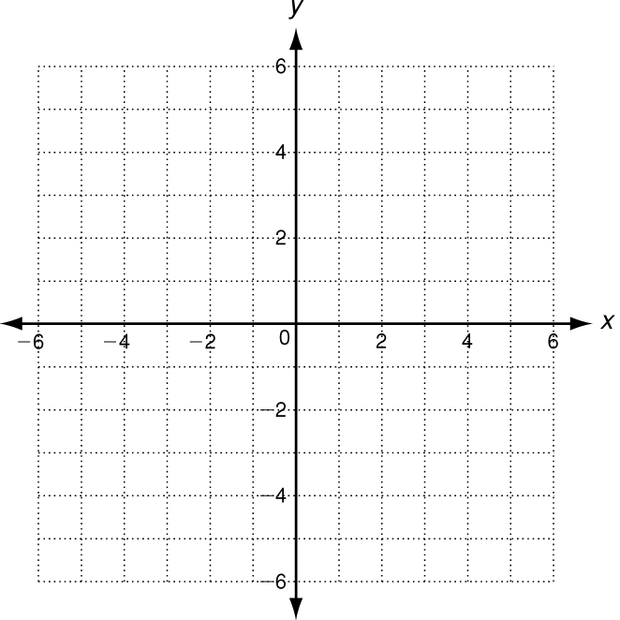
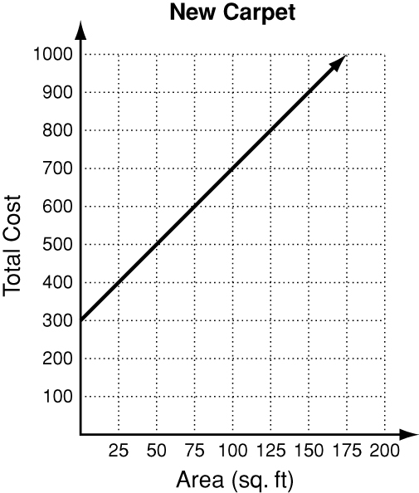
9. The Johnsons are putting new carpet in their home.
Installation is $300 and the carpeting costs $4 per
square foot. The total price of the job as a function of
area is shown in the graph.
a. Write an equation that represents the total price as
a function of area. __________________________________
b. Identify the slope and y-intercept and describe their
meanings. __________________________________________

c. Find the total cost if the area is 375 square feet.

Point Slope Form
Write an equation in point-slope form for the line with the given slope that contains the given point.
1. slope = $\frac{4}{3}$; (−5, −3) 2. slope = −3; (0, 8)

Graph the line described by each equation.
3. y − 1 = −2 (x − 2) 4. y + 3 = 2 (x + 1)
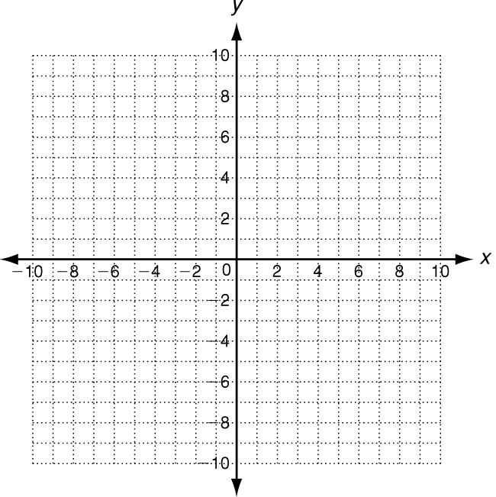
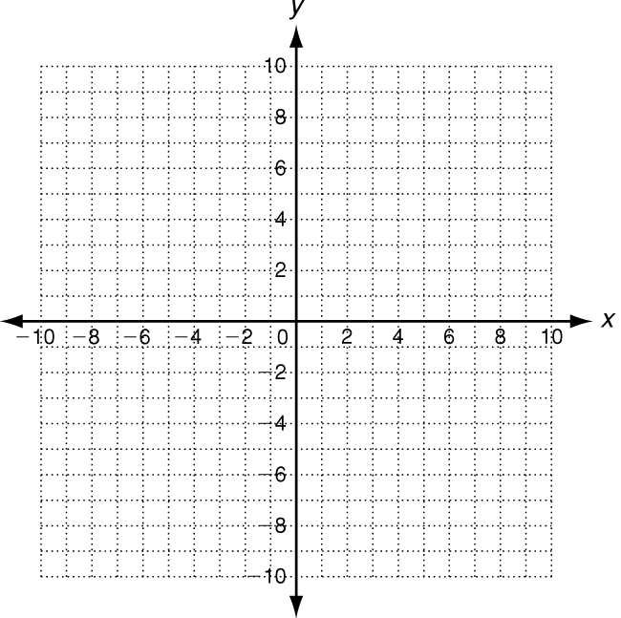

Write the equation that describes the line in slope-intercept form.
5. slope = −4; (2, −1) is on the line 6. slope = $\frac{1}{4}$; (−2, 3) is on the line

7. (−3, 6) and (2, 1) are on the line 8. (0, −5) and (6, −3) are on the line

Find the intercepts of the line that contains each pair of points.
9. (−7, 12) and (14, −6) __________________ 10. (2, 5) and (−6, 25) __________________
Time (min) | 12 | 20 | 50
Volume (gal) | 4962 | 4754 | 3974

11. A pool is being drained at a constant rate. The amount of water is
a function of the number of minutes the pool has been draining, as
shown in the table. Write an equation in slope-intercept form that
represents the function. Then find the amount of water in the poolafter two and a half hours.

The cost of a cell phone for one month is a linear function of the number of minutes used. The total cost for 20, 35, and 40 additional minutes are shown. Select the best answer.

4. What is the slope of the line represented
in the table?
A 0.1 C 2
B 0.4 D 2.5
5. What would be the monthly cost if 60
additional minutes were used?
F $64 H $84
G $72 J $150

Cell-Phone Costs
Number of  Additional Minutes | 20 | 35 | 40
Total Cost | $48 | $54 | $56
6. What does the y-intercept of the function
represent?
A total cost of the bill
B cost per additional minute
C number of additional minutes used
D cost with no additional minutes used

