

Name: ___________________________________ Mr. Murphey’s Analytical Geometry
Date: 3/17/2014 Block: 2
Standard: SWABAT Represent transformations in the plan compare transformations that preserve distance (MCC912. G.CO.2)
Pythagorean Theorem

Inbox Task Classify each triangle by its angle measures.

- 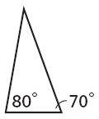 2. 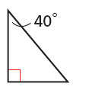

3. Simplify ${(2\sqrt{3})}^{2}$

4. If a = 6, b = 7, and c = 12, find a² + b² and find c². Which value is greater?

The Pythagorean Theorem
Use the Pythagorean Theorem and a calculator to find the value of x. Round to the nearest tenth if necessary.
1. 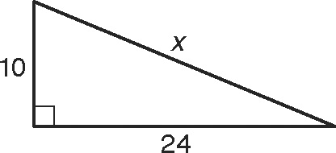 2. 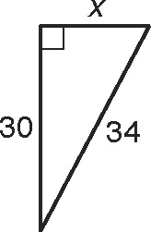 3. 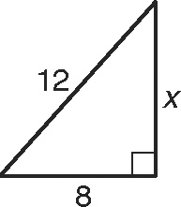

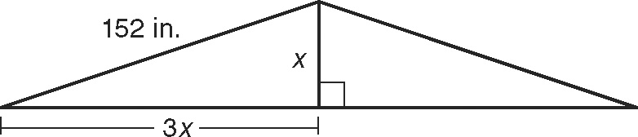
4. A home builder is designing the braces for a roof. She wants the length of the brace to be six times its height. Refer to the figure to find the height of the brace to the nearest inch. _______________________________

Fill in the blank to complete the definition of a Pythagorean Triple.
5. A set of three nonzero _________________ a, b, and c such that a² + b² = c² is called a Pythagorean Triple.
Use a calculator to find the missing side length. Round to the nearest tenth if necessary. Tell whether the side lengths form a Pythagorean Triple.
6. 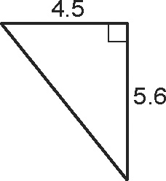 7. 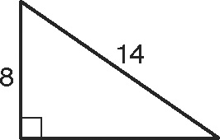 8. 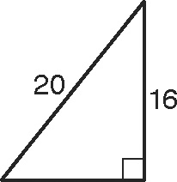
Three segments have lengths of 7, 9, and 11. Complete Exercises
9–12 to tell whether the segments can form a triangle and if the triangle is acute, obtuse, or right.
9. Tell whether the segments can form a triangle. __________________________________
10. The Pythagorean Theorem will tell you if the triangle is acute,
obtuse, or right. In a² + b² = c², the longest segment must
be c. Name the length of the longest segment. ____________________
11. Substitute the lengths of the segments into a² + b² and c². a² + b² = ___________ c² = ___________

12. If a² + b² is less than c², the triangle is acute. If a² + b² is greater than c², the triangle is obtuse. If a² + b² is equal to c², the triangle is right. What kind of triangle is made with segments of lengths 7, 9, and 11? ____________________
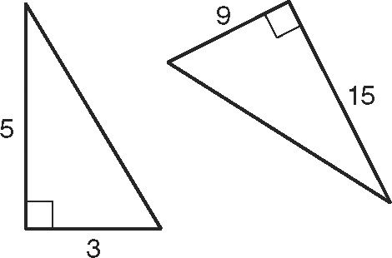

Use the figure for Exercise 13.
13. Find the missing side length in each triangle.

Use what you learned from Exercise 13 to find the missing side lengths below without using a calculator.
14. 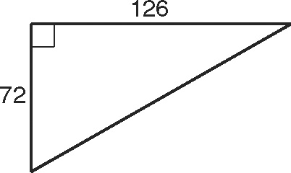 15. 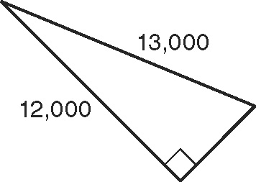 16. 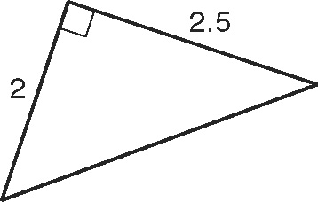

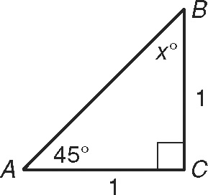
Applying Special Right Triangles
1. The sum of the angle measures in a triangle is 180°.
Find the missing angle measure. Then use the
Pythagorean Theorem to find the length
of the hypotenuse. _________________
In a 45°-45°-90° triangle, the legs have equal length and the hypotenuse is the length of one of the legs multiplied by Find the value of x.
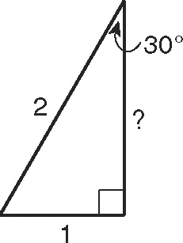
2. 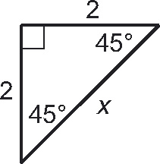 3. 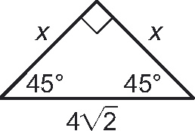 4. 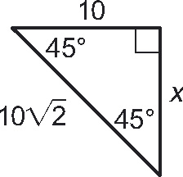

5. Find the missing angle measure. Then use the Pythagorean Theorem to find the missing length.
_________________

In a 30°-60°-90° triangle, the hypotenuse is the length of the shorter leg multiplied by 2, and the longer leg is the length of the shorter leg multiplied by Find the values of x and y.
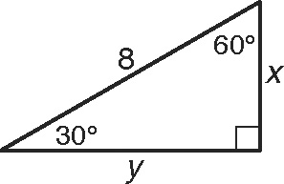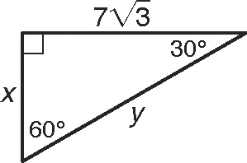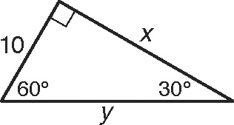
6. x = _______ y = _______ 7. x = _______ y = _______ 8. x = _______ y = _______

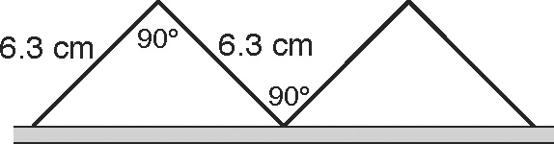
For Exercises 9 and 10, use a calculator to find each answer.
9. Andre is building a structure out of playing cards. Each card
is 6.3 centimeters long. He tries leaning the cards against
each other so that the angle at the top is 90°. Find the
distance between the edges of the cards to the nearest tenth. _________________

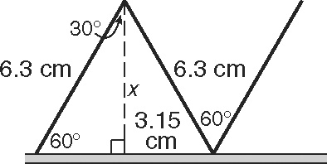
10. Andre tries leaning the cards against each
other so the angle at the top is 60°. Find the
height x of the tops of the cards. _________________

11. Tell whether Andre can lay another card across the peaks of
the structures he built in Exercises 9 and 10.

