Tranforming Linear Functions
Standard: SWABAT Identify the effect on the graph of replacing f(x) by f(x) + k, k f(x), f(kx), and f(x + k) (MCC912.F.BF.3)

Name: ___________________________________ Mr. Murphey’s Coordinate Algebra
Date: 3/18/2014 Block: 1 4



Inbox Task –
Give the coordinates of each transformation of (2, –3).

- horizontal translation right of 5
- vertical translation of –1
- reflection across the x-axis
- reflection across the y-axis

Evaluate f(–2) and f(1.5).
- $f(x) = 3(x + 5) – 1$

- $f(x) = x^{2} + 4x$

Transforming Linear Functions
Let g(x) be the indicated transformation of f (x). Write the rule for g(x).
1. 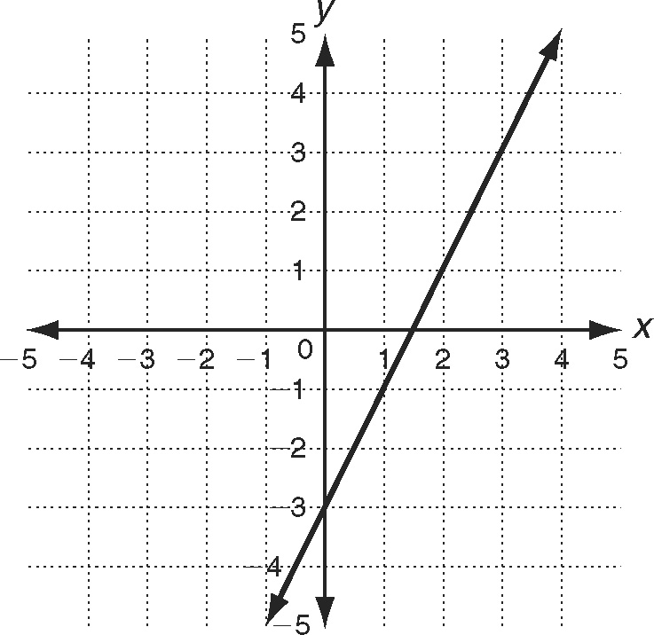 2.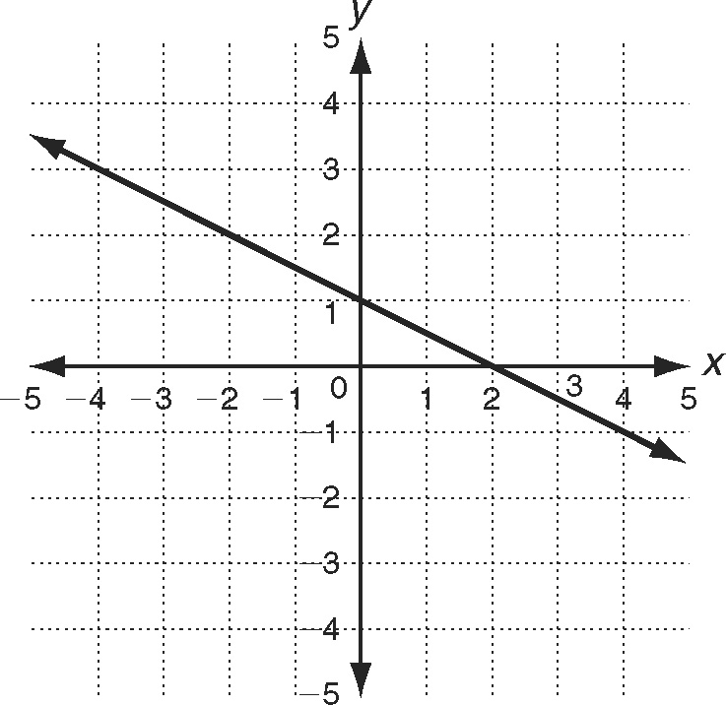 3.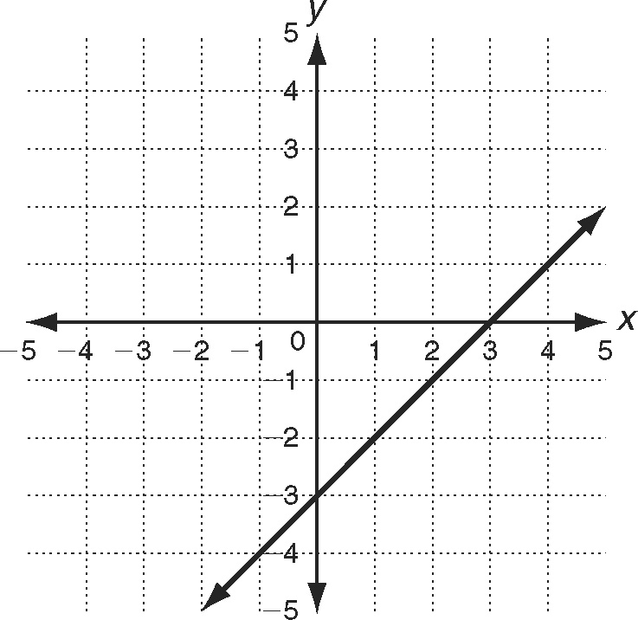
horizontal translation vertical compression by reflection across the
left 3 units a factor of $\frac{1}{5}$ y-axis

4. linear function defined by the table; horizontal stretch by a factor of 2.3
x | −5 | 0 | 7
y | −3 | 7 | 21
6

5. f (x) = 1.7x − 3; vertical compression by a factor of 0.7____________________

Let g(x) be the indicated combined transformation of f (x) = x. Write the rule for g(x).
6. vertical translation down 2 units followed by a
horizontal compression by a factor of $\frac{2}{5}$ _____________________________

7. horizontal stretch by a factor of 3.2 followed by
a horizontal translation right 3 units _____________________________
Solve.
8. The Red Cab Taxi Service used to charge $1.00 for the first $\frac{1}{5}$ mile and $0.75 for each additional $\frac{1}{5}$ mile. The company just raised its rates by a factor of 1.5.
a. Write a new price function g(x) for a taxi ride.

b. Describe the transformation(s) that have been applied.

Graph f (x). Write the rule for gf (x), using the transformation given, and then graph g(x).
1. 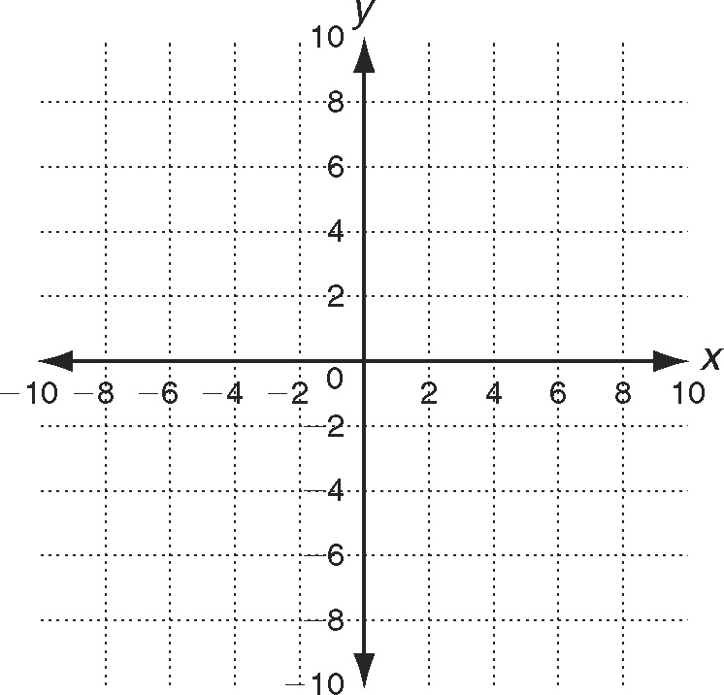 2.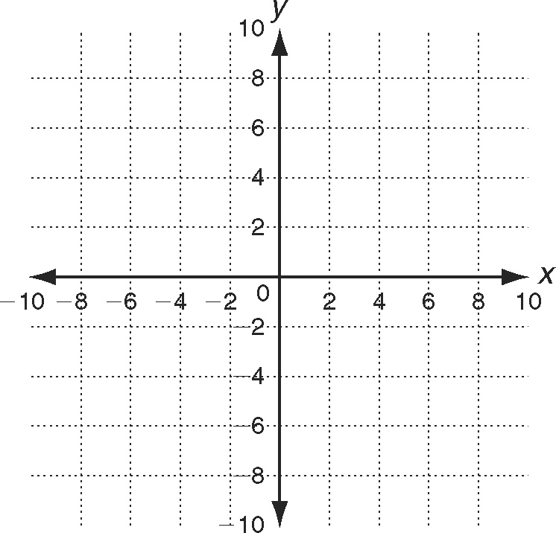3. 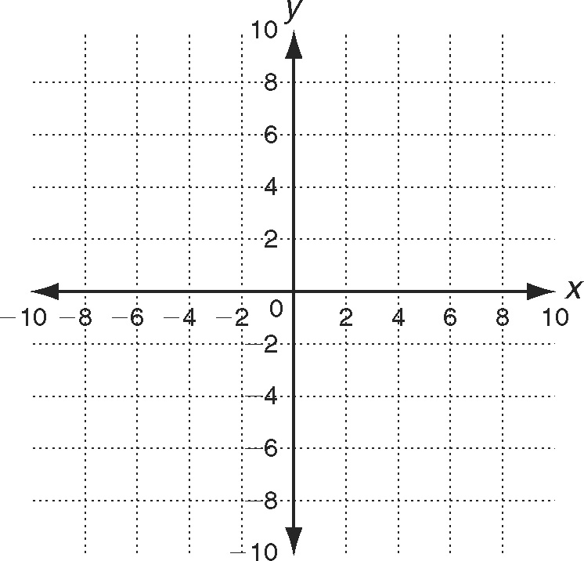
f (x) = 3x f (x) = −x − 5 f (x) = $\frac{x}{3}$ + 2
horizontal translation vertical compression by reflection across the
left 3 units a factor of $\frac{1}{5}$ x-axis

Solve.
4. The rate of increase in a certain city’s population in 2000 was 1.4%. The rate in 2001 was 1.9%.
a. Write a function to represent the increase in population in 2000. _____________________
b. Write a function to represent the increase in population in 2001. _____________________
c. Describe the transformation that can be applied to the first function to get the second function.

d. Find the difference between the two possible growth rates if the population in 2030 is 8.5 billion. _____________________
5. Let g(x) be the reflection of f (x) across the x-axis. Let h(x) = x − 1 be the reflection of g(x) across the y-axis.
a. Find the rule for g(x).
b. Find the rule for f (x).

The students in Ms. Hari’s English class are planning to print a booklet of their creative writings. Use the table of publishing prices.
Publishing Prices
 | Text  Only | Color Graphic
Per page | $0.55 | $1.25
Cover | $2.25 | $3.50

1. The students decide to print a booklet containing black and white text only. Write a function, C(p), to show the cost of printing a booklet of p pages with a cover that also has text only.

2. Julie wants the booklet cover to have a color graphic. Write a new function, J(p), to show this cost for a booklet of p pages.

3. What is the slope of each function? What does the slope tell you about the relationship of the lines? ___________________________________________________
4. What is the y-intercept of each function? What is represented by the y-intercept?

5. Describe the transformation that has been applied to the graph by the decision to change the cover.

6. Oscar suggests that the booklet have 30 pages, one for each person in the class. What is the cost of printing 50 booklets, using the function J(p)?

