Exponential Functions pg. 110
An exponential function has the independent variable as the exponent.
y = 3^{x} and y = −2 (0.5)^{x} are exponential functions.
A set of ordered pairs satisfies an exponential function if the y−values are multiplied
by a constant amount as the x−values change by a constant amount.
Tell whether the following ordered pairs satisfy an exponential function.
x | y |  |  | x | y
3 | 4 | Think 4 × ? = 12. |  | 1 | 2 | Think 2 × ? = 4.
5 | 12 | Think 12 × ? = 36. |  | 2 | 4 | Think 4 × ? = 6.
7 | 36 | Think 36 × ? = 108. |  | 3 | 6 | Think 6 × ? = 8.
9 | 108 |  |  | 4 | 8

The x-values increase by the constant The x-values increase by the constant
amount 2. amount 1.
Each y-value is multiplied by the constant The y-value is multiplied by 2, then 1.5,
amount 3. Then There is no constant ratio.
This is an exponential function. This is not an exponential function.
The population of a school can be described by the function f(x) = 1500 (1.02)^{x},
where x represents the number of years since the school was built. What will
be the population of the school in 12 years?
f(x) = 1500 (1.02)^{x}
f(12) = 1500 (1.02)¹² Substitute 12 for x.
≈ 1902 Round number of people to the nearest whole number.
Tell whether the ordered pairs satisfy an exponential function.
1. 2. 3.
x | y
−1 | 1.5
−2 | 3
−3 | 6
−4 | 12

x | y
−2 | −2
−1 | −10
0 | −50
1 | −250

x | y
1 | 1
2 | 2
3 | 6
4 | 24

4. If a rubber ball is dropped from a height of 10 feet, the function
f(x) = 20 (0.6)^{x} gives the height in feet of each bounce, where
x is the bounce number. What will be the height of the 5th bounce?
Round to the nearest tenth of a foot. _________________
5. A population of pigs is expected to increase at a rate of 4% each
year. If the original population is 1000, the function f(x) = 1000 (1.04)^{x}
gives the population in x years. What will be the population in 12 years? _________________
Exponential Functions continued
The graph of an exponential function is always a curve in two quadrants. y = ab^{x}
a > 0 and b > 1 | a < 0 and b > 1 | a > 0 and 0 < b < 1 | a < 0 and 0 < b < 1
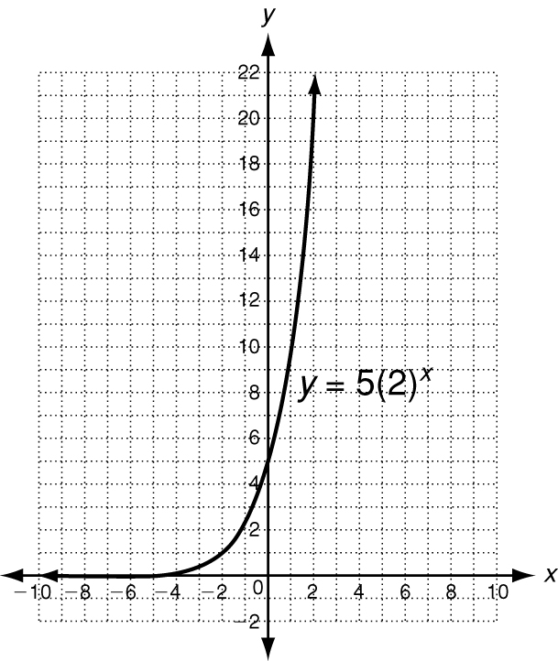 |  | 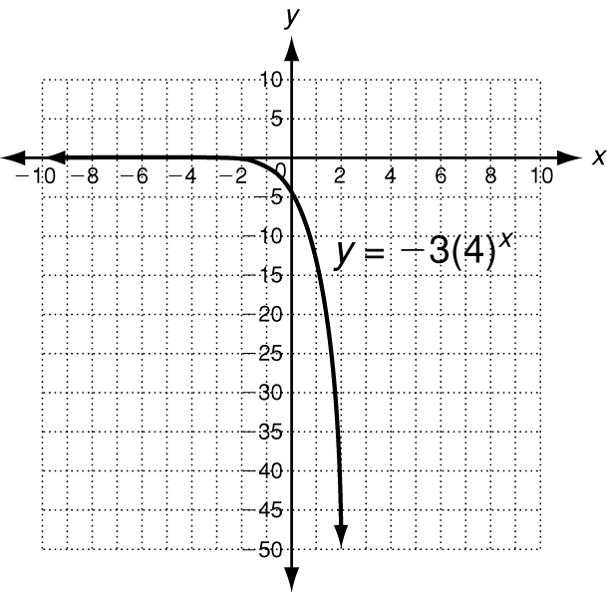  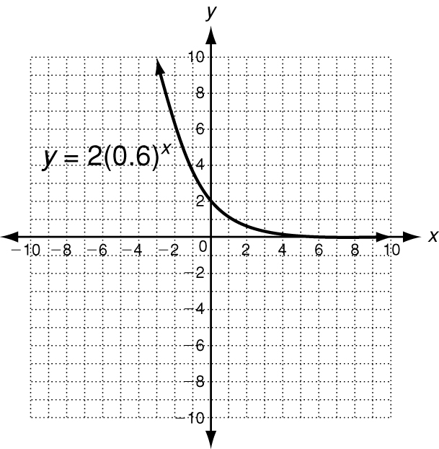 | 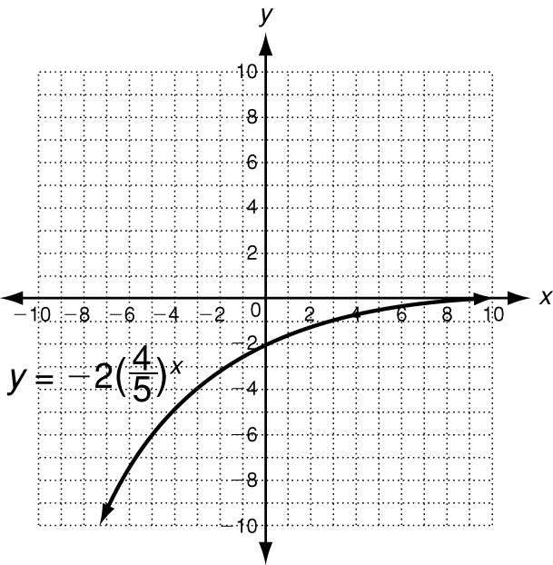

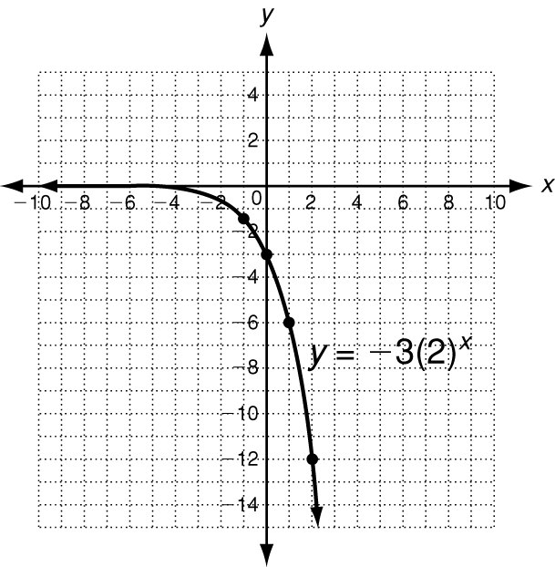
Graph y = −3 (2)^{x}.
x | y = −3 (2)^{x} | y
−1 | y = −3 (2)⁻¹ | −1.5
0 | y = −3 (2)⁰ | −3
1 | y = −3 (2)¹ | −6
2 | y = −3 (2)² | −12

Create a table of ordered pairs.
Plot the points.
Because a < 0 and b > 1,
this graph should look similar
to the second graph above.

Graph each exponential function.
6. y = −4 (0.5)^{x} 7. y = 2 (5)^{x} 8. y = −1 (2)^{x}
x | y = −1 (2)^{x} | y
−1
0
1
2

x | y = 2 (5)^{x} | y
−1
0
1
2

x | y = −4 (0.5)^{x} | y
−2
−1
0
1

