Names: ___________________________ Partner Name: ___________________________ Date:_________________________


Lab (Exponential Growth and Decay)

The purpose of this lab is to provide a model to illustrate exponential growth and decay. This growth and decay, as discussed in class already, can be the model for population growth, growth of cancerous cells in a body, the amount money in a bank based on principal and interest, the number of cell phones in circulation in the United States, the number of eliminated players in a tennis tournament, etc.

In our experiment, we will represent the growth of a cancer cell using M&Ms. First, we will focus on modeling exponential growth, then we will change the situation in order to represent exponential decay. You will conduct up to 14 trials and record the number of “cancerous cells” in the body.

DO NOT EAT the M&Ms until you are done collecting all the data!

Exponential Growth Procedure:
- Place 2 M&Ms in a cup. This is trial number 0.

- Shake the cup and dump the M&Ms on the plate/work surface.

FOR EVERY M&M THAT HAS THE “M” SHOWING, ADD ANOTHER M&M TO YOUR CUP AND THEN RECORD THE NEW POPULATION (If 2 M&Ms land face up, add 2 more M&Ms to the cup).

- Repeat Step 2 until you are done with 14 trials OR you run out of M&Ms.

Trial # | 0 | 1 | 2 | 3 | 4 | 5 | 6 | 7 | 8 | 9 | 10 | 11 | 12 | 13 | 14
# of M&Ms (cancer | 2
cells) | 2

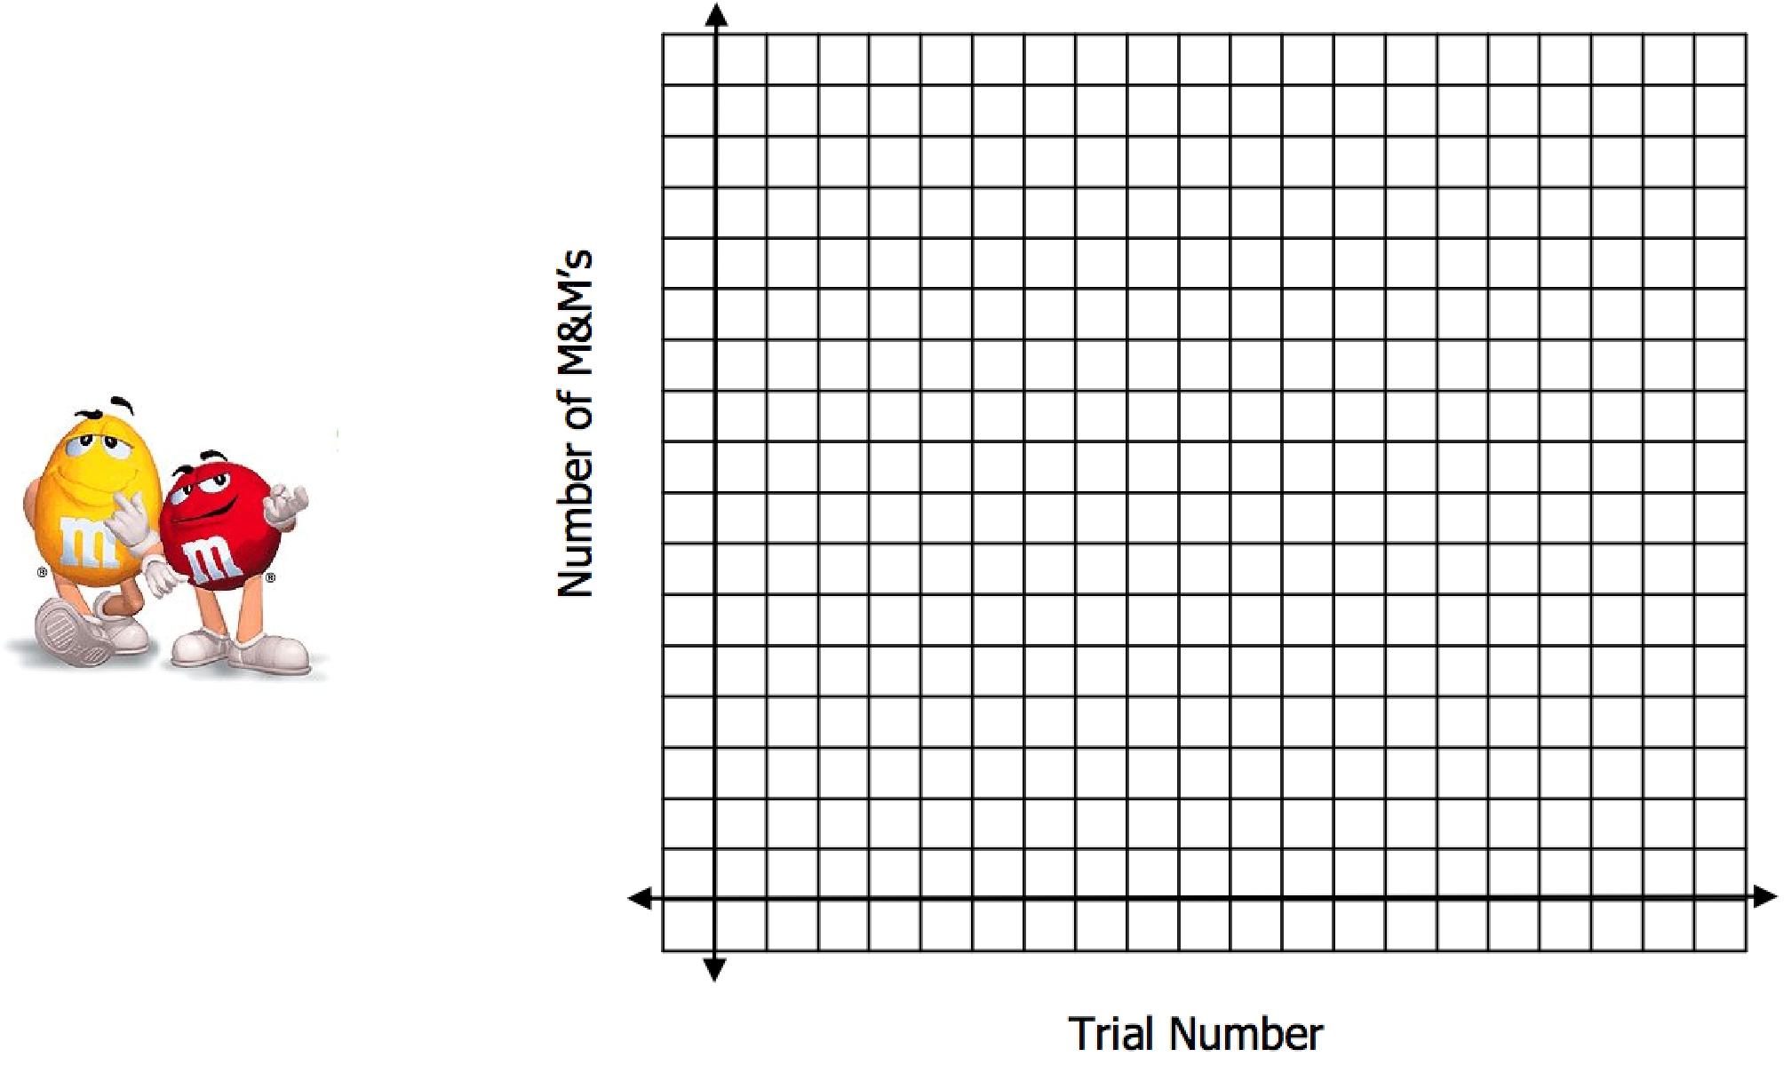
- Graph your data (scatterplot). The x-axis should represent the trial number and the y-axis should represent the number of M&Ms/cancer cells.

5. What is the y-intercept in the graph? What does the y-intercept represent in the context of the problem?

6. Will the graph ever cross the x-axis? Why or why not?

- After you shook the cup and before you emptied them out on the plate/work surface, what percentage of M&Ms did you expect to land with the M facing up? EXPLAIN YOUR REASONING.
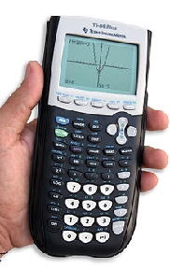

8. Calculate the actual percentage change between each trial, use the formula
 |  |  | #M&Ms in phase1 - #M&Ms in phase 0 ₌ new amount - old amount
 |  |  |  |  | # M&Ms in phase 0 |  |  |  |  |  |  |  |  |  | old amount
Trial # |  |  | 0 | 1 |  | 2 | 3 | 4 |  | 5 | 6 |  | 7 |  | 8 | 9 |  | 10 |  | 11 |  | 12 | 13 | 14
# of M&Ms (cancer |  |  | X
cells) |  |  | X

- CALCULATE THE AVERAGE OF ALL THE PERCENTS: _____________.

- We can write an exponential growth function that models the above data. The formula that we will use for the model is

y = C(1+ r)^{t} .
The initial number of M&Ms: | C = ____________.
Rate of growth (calculated in #9) | r = _____________ (written as a decimal).
Time (the phase/trial number) | t = # of the trial

Fill in the variables into the formula to get your exponential growth equation:

- Using the exponential model you came up with in #10, show your work and predict the number of cancerous cells there would be in:

Trial 25: __________________ Trial 50: __________________

Exponential Decay Procedure:

- Count the number of M&Ms that you have. Record this number under Trial 0.

- This time, when you shake the cup and dump out the M&Ms, remove the M&Ms that are face-up. Record the M&M population.

- Continue the process until you fill in the table OR when your M&M/bacteria population gets below 2. DO NOT RECORD 0 as your answer.

Trial # | 0 | 1 | 2 | 3 | 4 | 5 | 6 | 7 | 8 | 9 | 10

  - of M&Ms (cancer cells)

- Graph your data (scatterplot). The x-axis should represent the trial number and the y-axis should represent the number of M&Ms/cancer cells.
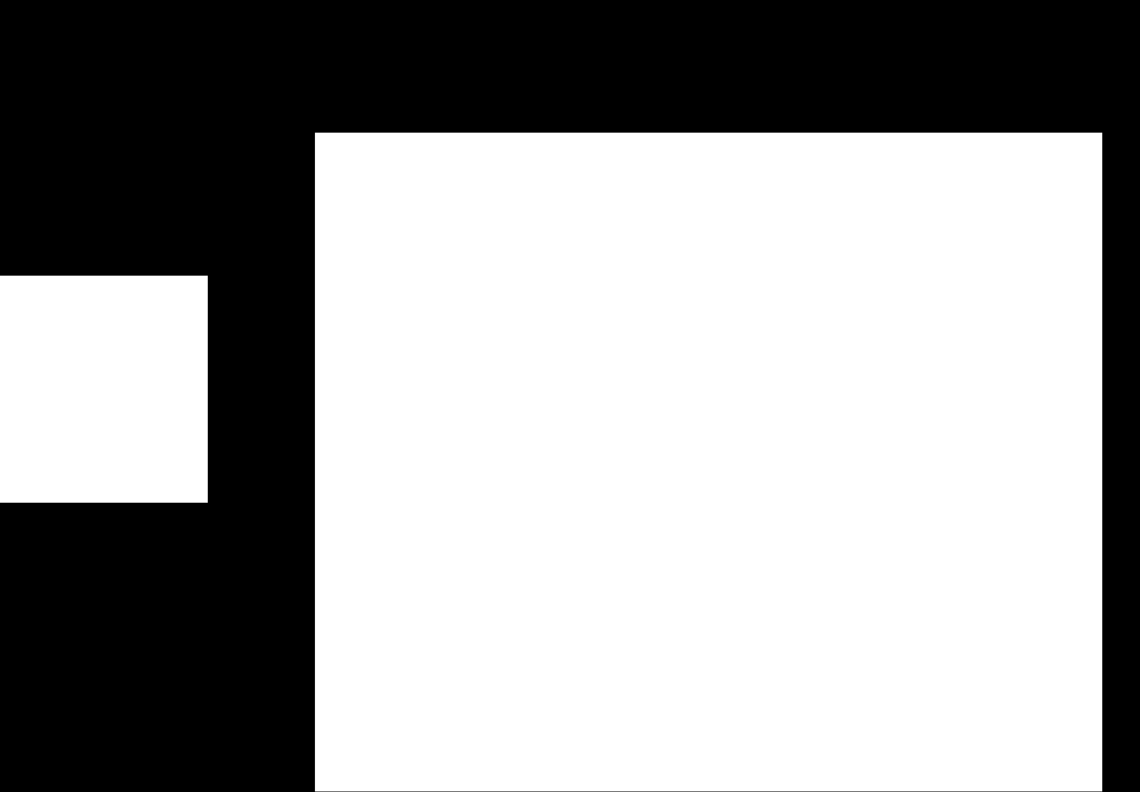
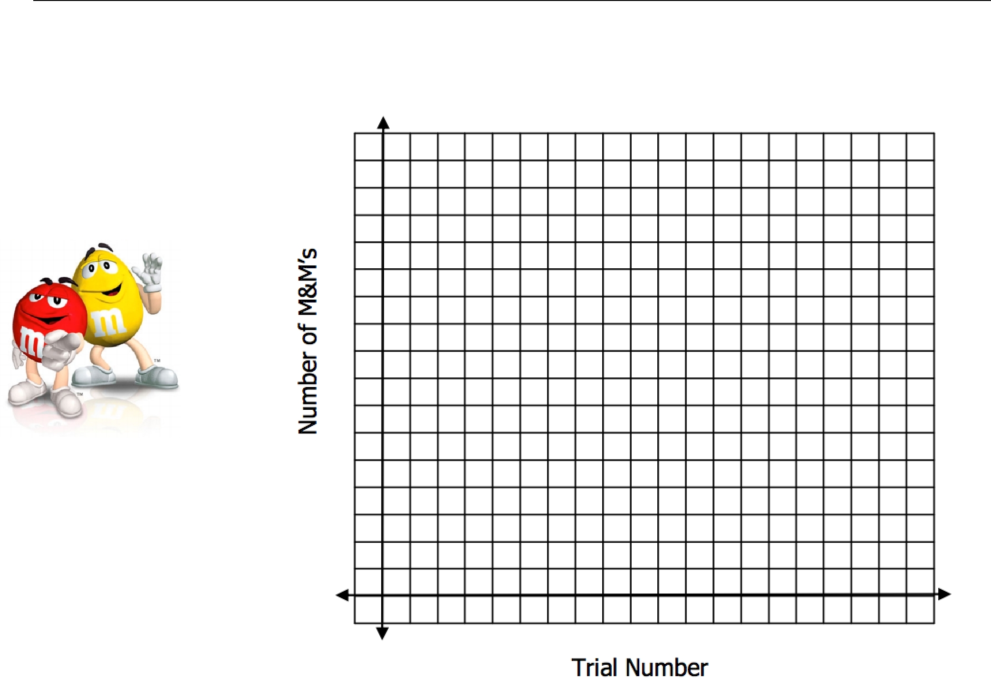

16. Calculate the actual percentage change between each trial, use the formula
 |  |  | #M&Ms in phase1 - #M&Ms in phase 0 ₌ new amount - old amount
 |  |  |  |  | # M&Ms in phase 0 |  |  |  |  |  |  |  |  |  | old amount
Trial # |  |  | 0 | 1 |  | 2 | 3 | 4 |  | 5 | 6 |  | 7 |  | 8 | 9 |  | 10 |  | 11 |  | 12 | 13 | 14
# of M&Ms (cancer |  |  | X
cells) |  |  | X

- CALCULATE THE AVERAGE OF ALL THE PERCENTS: _____________.

- We can write an exponential growth function that models the above data. The formula that we will use for the model is

y = C(1+ r)^{t} .
The initial number of M&Ms: | C = ____________.
Rate of growth (calculated in #9) | r = _____________ (written as a decimal).
Time (the phase/trial number) | t = # of the trial

Fill in the variables into the formula to get your exponential growth equation:

- Look back to the graph of the exponential growth of bacteria in #4. What do you notice about the shape of the graphs? What are the intercepts of each graph and what do they mean in the context of the problem? Which graph represents growth and which represents decay? How can you tell?

- In the directions for exponential decay, it is clearly stated not to record 0 as the final number? Why does the number of M&Ms never equal to 0? EXPLAIN.

Discussion:

- In the exponential model y = a ⋅ b^{x} , what does the a value represent? BE SPECIFIC.

- In the exponential model y = a ⋅ b ^{x} what does the b value represent? How can you tell if an exponential function is growth or decay just by looking at the function/equation? Give an example of growth and decay

