

Name: ___________________________________ Mr. Murphey’s Analytical Geometry
Date: 3/21/2014 Block: 2
Standard: SWABAT Understand that by similarity, side ratios in right triangles are properties of the angles in the triangle (MCC912. G.SRT.6)
Triangles Quiz 11 Review

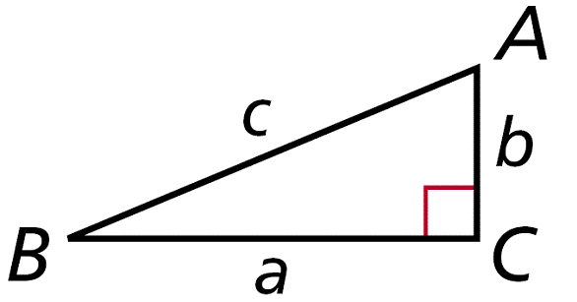
Inbox Task
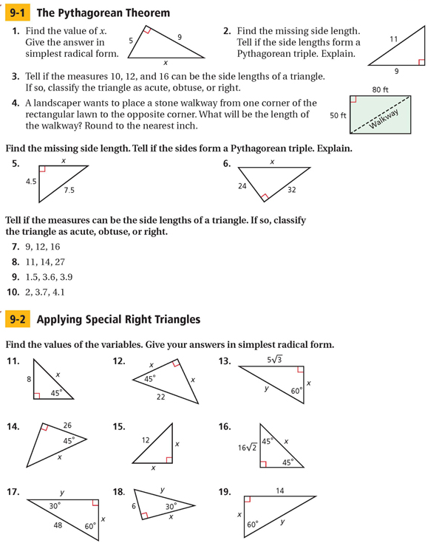

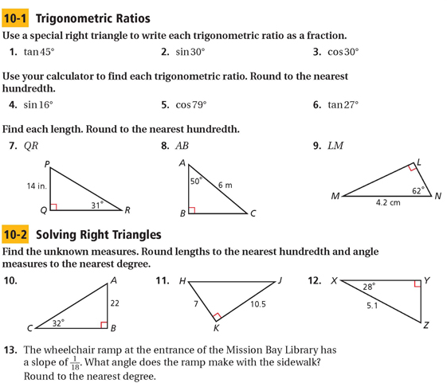

Angles of Elevation and Depression
In Exercises 1 and 2, fill in the blanks to complete the definitions.
1. An angle of elevation is the angle formed by a _______________ line and a line of sight to a point _______________ the line.
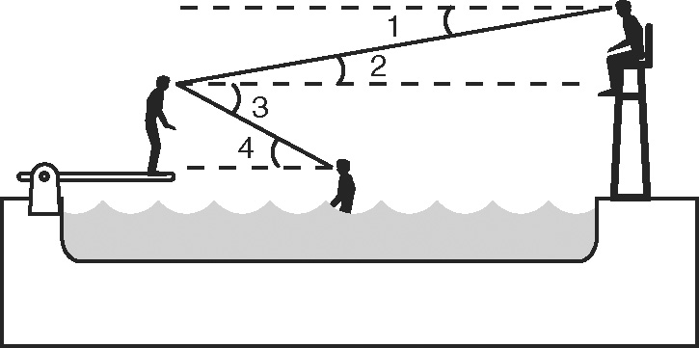
2. An angle of _______________ is the angle formed by a horizontal line and a line of sight to a point _______________ the line.
Ben is on the diving board at the neighborhood pool. Jenna is in the pool, and a lifeguard sits at her station on the opposite end of the pool. Classify each angle as an angle of elevation or an angle of depression.
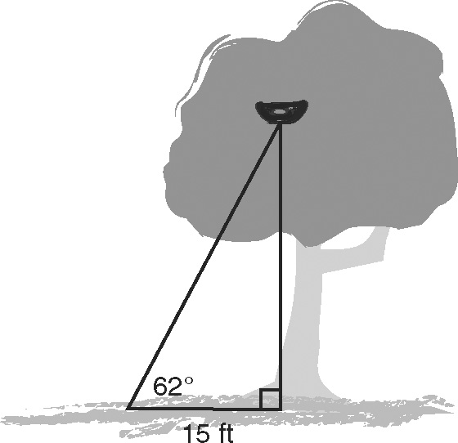
3. ∠1 ______________________ 4. ∠2 ______________________
5. ∠3 ______________________ 6. ∠4 ______________________
Lisa sees a bird’s nest high in a tree. She decides to use trigonometry to estimate how high the nest is.
7. Lisa walks 15 feet from the base of the tree. She measures an angle of elevation from the ground to the nest of 62°. Find how high the nest is above the ground, to the nearest foot.
8. Lisa spots the mother bird on a branch above the nest. She measures an angle of elevation to the bird of 67°. Find how high the mother bird is above the ground, to the nearest foot.

