Exponential Functions
Standard: SWABAT distinguish between situations that can be modeled with linear and exponential functions. (MCC912.F.LE.1)

Name: ___________________________________ Mr. Murphey’s Coordinate Algebra Support
Date: 10/25/2013 Block: 1 4



Inbox Task Find the value of each expression
- 3²

- 5⁴

- 2(3)³

- $\frac{2}{3}$(3)⁴

- -5(2)⁵

- $\frac{1}{2}$ (4)³

- $100{\left(.5\right)}^{2}$

- 3000(.95)⁸

Exponential Functions
Tell whether the ordered pairs satisfy an exponential function.
1. 2. 3.
x | y
−1 | 1.5
−2 | 3
−3 | 6
−4 | 12

x | y
−2 | −2
−1 | −10
0 | −50
1 | −250

x | y
1 | 1
2 | 2
3 | 6
4 | 24

4. If a rubber ball is dropped from a height of 10 feet, the function
f(x) = 20 (0.6)^{x} gives the height in feet of each bounce, where
x is the bounce number. What will be the height of the 5th bounce?
Round to the nearest tenth of a foot. _________________
5. A population of pigs is expected to increase at a rate of 4% each
year. If the original population is 1000, the function f(x) = 1000 (1.04)^{x}
gives the population in x years. What will be the population in 12 years? _________________
Graph each exponential function.
6. y = −4 (0.5)^{x} 7. y = 2 (5)^{x} 8. y = −1 (2)^{x}
x | y = −4 (0.5)^{x} | y
−2
−1
0
1

x | y = −1 (2)^{x} | y
−1
0
1
2

x | y = 2 (5)^{x} | y
−1
0
1
2

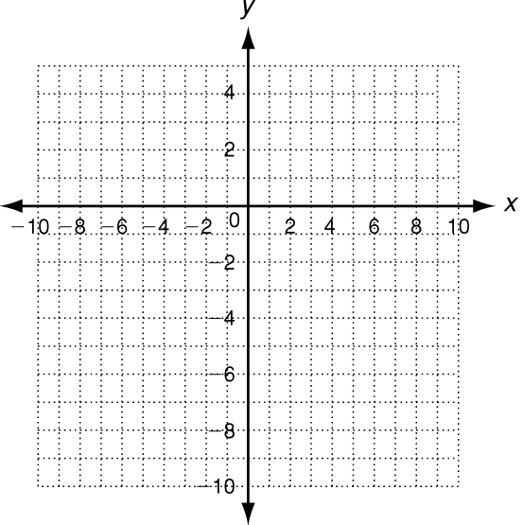
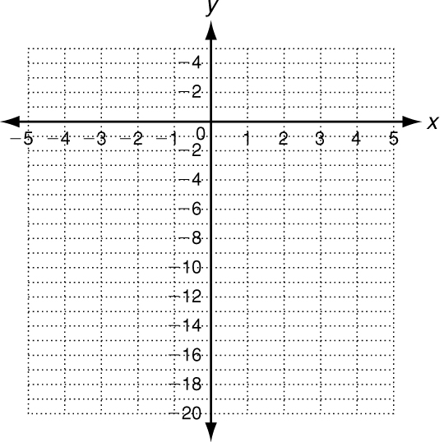
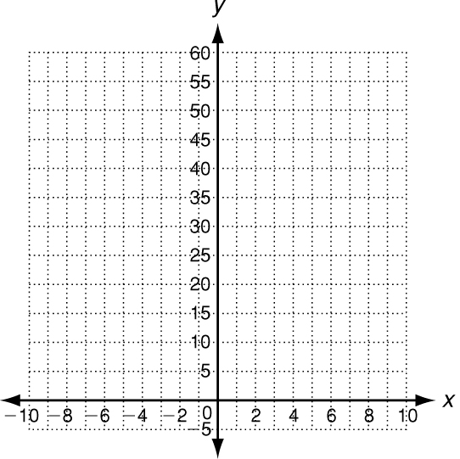

Practice
1. If a superball is bounced from a height of 20 feet, the function
f(x) = 20 (0.9)^{x} gives the height of the ball in feet of each bounce,
where x is the bounce number. What will be the height of the
6th bounce? Round your answer to the nearest tenth of a foot. ___________________________

Tell whether each set of ordered pairs satisfies an exponential function. Explain your answer.
2. {(1,10), (2, 20), (3, 40), (4, 80)} __________________________________________________________

3. {(1,5), (2, 10), (3, 15), (4, 20)} __________________________________________________________

Graph each exponential function.
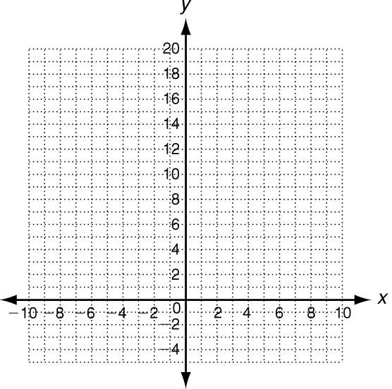
4. y = 2(3)^{x}
x | y = 2 (3)^{x} | y | (x, y)
−2 | y = 2(3)⁻²
−1 | y = 2(3)⁻¹
0 | y = 2(3)⁰
1 | y = 2(3)¹
2 | y = 2(3)²

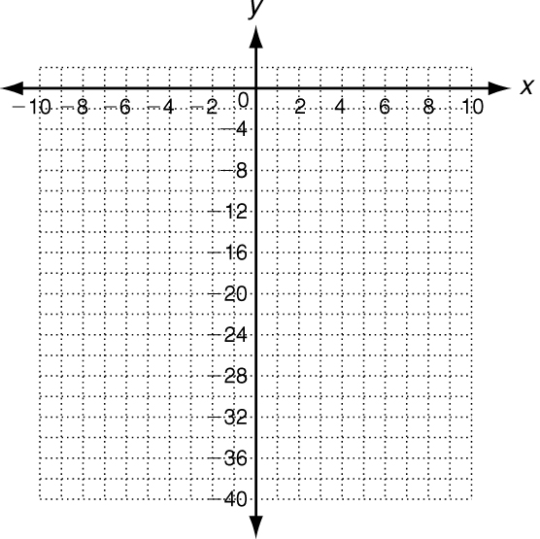

5. y = −2(4)^{x}
x | y = −2 (4)^{x} | y | (x, y)
−2
−1
0
1
2

In the absence of predators, the natural growth rate of rabbits is
4% per year. A population begins with 100 rabbits. The function
f(x) = 100(1.04)^{x} gives the population of rabbits in x years.
6. How long will it take the population of rabbits to double? ___________________________

7. How long will it take the population of rabbits to reach 1000? ___________________________

