Exponential Growth/Decay
Standard: SWABAT distinguish between situations that can be modeled with linear and exponential functions (MCC912.F.LE.1)

Name: ___________________________________ Mr. Murphey’s Coordinate Algebra
Date: 3/24/2014 Block: 1 4



Inbox Task – Simplify each expression.

- (4 + 0.05)²

- 25(1 + 0.02)³

- $1+\frac{.03}{4}$

- The first term of a geometric sequence is 3 and the common ratio is 2. What is the 5th term of the sequence?
- The function f(x) = 2(4)^{x} models an insect population after x days. What is the population after 3 days?

Exponential Growth and Decay
Write an exponential growth function to model each situation. Then find the value of the function after the given amount of time.
1. Annual sales for a furniture store are $375,000 and
are increasing at a rate of 6.75% each year; 9 years ________________________________
2. The population of Indiana showed an annual growth rate of
0.6% between 1998 and 1999. The population in 1999 was _______________________________
approximately 273,000,000. Based on this model, find the
population in 2007. ___________________________
3. Per capita income is the total income for a geographic area
divided by the number of people in that area. In Florida, the ___________________________
per capita personal income (PCPI) of $30,098 is increasing
at a rate of 3.6%; 8 years ___________________________
Write a compound interest function to model each situation. Then
find the balance after the given number of years.
4. $60,000 invested at a rate of 2.5% compounded annually; 8 years _______________; ____________

5. $27,000 invested at a rate of 3.75% compounded quarterly; 3 years ________________; ____________
___________________________
6. $95,000 invested at a rate of 4.2% compoundedmonthly; 10 years ________________; ____________

Write an exponential decay function to model each situation. Then find the value of the function after the given amount of time.
7. The population of a town is 1800 and is decreasing at a rate of
3.8% per year; 6 years ___________________________
___________________________
8. A population of 2300 manatees in Florida is thought to
be decreasing at a rate of 1.1% annually; 7 years ___________________________
___________________________
9. The half-life of Cobalt-60 is approximately 5.25 days. Find the
amount of Cobalt-60 left from a 30 gram sample after 42 days.
Round to the nearest thousandth of a gram. ___________________________

10. A condo in Austin, Texas, was worth $80,000 in 1990. The value of the condo increased by an average of 3% each year. Write an exponential growth function to model this situation. Then find the value of the condominium in 2005.
11. The population of a small Midwestern town is 4500. The population is decreasing at a rate of 1.5% per year. Write an exponential decay function to model this situation. Then find the number of people in the town after 25 years.

Linear, Quadratic, and Exponential Models
Graph each data set. Which kind of model best describes the data?
1. 2. {(−4, 5), (−3, 2), (−2, 1), (−1, 2) (0, 5)}
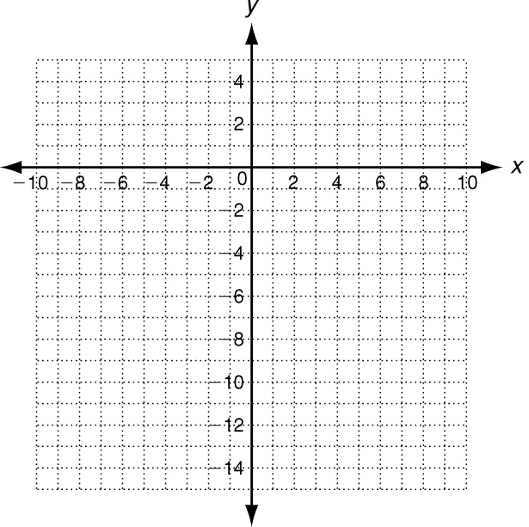
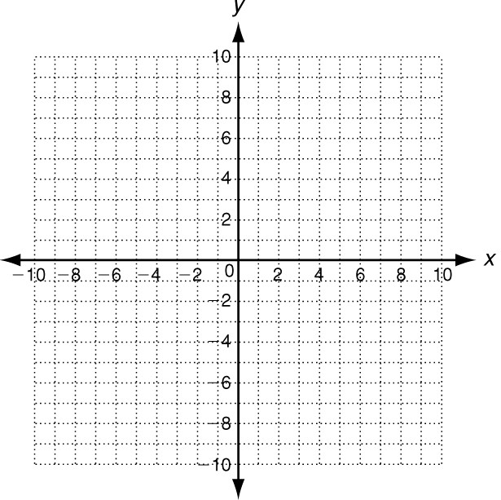

Look for a pattern in each data set to determine which kind of model best describes the data.
3. {(−4, −2), (−2, 1), (0, 4), (2, 7), (4, 10)} ___________________________
4. {(3, 225), (4, 337.5), (5, 506.25), (6, 759.375)} ___________________________
5. {(0, −8), (1, −15), (2, −16), (3, −11), (4, 0)} ___________________________
6. ___________________________
7. Use the data in the table to describe
how the restaurant’s sales are
changing. Then write a function that
models the data. Use your function to
predict the amount of sales after 10 years.
Year | 0 | 1 | 2 | 3
Sales ($) | 420,000 | 436,800 | 454,272 | 472,442.88

8. Use the data in the table to describe
how the total cost of the freezer changes
over time. Then write a function that
models the data. Use your function to
predict the total cost of the freezer after
5 months.
Cost to operate 17.0 ft³ freezer
Month | 0 | 1 | 2 | 3
Total Cost ($) | 450.00 | 457.51 | 465.02 | 472.53

Graph each data set. Which kind of model best describes the data?
1. (−2, −4), (−1, −2), (0, 0), (1, 2), (2, 4) 2. (−1, 4), (0, 2), (1, 1), ,

Look for a pattern in each data set to determine which kind of model best describes the data.
3. 4. 5.
x | y
0 | 10
1 | 18
2 | 28
3 | 40

x | y
3 | 4
6 | −2
9 | −8
12 | −14

x | y
0 | 6
1 | 12
2 | 24
3 | 48

