Comparing Functions
Standard: SWABAT distinguish between situations that can be modeled with linear and exponential functions (MCC912.F.LE.1)

Name: ___________________________________ Mr. Murphey’s Coordinate Algebra
Date: 3/25/2014 Block: 1 4



Inbox Task – Simplify each expression.

- (4 + 0.05)²

- 25(1 + 0.02)³

- $1+\frac{.03}{4}$

- The first term of a geometric sequence is 3 and the common ratio is 2. What is the 5th term of the sequence?
- The function f(x) = 2(4)^{x} models an insect population after x days. What is the population after 3 days?

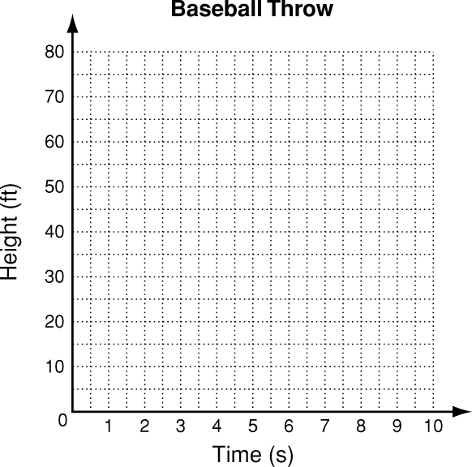
Linear, Quadratic, and Exponential Models
Write the correct answer.
1. The table shows the height of a baseball for different times after it was thrown. Graph the data. Which kind of model best describes the data?
Height of Baseball
Time (s) | 0 | 1 | 2 | 3 | 4
Height (ft) | 5 | 53 | 69 | 53 | 5

 | Screen1 | Screen 2
Day 1 | 400 | 3000
Day 2 | 440 | 2400
Day 3 | 480 | 1920
Day 4 | 520 | 1536

The chart shows the ticket sales for movies on two different screens at one theater over four days.
2. Which kind of model best describes the ticket sales for the movie on screen 1?
A linear C exponential
B quadratic D none of these
3. Which function describes the data for screen1?
F y = 40x² H y = 400x
G y = 40x + 400 J y = 400(40)^{x}
4. Which kind of model best describes the ticket sales for the movie on screen 2?
A linear C exponential
B quadratic D none of these

5. Which function describes the data for screen 2?
F y = −600x + 3000
G y = 600x² + 2400
H y = 3000(0.8)^{x}
J y = 3000(1.25)

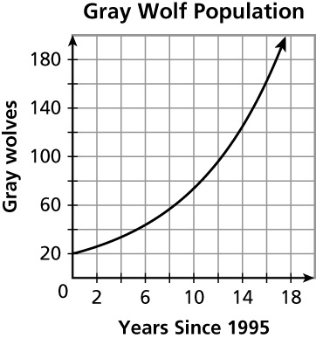
6. Exponential functions are often used to model population growth. Real data gathered over time can be used to generate a population model. A conservationist collected the data shown in the table for the population of gray wolves in Yellowstone National Park. Is the graph an accurate model of the data? Compare the table and the graph by finding and interpreting the average rates of change over the interval [0, 8] and [0, 15].
Year (1995 = 0) | Gray Wolves
0 | 14
1 | 31
3 | 112
5 | 119
8 | 174
12 | 171
13 | 124
15 | 128

Comparing Functions
1. Three functions are given below. Make a table of values for each function using nonnegative coordinates. Then graph all three functions on the same coordinate plane. Compare and interpret the tables, graphs, and rates of change over [0, 4].
 |  |  |  | 
  y = 5x + 10
  x | y
  y = 1 + 5^{x}
  x | y
  y = 5x² + 5x
  x | y
Rate of change | _________________ | _________________ | _________________
a. Compare the rates of change. _______________________________________________________

b. How do the y-values at x = 0 and x = 4 relate to the rates of change over [0, 4]?

2. An engineer designs headlight reflectors. Models for two of her designs are shown below. Complete the tables for each function. Compare the models by finding and interpreting the maximums, x-intercepts, and average rates of change over the x-interval [0, 4].
  Design Q:
  y = 3x² + 3x
  x | y
  0
  1
  2
  3
  4
  Design E:
  y = 3 + 3^{x}
  x | y
  0
  1
  2
  3
  4
Maximum value on [0, 4] | _________________ | _________________
x-intercepts | _________________ | _________________
Rate of change | _________________ | _________________

