Unit 3 Review
Standard: SWABAT distinguish between situations that can be modeled with linear and exponential functions (MCC912.F.LE.1)

Name: ___________________________________ Mr. Murphey’s Coordinate Algebra
Date: 3/26/2014 Block: 1 4


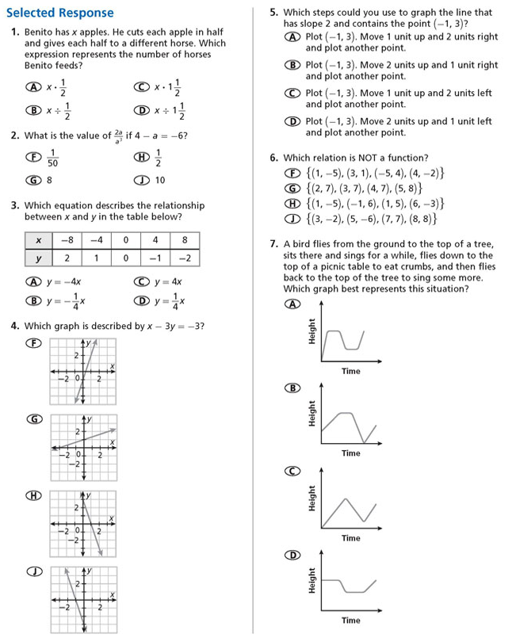

Inbox Task –

