

Name: ___________________________________ Mr. Murphey’s Analytical Geometry
Date: 3/27/2014 Block: 2
Standard: SWABAT Use volume formulas for cylinders, pyramids, cones, and spheres to solve problems. (MCC912. G.GMD.3)
Volumes of 3D Shapes

Inbox Task - Find the area of each figure. Round to the nearest tenth.
- an equilateral triangle w/ edge length 20 cm
- a regular hexagon with edge length 14 m

- a circle with radius 6.8 in.
- a circle with diameter 14 ft

Volume of Prisms and Cylinders Write each formula.
1. volume of a cube with edge length s
2. volume of a prism with base area B and height h
3. volume of a cylinder with radius r and height h
4. volume of a right rectangular prism with length , width w, and height h
Find the volume of each prism. Round to the nearest tenth if necessary.
5. 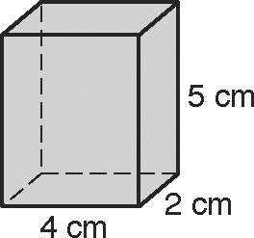 6. 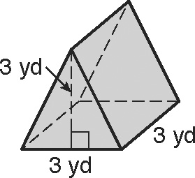
the right rectangular prism the triangular prism

7. Laetitia needs to store 8 boxes while she is moving. Each box is a cube with edge length 3 feet. A storage facility charges $0.75 for every cubic foot of storage per month. Find the amount of money Laetitia will pay to store her boxes for one month. _________________________________
Find the volume of each cylinder. Give your answers both in terms of π and rounded to the nearest tenth.
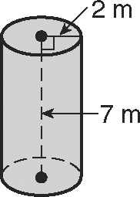
8. 9. a cylinder with diameter 20 in.
and height 2 in.

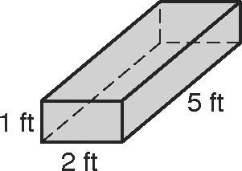
Complete Exercises 10–12 to describe the effect
on the volume of multiplying each dimension of
a prism by 3.
10. Find the volume of the prism.
11. Find the volume of the prism after each dimension
is multiplied by 3.
12. Describe the effect on the volume of multiplying each dimension of a prism by 3.
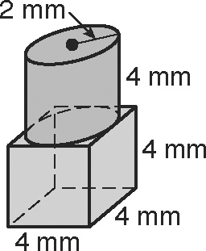
13. Find the volume of the composite figure.
Round to the nearest tenth.

14. a cylinder with base circumference 18π ft and height 10 ft
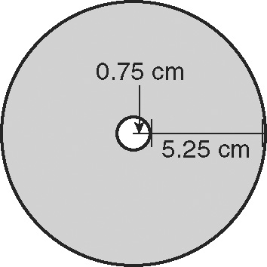
15. CDs have the dimensions shown in the figure. Each CD
is 1 mm thick. Find the volume in cubic centimeters of a
stack of 25 CDs. Round to the nearest tenth.
Describe the effect of each change on the volume of the given figure.
16. 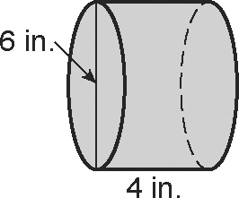 17. 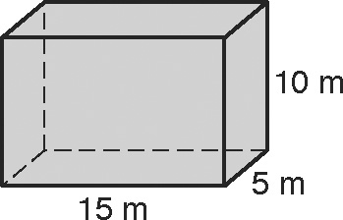
The dimensions are halved. The dimensions are divided by 5.

Volume of Pyramids and Cones
Find the volume of each pyramid. Round to the nearest tenth if necessary.
1. 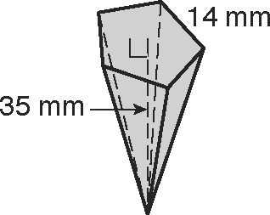 2. 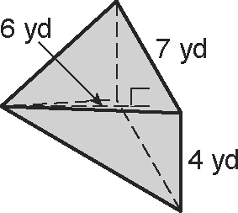
the regular pentagonal pyramid the rectangular right pyramid
3. Giza in Egypt is the site of the three great Egyptian pyramids. Each pyramid has
a square base. The largest pyramid was built for Khufu. When first built, it had base edges of 754 feet and a height of 481 feet. Over the centuries, some of the stone eroded away and some was taken for newer buildings. Khufu’s pyramid today has base edges of 745 feet and a height of 471 feet. To the nearest cubic foot, find the difference between the original and current volumes of the pyramid.

Find the volume of each cone. Give your answers both in terms of π and rounded to the nearest tenth.
4. 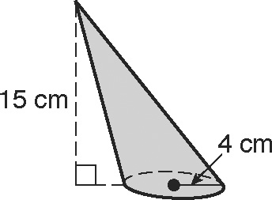 5. 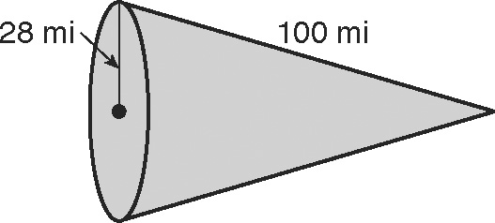

6. a cone with base circumference 6π m and a height equal to half the radius
7. Compare the volume of a cone and the volume of a cylinder with equal height and base area.

Describe the effect of each change on the volume of the given figure.
8. 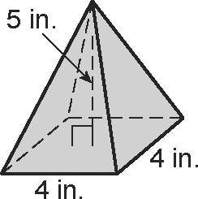 9. 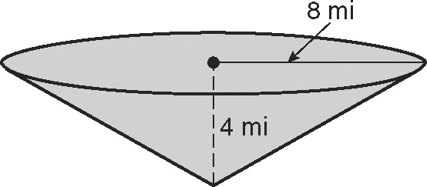
The dimensions are multiplied by $\frac{2}{3}$. The dimensions are tripled.
Find the volume of each composite figure. Round to the nearest tenth.
10. 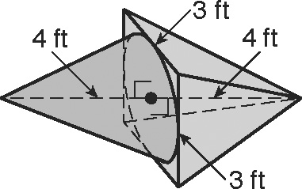 11. 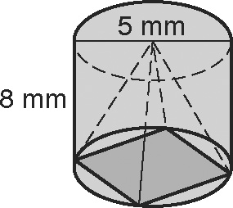

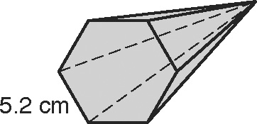
12. The hexagonal base in the pyramid is a regular polygon. What is the volume of the pyramid if its height is 9 centimeters? Round to the nearest tenth.
13. A paper cone for serving roasted almonds has a volume of 406π cubic centimeters. A smaller cone has half the radius and half the height of the first cone. What is the volume of the smaller cone? Give your answer in terms of π.

