Displaying Data
Standard: SWABAT Represent data with plots on the real number line (dot plots, histograms, and box plots). (MCC912.S.ID.1)

Name: ___________________________________ Mr. Murphey’s Coordinate Algebra
Date: 3/28/2014 Block: 1 4



Inbox Task – Write the equivalent percent.

- $\frac{4}{16}$
- $\frac{12}{60}$
- $\frac{35}{280}$

Find each value.

- 20% of 360

- 75% of 360

- $\frac{1}{15}$ of 360

Identify the least and greatest value in each data set.

7. 34, 62, 45, 35, 75, 23, 35, 65, 23
8. 1.6, 3.4, 2.6, 4.8, 1.3, 3.5, 4.0

Organizing and Describing Data
Look at the double bar graph.
1. About how many times more females than males attended the library on Wednesday?
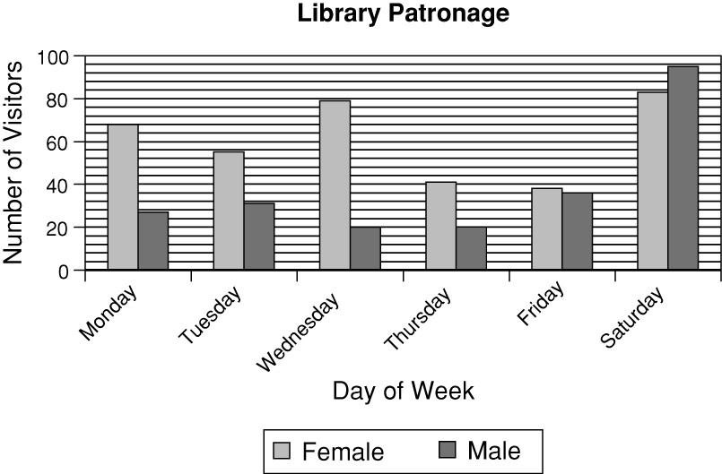
2. On which day of the week was library attendance by males and
females the closest?

3. On which day did the library have
the least number of patrons?

Look at the double line graph.
4. How many years had the products been on the market before their
costs were about the same?
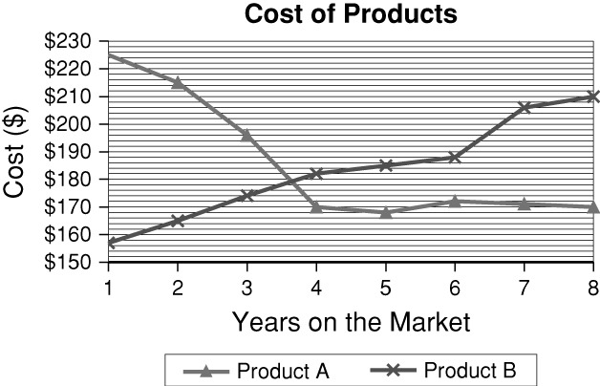
5. How much more was the differencein costs during year 1 than year 8?

6. Describe the trend of the cost of Product A over the 8 years shown.

7. The table shows the number of customers who
ordered each of the different types of burgers at
Luke’s Place on a given day. Use the data to make
a graph. Explain why you chose that type of graph.
Cheese | Fiesta | Bleu | Mushroom | Veggie
24 | 16 | 12 | 8 | 2

Frequency and Histograms
Cost of Housing
1  2  3  4 | 8 8  2 3 7  5  0 Key:
 | 2|3 means 230,000

1. The costs of houses in one neighborhood, in
hundred thousands, is given at right.
a. Which cost occurs twice?
b. What is the cost of the most expensive house?

2. The total team rushing yards for two
professional football teams in each of
the 16 regular season games is given.
Use the data to make a back-to-back
stem-and-leaf plot.

Team A: 112 198 176 154 101 132
137 149 189 172 117 119
173 154 149 177
Team B: 192 167 155 147 138 142
151 168 188 112 108 139
141 154 126 138

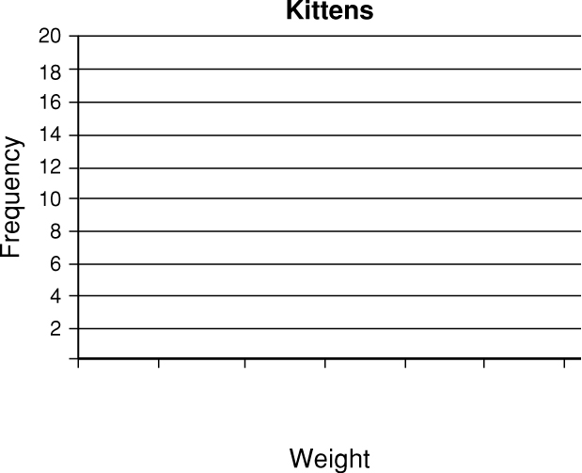
3. The weights of 50 kittens are given below.
Use the data to make a histogram.
Use 2.5 – 2.9 for the first interval.

Weights (lbs)
4.0 | 4.5 | 4.8 | 4.3 | 5.2 | 4.6 | 4.7 | 2.6 | 4.0 | 4.6
4.8 | 4.2 | 4.5 | 4.3 | 4.2 | 4.1 | 4.7 | 4.5 | 3.1 | 4.0
4.0 | 4.2 | 4.1 | 5.4 | 4.5 | 3.2 | 4.4 | 3.5 | 4.8 | 3.9
4.9 | 4.8 | 4.7 | 4.0 | 3.6 | 4.0 | 3.9 | 3.2 | 4.1 | 3.7
4.1 | 3.3 | 4.9 | 4.2 | 3.8 | 3.9 | 4.9 | 4.2 | 3.7 | 4.4

4. Several people were asked how many
miles their workplace is from home. The
results are shown below.
Distance to Work
Miles | Frequency | Cumulative Frequency

Distance to Work (mi)
11 | 21 | 14 | 39 | 1 | 18
37 | 24 | 2 | 93 | 12 | 26
10 | 6 | 41 | 7 | 52 | 30

a. Use the data to make a cumulative frequency table.
b. What percent of people surveyed work less than 40 miles from home?

The table below gives the top five ringtone genres reported during
a survey of cell phone subscribers in August, 2005.

Ringtone  genre | Males (millions) | Females (millions)
Hip Hop or Rap | 2.232 | 2.472
Rock or Alternative | 2.219 | 2.082
Pop | 1.044 | 2.069
TV/Movie/Game Themes | 1.161 | 1.371
Classic Rock | 0.949 | 0.918
6. From the graph (not the table), explain how you can tell that the Pop genre is nearly twice as popular with females as males.

5. Use the data to make a graph below. Explain why you chose that type of graph.

