Linear, Quadratic, & Exponential
Standard: SWABAT distinguish between situations modeled with linear functions and with exponential functions (MCC912.F.LE.1)

Name: ___________________________________ Mr. Murphey’s Coordinate Algebra Support
Date: 10/29/2013 Block: 1 4



Inbox Task Find the value of each expression
- Find the slope and y-intercept of the line that passes through (4, 20) and (20, 24).

The population of a town is decreasing at a rate of 1.8% per year. In 1990, there were 4600 people.
- Write an exponential decay function to model this situation.

- Find the population in 2010.

- When would the population be half of what it was in 1990
Linear, Quadratic, and Exponential Models
Graph to decide whether data is best modeled by a linear, quadratic or exponential function.
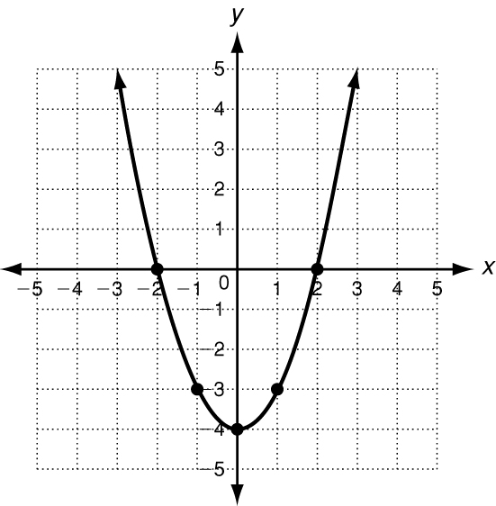
Graph (−2, 0), (−1, −3), (0, −4), (1, −3), (2, 0). What kind of model best describes the data?
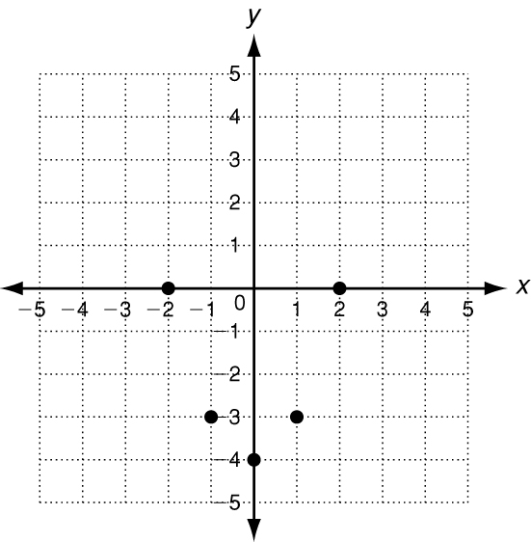
Connect the points.
The data appear to be quadratic.

You can also look at patterns in data to determine the correct model.
Exponential functions
have a constant ratio.
Quadratic functions have constant 2nd differences.
Linear functions have constant 1st differences.

x | y |  |  |  |  | x | y |  |  |  | x | y
2 | 5 | −3 |  |  |  | 1 | −8 |   +3 |  |  | 0 | −2 | ×4
4 | 2 | −3 |  |  |  | 2 | −5 | +5 | +2 |  | 1 | −8 | ×4
6 | −1 | −3 |  |  |  | 3 | 0 | +7 | +2 |  | 2 | −32 | ×4
8 | −4 |  |  |  |  | 4 | 7 |  |  |  | 3 | −128

Graph each data set. Which kind of model best describes the data?
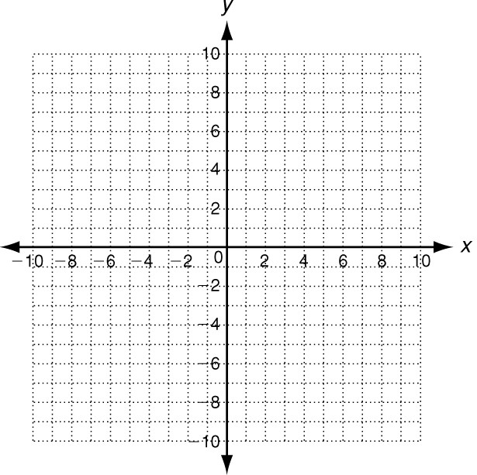
1. (−2, −4), (−1, −2), (0, 0), (1, 2), (2, 4) 2.(−1, 4), (0, 2), (1, 1),(2,$\frac{1}{2}$), (3,$\frac{1}{4}$),

Look for a pattern in each data set to determine which kind of model best describes the data.
3. 4. 5.
x | y
0 | 10
1 | 18
2 | 28
3 | 40

x | y
3 | 4
6 | −2
9 | −8
12 | −14

x | y
0 | 6
1 | 12
2 | 24
3 | 48

Graph each data set. Write linear, quadratic, or exponential.
1. {(0, −4), (1, −2), (2, 0), (3, 2), (4, 4)} 2. {(−2, −5), (−1, −8), (0, −9), (1, −8), (2, −5)}

Look for a pattern in each data set. Write linear, quadratic, or exponential.
3. 4. 5.
x | y
0 | 2
1 | 6
2 | 12
3 | 20

x | y
−2 | −10
−1 | −8
0 | −6
1 | −4

x | y
0 | 3
1 | 6
2 | 12
3 | 24

Graph each data set. Which kind of model best describes the data?
6. {(−2, 0), (−1, −3), (0, −4), (1, −3), (2, 0)} 7. {(0, 3), (1, 6), (2, 12), (3, 24), (4, 48)}
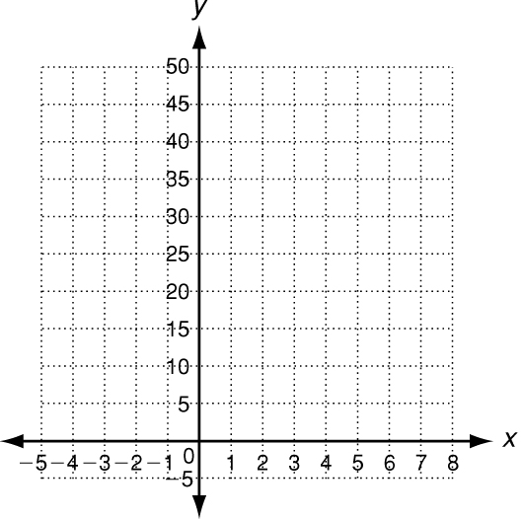

Look for a pattern in each data set to determine which kind of model best describes the data.
8. {(−5, 9), (−4, 0), (−3, −7), (−2, −12)} ___________________________

9. {(−2, 9), (−1, 13), (0, 17), (1, 21)} ___________________________

10. {(1, 4), (2, 6), (3, 9), (4, 13.5)} ___________________________

11. {(0, 4), (2, 12), (4, 36), (6, 76)} ___________________________
12. ___________________________

