Comparing Functions
Standard: SWABAT compare properties of two functions each represented in a different way (MCC912.F.IF.9)

Name: ___________________________________ Mr. Murphey’s Coordinate Algebra
Date: 10/30/2013 Block: 2



Inbox Task
Find the slope of the line that contains each pair of points.

- (4, 8) and (-2, -10)

2. (-1, 5) and (6, -2)

Tell whether each function could be quadratic. Explain.

3. {(-1, -3), (0, 0), (1, 3), (2, 12)}
4. {(-2, 11), (-1, 9), (0, 7), (1, 5), (2, 3)}
Comparing Functions
1. Jon and Jeremy each save money weekly from their allowances, as shown. Compare the accounts by finding and interpreting slopes and y-intercepts.
Jon's Savings | 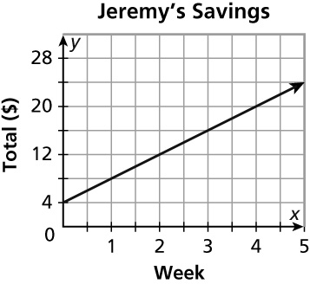  a. Slopes ________________________________  b. Interpret and compare: _________________  _______________________________________  c. y-intercepts: ___________________________  d. Interpret and compare: _________________  ________________________________________
  Week | 0 | 1 | 2 | 3 | 4
  Total ($) | 11 | 16 | 21 | 26 | 31
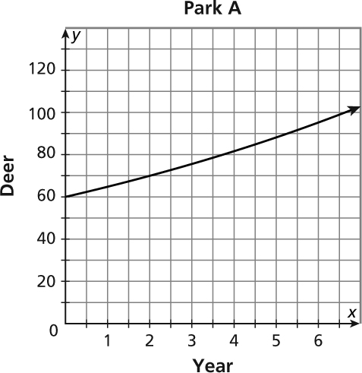
2. The table and graph represent the number of deer in two different parks. Compare the populations by finding and interpreting the average rates of change from year 1 to year 5.
Park A
Year | 1 | 2 | 3 | 4 | 5
Deer | 80 | 92 | 99 | 108 | 120

a. Rates of change: ____________________________________________________________
b. Interpret and compare: _______________________________________________________

3. Complete the tables for each function below. Find the rate of change over [0, 4] for each function. Then graph all three functions on the same coordinate plane.
 |  |  | 
  y = 5x + 10
  x | y
  0
  1
  2
  3
  4
  y = 1 + 5^{x}
  x | y
  0
  1
  2
  3
  4
  y = 5x² + 5x
  x | y
  0
  1
  2
  3
  4
Rate of change___________ ____________ ________________
a. Compare the rates of change. _______________________________________________________

b. How do the y-values at x = 0 and x = 4 relate to the rates of change over [0, 4]?

4. An engineer designs satellite dishes. Equations for two designs are shown below. Complete the tables for each function. Find and compare the average rates of change, minimums, and maximums over the interval [0, 4].
  Design 1:
  y = 3x² + 3x
  x | y
  0
  1
  2
  3
  4
  Design 2:
  y = 3 + 3^{x}
  x | y
  0
  1
  2
  3
  4
Rate of change _________________ _________________
Minimum value on [0, 4]_________________ _________________
Maximum value on [0, 4] _________________ _________________
5. Three functions are given below. Complete the tables and find the rate of change over [0, 3] for each function. Then graph all three functions on the same coordinate plane.
  y = 4x + 10
  x | y
  0
  1
  2
  3
  4
  y = 1 + 4^{x}
  x | y
  0
  1
  2
  3
  4
  y = 4x² + 4x
  x | y
  0
  1
  2
  3
  4
Rate of change____________ ______________ _______________
a. Compare the rates of change. _______________________________________________________
b. How do the y-values at x = 0 and x = 3 relate to the rates of change over [0, 3]?
6. An engineer designs headlight reflectors. Equations for the shapes of two of his designs are shown below. Complete the tables for each function. Compare the designs by finding and comparing average rates of change, minimums, and maximums over the interval [0, 3].
  Design A:
  y = 5x² + 5x
  x | y
  0
  1
  2
  3
  Design B:
  y = 5 + 5^{x}
  x | y
  0
  1
  2
  3

