Happy Halloween!
Standard: SWABAT compare properties of two functions each represented in a different way (MCC912.F.IF.9)

Name: ___________________________________ Mr. Murphey’s Coordinate Algebra
Date: 10/31/2013 Block: 2



Inbox Task
Find the slope and y-intercept of the line that contains each pair of points.

- (2, 2) and (-2, -16)

2. (-1, 1) and (5, -2)

Tell what type of function each is. Explain.

3. {(-1, -1), (0, -3), (1, -9), (2, -27)}
4. {(-2, 11), (-1, 5), (0, 3), (1, 5), (2, 11)}
Comparing Functions
1. Three functions are given below. Make a table of values for each function using nonnegative coordinates. Then graph all three functions on the same coordinate plane. Compare and interpret the tables, graphs, and rates of change over [0, 4].
 |  |  |  | 
  y = 5x + 10
  x | y
  y = 1 + 5^{x}
  x | y
  y = 5x² + 5x
  x | y
Rate of change | _________________ | _________________ | _________________
a. Compare the rates of change. _______________________________________________________
b. How do the y-values at x = 0 and x = 4 relate to the rates of change over [0, 4]?

2. An engineer designs headlight reflectors. Models for two of her designs are shown below. Complete the tables for each function. Compare the models by finding and interpreting the maximums, x-intercepts, and average rates of change over the x-interval [0, 4].
  Design Q:
  y = 3x² + 3x
  x | y
  0
  1
  2
  3
  4
  Design E:
  y = 3 + 3^{x}
  x | y
  0
  1
  2
  3
  4
Max on [0, 4] | _________________ | _________________
x-intercepts | _________________ | _________________
Rate change | _________________ | _________________

Graph each data set. Which kind of model best describes the data?
1. {(−2, $-\frac{3}{4}$), (−1, $-\frac{3}{2}$), (0, -3), (1, -6) (2, -12)} 2. {(−4, 5), (−3, 2), (−2, 1), (−1, 2) (0, 5)}
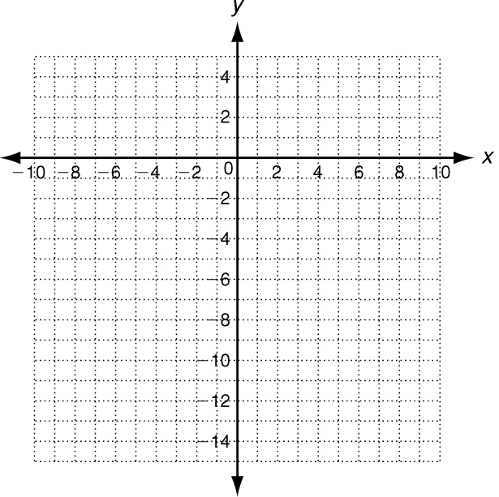
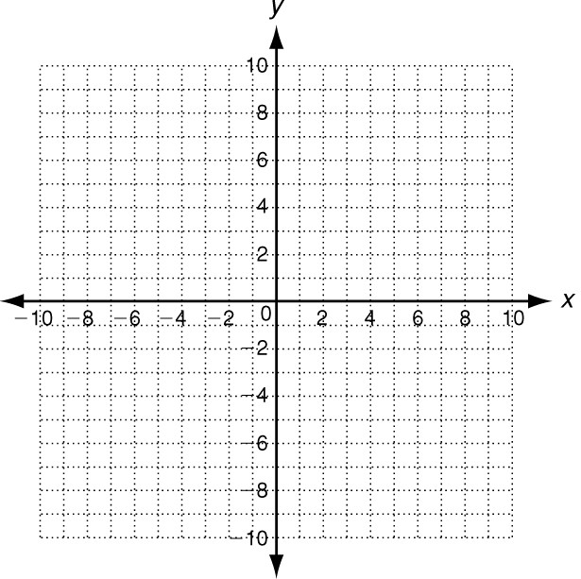

Look for a pattern in each data set to determine which kind of model best describes the data.
3. {(3, 225), (4, 337.5), (5, 506.25), (6, 759.375)} ___________________________
4. ___________________________
5. Use the data in the table to describe
how the restaurant’s sales are
changing. Then write a function that
models the data. Use your function to
predict the amount of sales after 10 years.
Year | 0 | 1 | 2 | 3
Sales ($) | 420,000 | 436,800 | 454,272 | 472,442.88

6. The first term of a geometric sequence is −3
and the common ratio is $\frac{1}{2}$ Find the 8th term.
________________________________________
7. The first term of a geometric sequence is −0.25
and the common ratio is −3. Find the 10th term.
________________________________________
8. What is the 14th term of the geometric sequence
−4, −12, −36, …?
________________________________________
9. What is the 12th term of the geometric sequence
2, −6, 18, …?
________________________________________
10. What is the 8th term of the geometric sequence
50, 10, 2, …?

11. If a golf ball is dropped from a height of 25 feet, the function
f(x) = 25${(\frac{2}{3})}^{x}$ gives the height in feet of each bounce.
What will be the height of the golf ball on the 6th bounce?
Round to the nearest tenth of a foot. _____________________________
Tell whether each set of ordered pairs satisfies an exponential function. Explain your answer.
12. _______________________________________________________

13. {(0, 3), (1, 7.5), (2, 18.75), (3, 46.875)} __________________________________________________

14. {(3, 7.5), (6, 6), (9, 4.8), (12, 3.84)} ______________________________________________________

Graph each exponential function.
15. y = 3(2.5)^{x} 16. y = −0.5(3.5)^{x} 17. y =
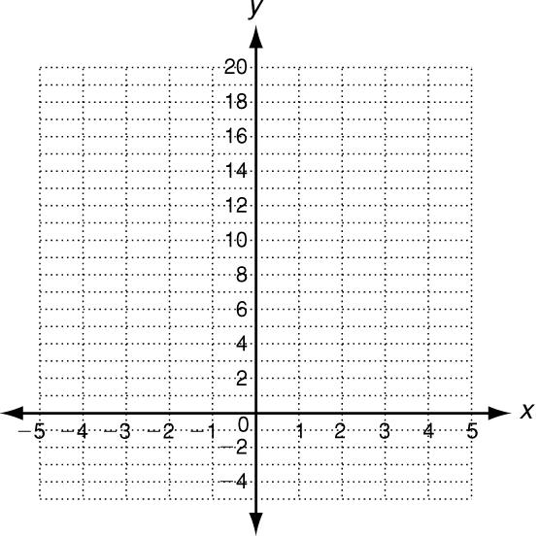
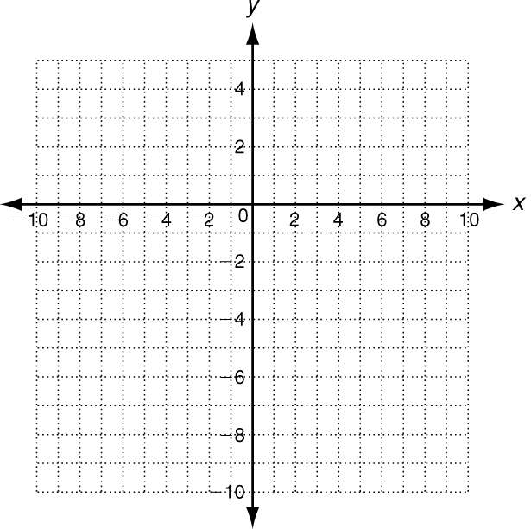
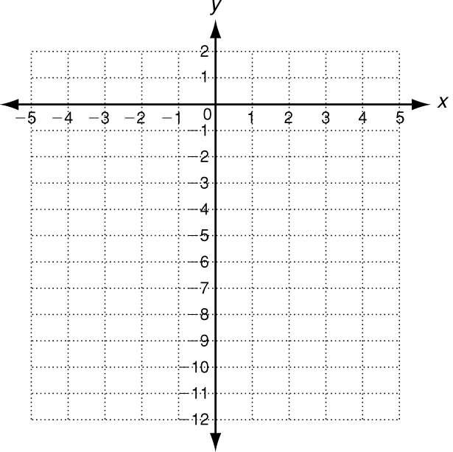

The Mendez family bought two used cars: one domestic
and one foreign. The domestic car was purchased for
$11,600. The foreign car was purchased for $9700. The
functions in the table represent the value of each car x
years from now due to depreciation.
Domestic Car | f(x) = 11,600 (0.88)^{x}
Foreign Car | f(x) = 9700 (0.93)^{x}

18. How much is each car worth 2 years from now? ___________________________
___________________________
19. In how many years will the foreign car be worth more than the domestic car? ______________

Write the correct answer.

20. A condo in Austin, Texas, was worth $80,000 in 1990. The value of the condo increased by an average of 3% each year. Write an exponential growth function to model this situation. Then find the value of the condominium in 2005.

21. Markiya deposited $500 in a savings account. The annual interest rate is 2%, and the interest is compounded monthly. Write a compound interest function to model this situation. Then find the balance in Markiya’s account after 4 years.
22. The population of a small Midwestern town is 4500. The population is decreasing at a rate of 1.5% per year. Write an exponential decay function to model this situation. Then find the number of people in the town after 25 years.

23. Twelve students at a particular high school passed an advanced placement test in 2000. The number of students who passed the test increased by 16.4% each year thereafter. Find the number of students who passed the test in 2004.

