Data Distributions
Standard: SWABAT Use statistics appropriate to the shape of the data distribution to compare center and spread. (MCC912.S.ID.2)

Name: ___________________________________ Mr. Murphey’s Coordinate Algebra
Date: 4/1/2014 Block: 1 4



Inbox Task – Identify the least and greatest value in each set.

- 34, 62, 45, 35, 75, 23, 35, 65
- 1.6, 3.4, 2.6, 4.8, 1.3, 3.5, 4.0

- Use the data below to make a stem-and-leaf plot.
7, 8, 10, 18, 24, 15, 17, 9, 12, 20, 25, 18, 21, 12

Data Distributions
Find the mean, median, mode, and range of each data set.
1. 35, 20.5, 100, 55, 2.5 2. –6, 4, 6, –6, 0, 3, 4, 1

3. 4. –1, –1, 0, 0, 1, 1

Identify the outlier in each data set, and determine how the outlier affects the mean, median, mode, and range of the data.
5. 119, 125, 183, 122, 120, 111 6. 0.015, 0.01, 0.8, 0.02, 0.016

7. The weights of randomly selected vitamins, in milligrams, in a quality control test were 582.4, 585, 579.8, 561.4, and 583.1. For each question, choose the mean, median, or mode, and give its value.
a. Which value describes the average weight of the vitamins? _____________________
b. Which value describes the typical weight of a vitamin? _________________________
c. The ideal weight of a vitamin is 581.5 milligrams. Which value would a technician give his boss to convince him that their machinery needs to be inspected? Explain.

Use the data to make a box-and-whisker plot.
8. 6.2, 6.1, 6.9, 7.4, 8.3, 6.3, 7.5, 6.2 9. 105, 76, 101, 93, 125, 127, 110, 98, 95

The number of e-mails received by two friends per day every day for one month is shown in the box-and-whisker plots.
10. Estimate the difference in the median number of e-mails.
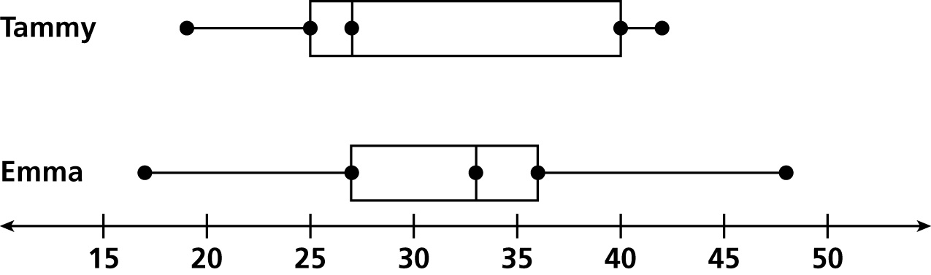
11. Overall, who would you say gets more e-mails?
Explain. ________________________________

Write the correct answer.
1. While window shopping, Sandra recorded the prices of shoes she would like to try on. The prices were $48, $63, $52, $99, and $58. Find the mean, median, and mode of the prices. Which best represents the typical shoe she looked at? Why?

3. The amounts due on the Harvey’s electric bill, rounded to the nearest dollar, for the past six months were $64, $83, $76, $134, $76, and $71. Find the mean, median, and mode of the amounts. Which value should Mr. Harvey tell his family to convince them to cut down on electric use?
________________________
2. The number of cans Xavier recycled each week for eight weeks is 24, 33, 76, 42, 35, 33, 45, and 33. Find the mean, median, and mode of the numbers of cans. How do the mean and median change when the outlier is removed?

4. A manager at a bowling alley surveys adult patrons about their shoes sizes. He records sizes 11, 12, 8, 4, 8, 5, 8, 7, 9, 10, 8, 9, 8, and 10. Find the mean, median, and mode of the sizes. Which is most important to the manager when ordering new rental shoes?

Box-and-whisker plots can be misleading if either the minimum or maximum value is an outlier. The fair options are either to not use box-and-whisker plots for data with outliers or to show them as individual points.
Mathematically, a value is accepted as an outlier if it is at least 1.5(IQR) below Q1 or 1.5(IQR) above Q3.
For the data set {46, 22, 19, 2, 17, 23, 31, 42, 73, 16, 22, 26, 28}:
1. Find Q1. 2. Find Q3. 3. Find the IQR.

4. Find 1.5(IQR). 5. Find Q1 – 1.5(IQR). 6. Find Q3 + 1.5(IQR).

7. Using the rule of being 1.5(IQR) away from Q1 or Q3, what is the outlier in the data set above?________
Outliers can be mild or extreme. A mild outlier is more than 1.5(IQR) from Q1 or Q3, but less than 3(IQR) from them. An extreme outlier is more than 3(IQR) from Q1 or Q3.
8. Classify the outlier identified in question 7. ____________________
To draw a box-and-whisker plot that has outliers, first plot Q1, the median, and Q3 as usual. Draw the box. Plot the minimum and maximum points that are not outliers. Draw the whiskers to these points. Then plot mild outliers with a closed dot and extreme outliers with an open dot.
9. Draw a box-and-whisker plot, displaying the outlier, for the data set above.

Draw box-and-whisker plots, displaying outliers, for each data set.
10. 41, 43, 30, 42, 29, 42, 41, 51, 43, 41, 43, 48

11. 30, 28, 27, 29, 33, 10, 21, 32, 27, 29

