

Name: ___________________________________ Mr. Murphey’s Analytical Geometry
Date: 4/1/2014 Block: 2
Standard: SWABAT derive using similarity the length of the arc intercepted by an angle is proportional to the radius. (MCC912.G.C.5)
Sector Area & Arc

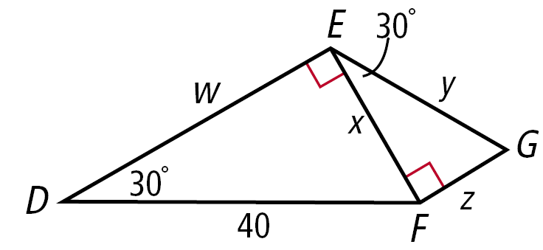
Inbox Task -
- Find w, y, and z. Give the answers in simplest radical form.

Sector Area and Arc Length
In Exercises 1 and 2, fill in the blanks to complete each formula.
1. The area of a sector of a circle with radius r and central
angle m° is A = __________________.
2. The length of an arc with central angle m° on a circle
with radius r is L = __________________.
Find the area of each sector. Give your answer in terms of π and
rounded to the nearest hundredth.
3. 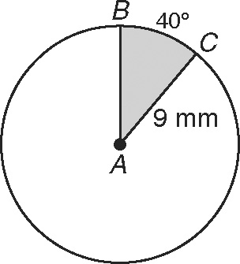 4. 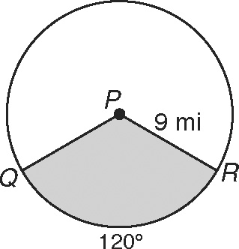
sector BAC sector QPR

Different animals have different fields of view. Humans can generally see a
180° arc in front of them. Horses can see a 215° arc. A horse and rider are in
heavy fog, so they can see for only 25 yards in any direction. Round your
answers to Exercises 5 and 6 to the nearest square yard.
5. Find the area of the rider’s field of view. __________________
6. Find the area of the horse’s field of view. __________________
Complete Exercises 7–9 to find the area of segment KJL.
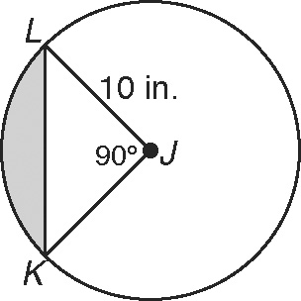
7. Find the area of sector KJL.
Give your answer in terms of π. __________________
8. Find the area of KJL. __________________
9. Subtract the area of KJL from the area
of sector KJL to find the area of segment
KJL. Round to the nearest hundredth. __________________

Find each arc length. Give your answer in terms of π and rounded to the nearest hundredth.
10. 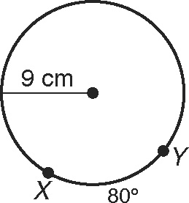 11. 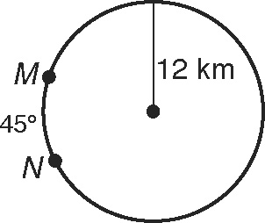

Find the area of each sector. Give your answer in terms of π and rounded to the nearest hundredth.
12. 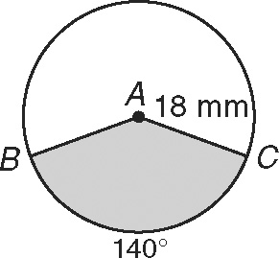 13. 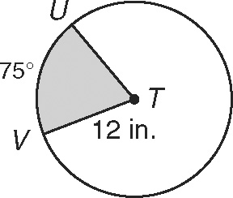
sector BAC sector UTV
14. 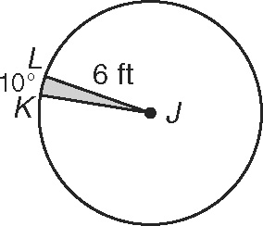 15. 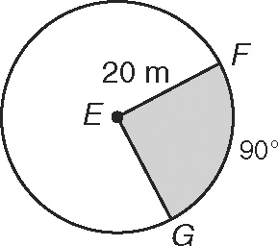
sector KJL sector FEG
16. The speedometer needle in Ignacio’s car is 2 inches long. The needle
sweeps out a 130° sector during acceleration from 0 to 60 mi/h. Find
the area of this sector. Round to the nearest hundredth. ____________
Find the area of each segment to the nearest hundredth.
17. 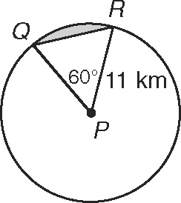 18. 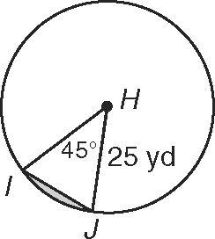

19. 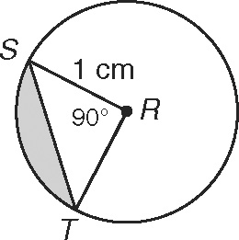 20. 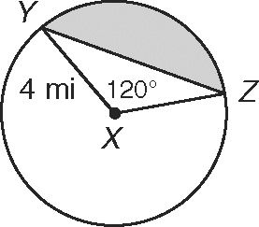

Find each arc length. Give your answer in terms of π and rounded to the nearest hundredth.
21. 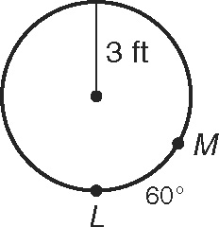 22. 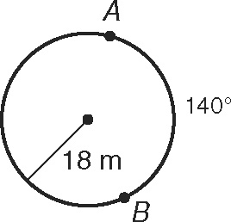

23. an arc with measure 45° in a circle with radius 2 mi _________________

24. an arc with measure 120° in a circle with radius 15 mm _________________

