Scatter Plots & Trend Lines
Standard: SWABAT represent data on two quantitative variables on a scatter plot, & describe how variables are related. (MCC912.S.ID.2)

Name: ___________________________________ Mr. Murphey’s Coordinate Algebra
Date: 4/2/2014 Block: 1 4



Inbox Task – Identify the least and greatest value in each set.

- 34, 62, 45, 35, 75, 23, 35, 65
- 1.6, 3.4, 2.6, 4.8, 1.3, 3.5, 4.0

- Use the data below to make a stem-and-leaf plot.
7, 8, 10, 18, 24, 15, 17, 9, 12, 20, 25, 18, 21, 12

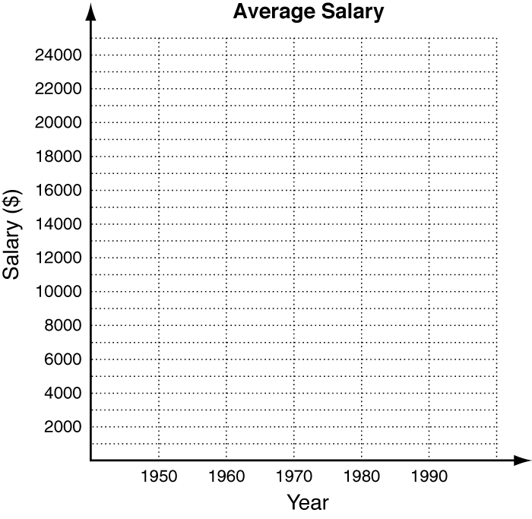
Scatter Plots and Trend Lines
Graph a scatter plot using the given data.
1. The table shows the average salary (rounded to the
nearest hundred) for one type of worker, listed by
decade. Graph a scatter plot using the given data.
Decade | 1950 | 1960 | 1970 | 1980 | 1990
Avg. Salary | $2800 | $4800 | $8300 | $15,400 | $23,700

Identify the correlation you would expect to see between
the pair of data sets. Explain.

2. The number of chicken pox vaccines given and the number of chicken pox cases reported.

3. The number of vacation days given to employees and their level of job satisfaction.

The average number of gallons of coffee per person consumed in the United States is shown in the table below.
Years | 1998 | 1999 | 2000 | 2001 | 2002 | 2003
Avg. annual  per capita consumption | 23.9 | 25.1 | 26.3 | 24.2 | 23.6 | 24.3
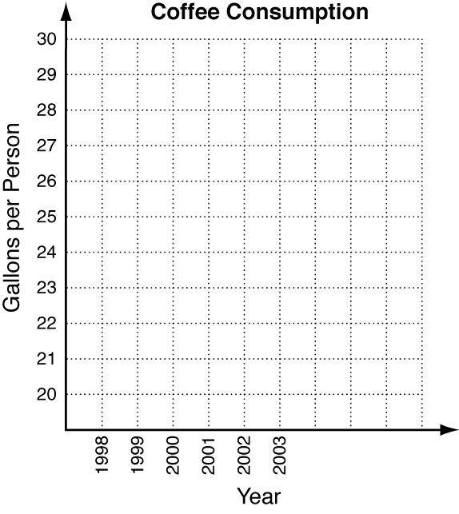
4. Graph a scatter plot of the data.
5. Draw a trend line.
6. Describe the correlation.

7. Based on the trend line you drew, predict the average
amount of coffee consumed per person in 2007.

8. How confident are you in your prediction? Explain.

Fawn is trying to improve her reading skills by taking a speed-reading class. She is measuring how many words per minute (wpm) she can read after each week of the class.

1. Graph a scatter plot using the given data.
Weeks | 1 | 2 | 3 | 4 | 5
wpm | 220 | 230 | 260 | 260 | 280
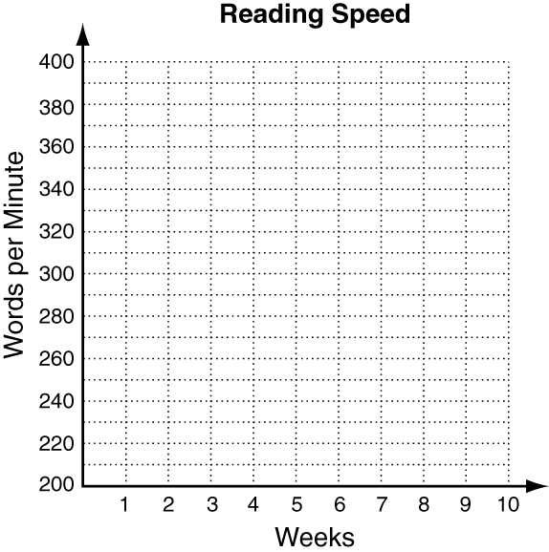
2. Describe the correlation illustrated by the scatter plot.

3. Draw a trend line and use it to predict the number of words per minute that Fawn will read after 8 weeks of this class.

4. Fawn is paying for this class each week out of her savings account. Identify the correlation between the number of classes and Fawn’s account balance.

Choose the scatter plot that best represents the described relationship.
5. the distance a person runs and how physically tired that person is
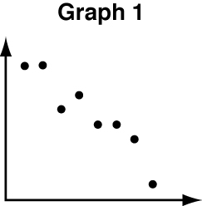
A Graph 1 C Graph 3
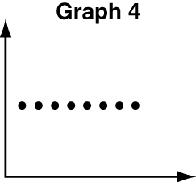
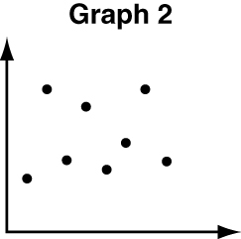
B Graph 2 D Graph 4
6. the price of a new car and the number of hours in a day
F Graph 1 H Graph 3
G Graph 2 J Graph 4
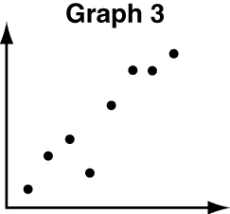
7. a person’s age and the amount of broccoli the person eats
A Graph 1 C Graph 3
B Graph 2 D Graph 4
8. the number of cats in a barn and the number of mice in that barn
F Graph 1 H Graph 3
G Graph 2 J Graph 4

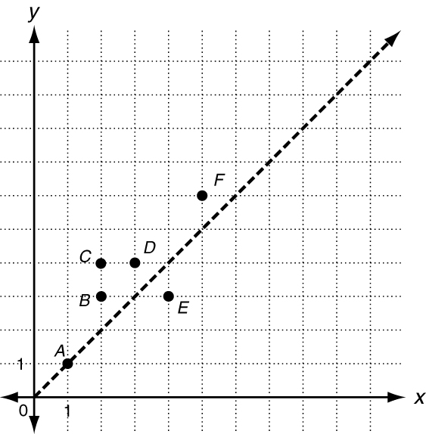
A scatter plot that represents a data set has many advantages.
When you visualize the data on the coordinate plane, you can
draw an inference about whether there may be a correlation,
positive or negative. You may also be able to draw the
inference that no correlation is apparent.
In the graph at right, you can see a scatter plot for the
data set below.
(1, 1), (2, 3), (2, 4), (3, 4), (4, 3), and (5, 6)
The scatter plot shows a positive correlation between x and y.
The points cluster closely to the line y = x. The greatest
difference in the y-coordinates of the data points and the
corresponding y-coordinates of the graph of y = x is 2.
Refer to the graph above.
9. a. On the coordinate grid above, graph y = x + 2.
b. On the coordinate grid above, graph y = x − 1.
c. Do the graphs that you sketched in parts a and b bound
or enclose all the given data points? Explain your response.
_____________________________________________________________________________________
The graph at right shows a scatter plot and the line y = x.

