Best Fit Line & U4 Review
Standard: SWABAT represent data on two quantitative variables on a scatter plot, & describe how variables are related. (MCC912.S.ID.2)

Name: ___________________________________ Mr. Murphey’s Coordinate Algebra
Date: 4/3/2014 Block: 1 4



Inbox Task – Identify the least and greatest value in each set.

- 34, 62, 45, 35, 75, 23, 35, 65
- 1.6, 3.4, 2.6, 4.8, 1.3, 3.5, 4.0

- Use the data below to make a stem-and-leaf plot.
7, 8, 10, 18, 24, 15, 17, 9, 12, 20, 25, 18, 21, 12

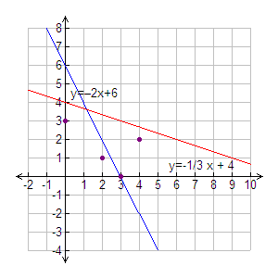
Line of Best Fit
x | 0 | 2 | 3 | 4
y | 3 | 1 | 0 | 2
1. The data in the table are graphed at the right along with two lines of fit.

a. Find the sum of the squares of the residuals for
y = −2x + 6.___________________________
b. Find the sum of the squares of the residuals for ___________________________
c. Which line is a better fit for the data? ___________________________
2. Use the data in the table to answer the questions that follow.
x | 2.1 | 4.8 | 6.5 | 8.2 | 9.4
y | –3.08 | −1.62 | –5.8 | 0.25 | 0.84

a. Find an equation for a line of best fit. ___________________________
b. What is the correlation coefficient? ___________________________
c. How well does the line represent the data? ___________________________
d. Describe the correlation. ___________________________
3. The table shows the number of patients in a doctor's office and the length of time it took to see them. Use the data in the table to answer the questions that follow.
Patients | 2 | 4 | 6 | 8 | 10
Time (h) | 0.5 | 1.1 | 2.3 | 3.8 | 5.2

a. Find an equation for a line of best fit. ___________________________
b. What is the correlation coefficient? ___________________________
c. How well does the line represent the data? ___________________________
d. Describe the correlation. ___________________________
4. Students were surveyed about how much time they spent studying during one week and how much time they spent watching TV during the same week. The equation of the least-squares line is y ≈ –0.82x + 4.36, and r ≈ –0.96. Discuss correlation and causation for the data set.
Studying (h) | 0 | 1 | 1.5 | 2 | 2.5 | 3 | 3.5
TV (h) | 4 | 3.9 | 3.2 | 2.7 | 2.6 | 1.9 | 1.2

