Line of Best Fit pg. 146
x | 1 | 2 | 3 | 4
y | 8 | 5 | 5 | 2
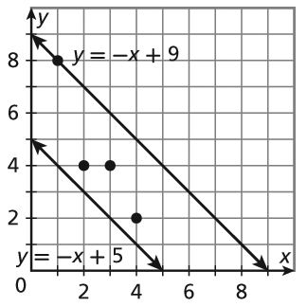
The data in the table are graphed along with two lines of fit. The line that is a better fit will have the lesser sum of the square of the residuals. A residual is the vertical distance between a data point and a line of fit.
Find the sum of the squares of the residuals for y = −x + 5.
Step 1 Use the equation to find the y-values when
x = 1, 2, 3, and 4.
x | −x + 5 = y
1 | −1 + 5 = 4
2 | −2 + 5 = 3
3 | −3 + 5 = 2
4 | −4 + 5 = 1

Step 2 Subtract each y-value in Step 1 from the corresponding
y-value in the original table to find the residuals.
8 − 4 = 4 5 − 3 = 2 5 − 2 = 3 2 − 1 = 1
Step 3 Add the squares of the residuals.
4² + 2² + 3² + 1² = 16 + 4 + 9 + 1 = 30
The sum of the squares of the residuals for y = −x + 5 is 30.
1. Find the sum of squares of the residuals for y = −x + 9.
a. Use the equation to find the y-values when x = 1, 2, 3, and 4.
x | 1 | 2 | 3 | 4
y
b. Subtract each y-value in Step 1 from the corresponding y-value in the original table to find the residuals.
8 − _____ = _____ 5 − _____ = _____ 5 − _____ = _____ 2 − _____ = _____
c. Add the squares of the residuals.
_____² + _____² + _____² + _____² = _____ + _____ + _____ + _____ = _____
The line for which the sum of the squares of the residuals is lesser is the better fit for the data.
2. _________________ is the better fit.

Line of Best Fit pg. 146
x | 1 | 2 | 3 | 4
y | 8 | 5 | 5 | 2
The data in the table are graphed along with two lines of fit. The line that is a better fit will have the lesser sum of the square of the residuals. A residual is the vertical distance between a data point and a line of fit.
Find the sum of the squares of the residuals for y = −x + 5.
Step 1 Use the equation to find the y-values when
x = 1, 2, 3, and 4.
x | −x + 5 = y
1 | −1 + 5 = 4
2 | −2 + 5 = 3
3 | −3 + 5 = 2
4 | −4 + 5 = 1

Step 2 Subtract each y-value in Step 1 from the corresponding
y-value in the original table to find the residuals.
8 − 4 = 4 5 − 3 = 2 5 − 2 = 3 2 − 1 = 1
Step 3 Add the squares of the residuals.
4² + 2² + 3² + 1² = 16 + 4 + 9 + 1 = 30
The sum of the squares of the residuals for y = −x + 5 is 30.
1. Find the sum of squares of the residuals for y = −x + 9.
a. Use the equation to find the y-values when x = 1, 2, 3, and 4.
x | 1 | 2 | 3 | 4
y
b. Subtract each y-value in Step 1 from the corresponding y-value in the original table to find the residuals.
8 − _____ = _____ 5 − _____ = _____ 5 − _____ = _____ 2 − _____ = _____
c. Add the squares of the residuals.
_____² + _____² + _____² + _____² = _____ + _____ + _____ + _____ = _____
The line for which the sum of the squares of the residuals is lesser is the better fit for the data.
2. _________________ is the better fit.

