Name: ___________________________________ Mr. Murphey’s Coordinate Algebra Support
Date: 11/4/2013 Block: 1 4
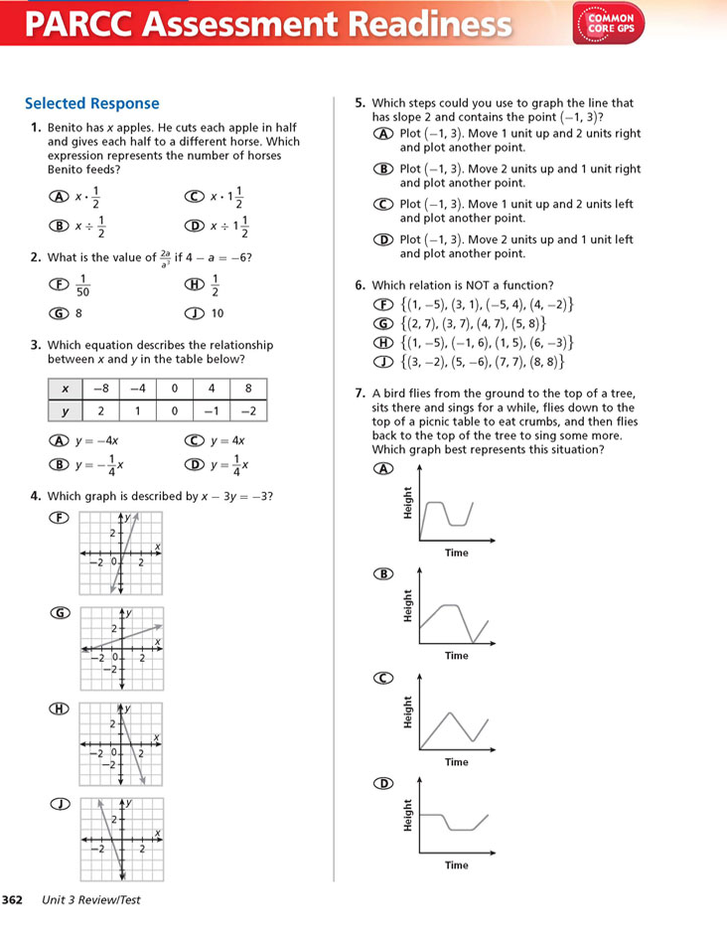
Standard: SWABAT recognize situations in which a quantity grows or decays by a constant percent rate. (MCC912.F.LE.1c)

Unit 3b Review
