`
Organizing/Displaying Data
Standard: SWABAT Represent data with plots on the real number line (dot plots, histograms, and box plots). (MCC912.S.ID.1)

Name: ___________________________________ Mr. Murphey’s Coordinate Algebra
Date: 11/7/2013 Block: 2



Inbox Task
Identify the least & greatest in each set.
- 34, 62, 45, 35, 75, 23, 35, 65, 23

2. 1.6, 3.4, 2.6, 4.8, 1.3, 3.5, 4.0
Order the data from least to greatest.
3. 2.4, 5.1, 3.7, 2.1, 3.6, 4.0, 2.9

4. 5, 5, 6, 8, 7, 4, 6, 5, 9, 3, 6, 6, 9

Organizing and Describing Data
Use the bar graph for Exercises 1–3.
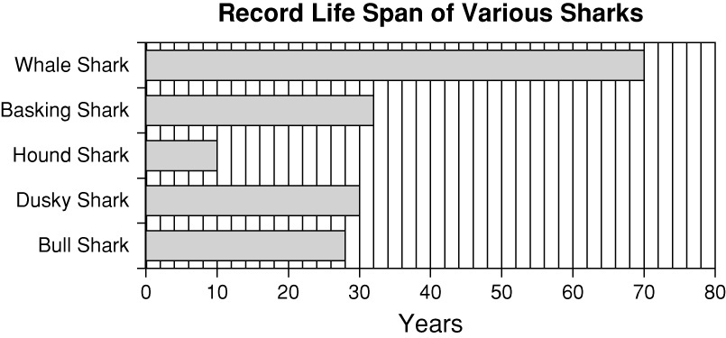
- Which shark lived longer than any
other shark?

2. About how long did the Basking
Shark live?

- Which shark lived about one-third
as along as the Dusky Shark?

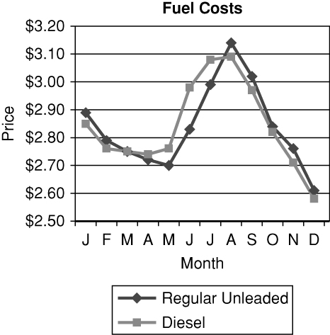
Use the line graph for Exercises 4–6.
4. In what month was the cost of diesel
fuel and regular unleaded the same?

5. For how many months was the cost
of diesel fuel more than regular
unleaded?

6. About how much more was the
cost of diesel fuel in July than in
December?


7. The table shows what types of pizzas were
ordered at Vinnie’s Restaurant one weekend.
Use the data to make a circle graph. Then tell
why a circle graph is appropriate for this data set.
Type | # of Orders
extra cheese | 15
pepperoni | 55
veggie | 30
meat | 30
plain | 70

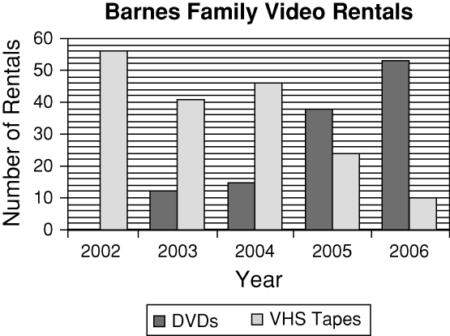
Look at the double bar graph.
1. Which was the first year that the
Barnes rented more DVDs than
VHS tapes?

2. About how many videos did the
Barnes family rent in all in 2003?

Look at the line graph.
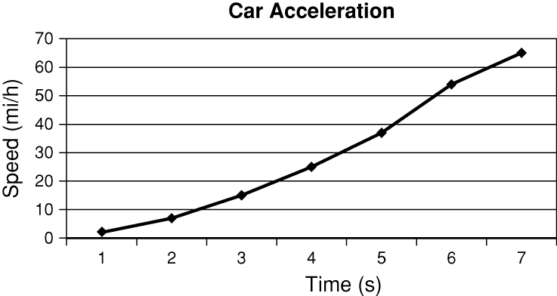
3. During which time interval did the
car’s speed increase the least?

4. Describe how the speed changed
over time.

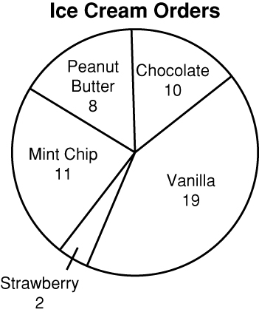
Look at the circle graph.
5. There were 5 times the number of orders for
____________________ as there were for strawberry.
6. What percent of the orders for ice cream were for
mint chip or vanilla? _________________
7. The table shows the number of customers
who pumped 4 types of fuel at a gas station
in a given time period. Use the given data to
make a graph. Explain why you chose that
type of graph.
87  Octane | 89  Octane | 93  Octane | Diesel
12 | 1 | 5 | 2

