Translations/Reflections
Standard: SWABAT Develop definitions of rotations, reflections, and translations in terms of lines, and line segments. (MCC912.G.CO.4)

Name: ___________________________________ Mr. Murphey’s Coordinate Algebra
Date: 4/14/2014 Block: 1 4



Inbox Task – Given that ∆ABC ≅ ∆DEF, identify a segment or angle congruent to each of the following.
- 
- 
- 

Find the coordinates of the image of ∆ABC with vertices A(3, 4), B(–1, 4), and C(5, –2), after each reflection.

- across the x-axis
- across the y-axis
- across the line

Translations - Tell whether each transformation appears to be a translation.
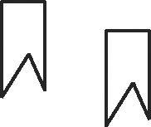
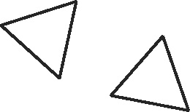
1. _________ 2. _________

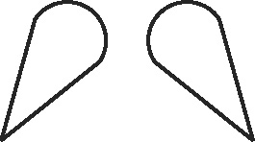
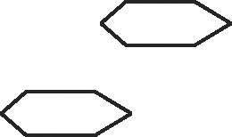
3. _________ 4. _________

Draw the translation of each figure along the given vector.
5. 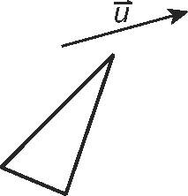 6. 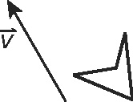
Translate the figure with the given vertices along the given vector.
7. A(−1, 3), B(1, 1), C(4, 4); ⟨0, −5⟩ 8. P(−1, 2), Q(0, 3), R(1, 2), S(0, 1); ⟨1, 0⟩
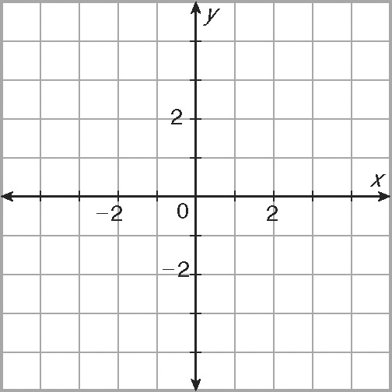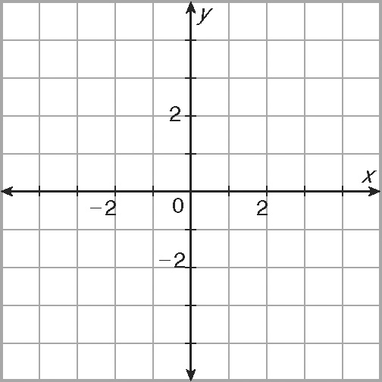
9. L(3, 2), M(1, −3), N(−2, −2); ⟨−2, 3⟩ 10. D(2, −2), E(2, −4), F(1, −4),
G(−2, −2); ⟨2, 5⟩
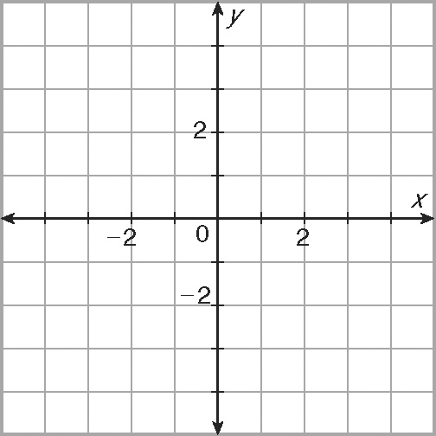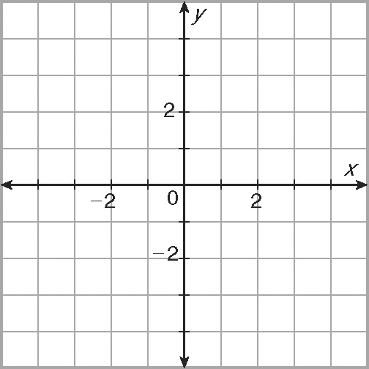
11. A builder is trying to level out some ground with a front-end loader. He picks up some
excess dirt at (9, 16) and then maneuvers through the job site along the vectors
⟨−6, 0⟩, ⟨2, 5⟩, and ⟨8, 10⟩ to get to the spot to unload the dirt. Find the coordinates
of the unloading point. Find a single vector from the loading point to the unloading point.
Reflections - Tell whether each transformation appears to be a reflection.
1. 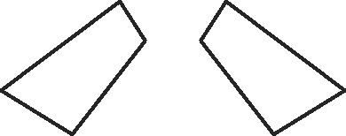 _________ 2. 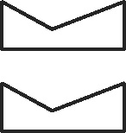 _________
3. 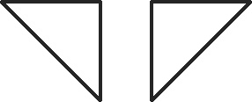 _________ 4. 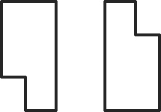 _________
Draw the reflection of each figure across the line.
5. 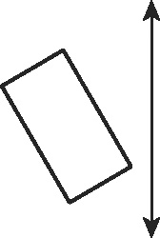 6. 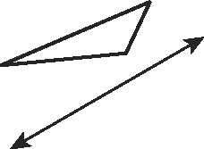
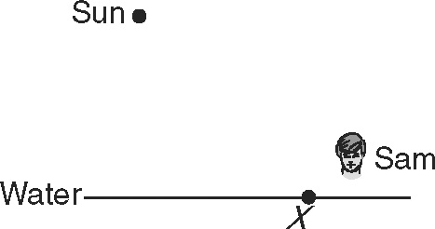
7. Sam is about to dive into a still pool, but some sunlight is
reflected off the surface of the water into his eyes. On the
figure, plot the exact point on the water’s surface where the
sunlight is reflected at Sam.
Reflect the figure with the given vertices across the given line.
8. A(4, 4), B(3, −1), C(1, −2); y-axis 9. D(−4, −1), E(−2, 3), F(−1, 1); y = x
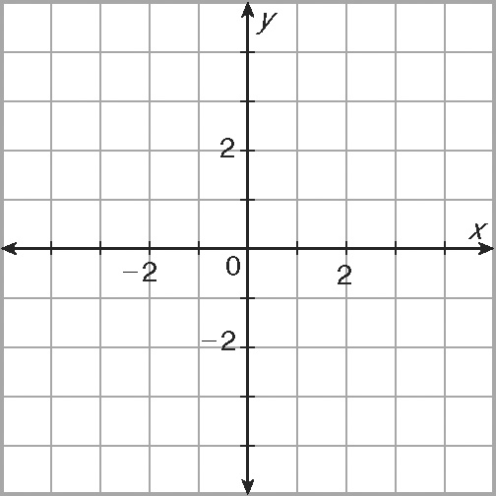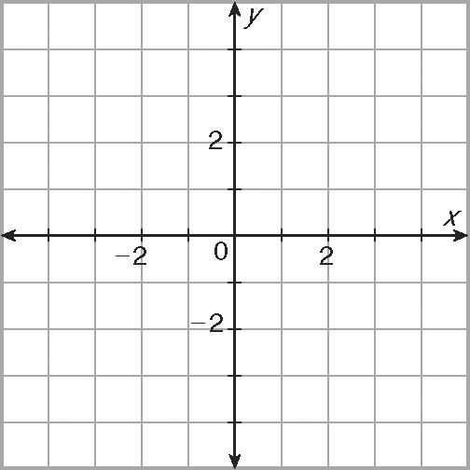
10. P(1, 3), Q(−2, 3), R(−2, 1), S(1, 0); 11. J(3, −4), K(1, −1), L(−1, −1),
x-axis M(−2, −4); y = x
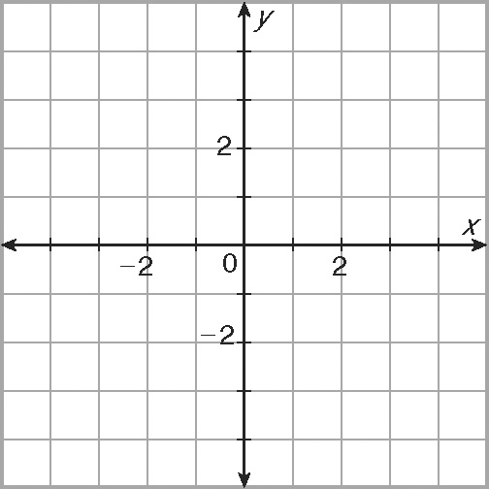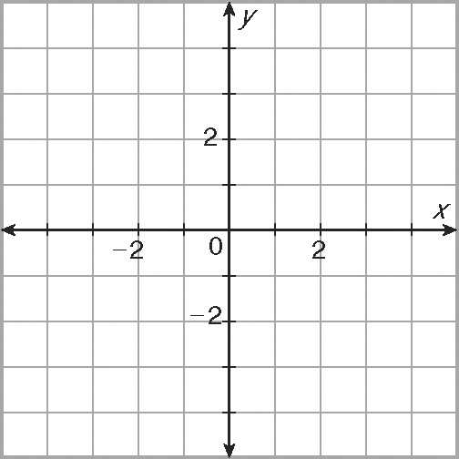

12. Quadrilateral JLKM has vertices J(7, 9), K(0, −4), L(2, 2), and M(5, −3). If the figure is reflected across the line y = x, what are the coordinates of M′?

14. The function y = −3^{x} passes through
the point P(6, −729). If the graph is
reflected across the y-axis, what are the coordinates of the image of P?

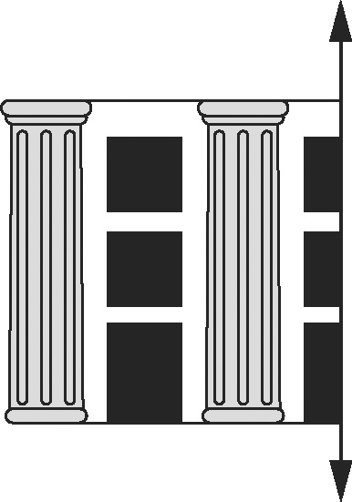
13. In the drawing, the left side of a structure is shown with its line of reflection. Draw the right side of the structure.

4. A group of hikers walks 2 miles east and then 1 mile north. After taking a break, they then hike 4 miles east and set up camp. What vector describes their hike from their starting position to their camp? Let 1 unit represent 1 mile.

