Rotations/Transformations
Standard: SWABAT Develop definitions of rotations, reflections, and translations in terms of lines, and line segments. (MCC912.G.CO.4)

Name: ___________________________________ Mr. Murphey’s Coordinate Algebra
Date: 4/15/2014 Block: 1 4



Inbox Task – Given that ∆ABC ≅ ∆DEF, identify a segment or angle congruent to each of the following.
- Draw a line that divides a right angle in half.
- Draw three different squares with (3, 2) as one vertex.
- Find the values of x and y if (3, –2) = (x + 1, y – 3)

Rotations Find the measure of the angle of rotation for each point and its image given below. Round to the nearest degree. Assume each rotation is counterclockwise around the origin.
1. A(19.3, 5.2), A′(−11.5, 16.4) 2. B(5, 0), B′(−4.4, −2.3) 3. C(3.5, −6.1), C′(6.1, 3.5)

4. D(−2.6, 3.1), D′(−3.5, 2) 5. E(0.4, −2.1), E′(−2.1, −0.4) 6. F(−10.8, −1.9), F′(0, −11)

Find the coordinates of the image of each point after a counterclockwise rotation about the origin through the given angle. Round to the nearest tenth.
7. G(0, 3.2); 67° 8. H(12.3, 8.6); 270° 9. I(−0.8, 3.9), 102°

10. J(0.1, 0.9); 180° 11. K(−10, 0); 307° 12. L(−8, −13.9); 4°

13. A point has a negative x-coordinate and a positive y-coordinate. After a rotation
around the origin, the image of the point has a positive x-coordinate and a negative
y-coordinate. Find the range of possible values for A, the measure of the angle of
rotation. Remember that zero is considered neither positive nor negative.

14. A rotation through an angle that measures 520° will be indistinguishable from a
rotation through an angle less than 360° that measures how many degrees?
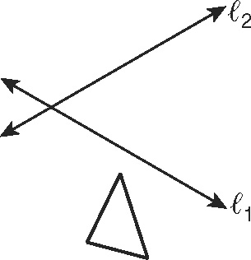
15. Reflect the triangle across Then reflect that image across
Describe the relation of the second image to the original preimage.

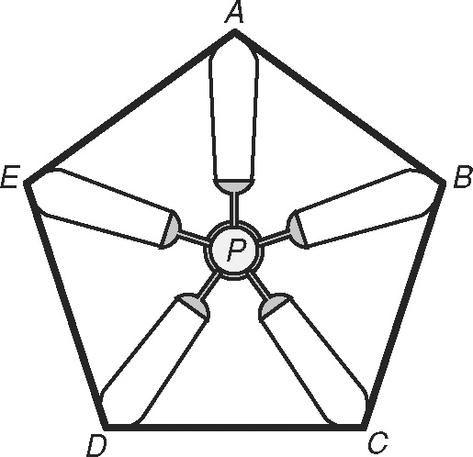
16. A rotation can be interpreted as successive reflections across
two intersecting lines. Tell which point is the center of rotation.

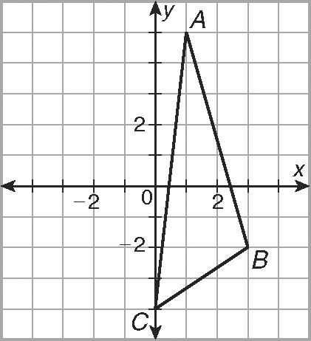
18. ABC is rotated about the origin so that A′ has coordinates (−1, −5). What are the coordinates of B′?

19. The five blades of a ceiling fan
form a regular pentagon. Which
clockwise rotation about point P
maps point B to point D?
F 60° H 120°
G 72° J 144°

Transformations in the Coordinate Plane
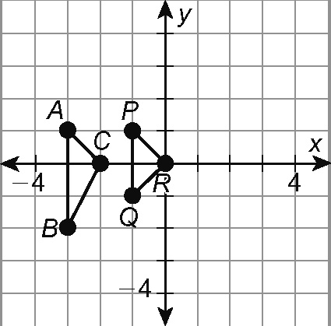
Use the figure for Exercises 1–3.
1. Draw the images of ΔABC and ΔPQR reflected across the
y-axis. Tell which triangle(s) can be rotated so that the rotation
image exactly covers the reflection image.

2. Tell how the image and preimage of the triangle do not match
up after the rotation mentioned in Exercise 1.

3. Imagine ΔABC and ΔPQR reflected across the y-axis and then the
x-axis. Name which triangle(s) can be rotated so that the image
exactly covers the preimage.

Find the coordinates.
4. Determine the coordinates of any point A(x, y) reflected
across the x-axis and then across the y-axis. _______________
5. Determine the coordinates of any point A(x, y) rotated
90° clockwise around the origin. _______________
6. Determine the coordinates of any point A(x, y) rotated
180° clockwise around the origin. _______________
7. Determine the coordinates of any point A(x, y) reflected
across the x-axis and then across the y-axis and then
rotated 180° around the origin. (Hint: Use your answers
to Exercises 4 and 6.) _______________
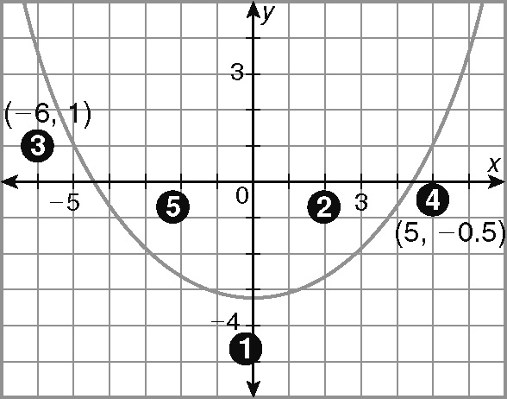
Use the diagram of the starting positions of five basketball players
for Exercises 8 and 9.
8. After the first step of a play, player 3 is at (−1.5, 0)
and player 4 is at (1, 0.5). Write a rule to describe
the translations of players 3 and 4 from their starting
positions to their new positions.

9. For the second step of the play, player 3 is to move to a position described by
the rule (x, y) → (x − 4, y − 2) and player 4 is to move to a position described
by the rule (x, y) → (x + 3, y − 2). What are the positions of these two players
after this step of the play?

10. Triangle HJK has vertices H(0, −9), J(−1, −5), and K(7, 8). What are the
coordinates of the vertices after the translation (x, y) → (x − 1, y − 3)?
A H′(−1, 12), J′(−2, 8), K′(6, −5) C H′(−1, −12), J′(−2, −8), K′(6, 5)
B H′(1, −12), J′(2, −8), K′(−6, 5) D H′(1, 12), J′(2, 8), K′(−6, −5)

