Rotations pg.160
A rotation is a transformation that turns a figure around a fixed point, called the
center of rotation.
Rotation Not a Rotation
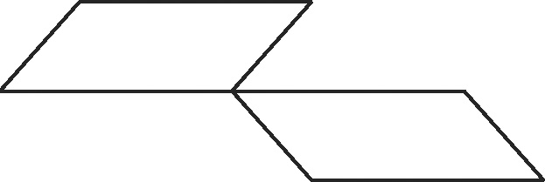
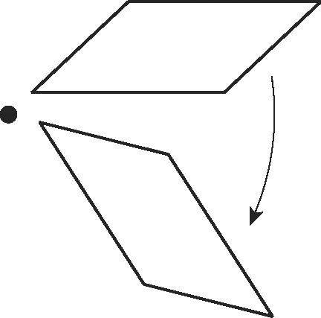
center of rotation

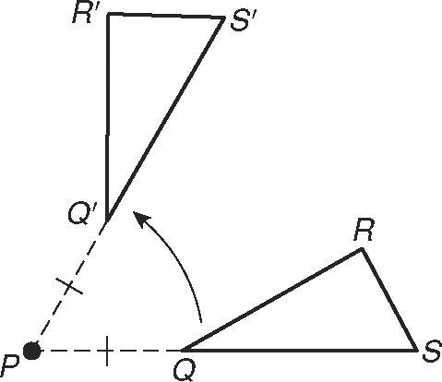
A rotation is a transformation about a point P such that
each point and its image are the same distance from P.
angle of rotation
PQ = PQ′
PR = PR′
PS = PS′

Tell whether each transformation appears to be a rotation.
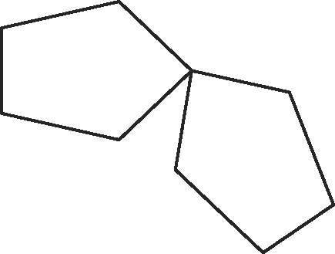
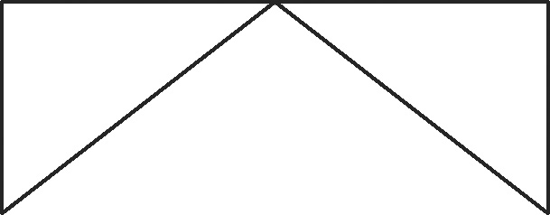
1. 2.

Copy each figure and the angle of rotation. Draw the rotation of the figure about point P by m∠A.
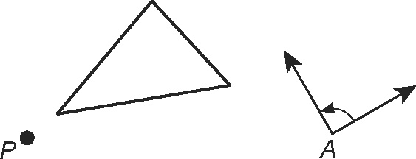
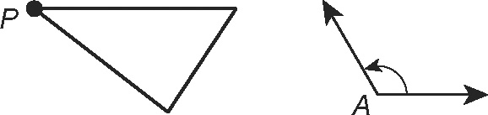
3. 4.
Rotations continued
Rotations in the Coordinate Plane
By 90° About the Origin | By 180° About the Origin
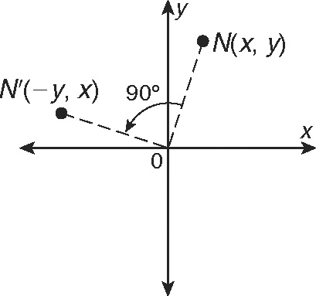  (x, y) → (−y, x) | 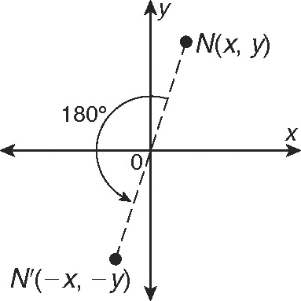  (x, y) → (−x, −y)

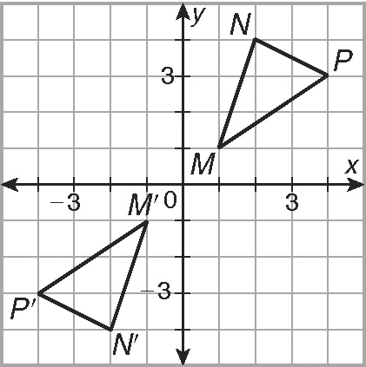
Rotate MNP with vertices M(1, 1), N(2, 4),
and P(4, 3) by 180° about the origin.
The image of (x, y) is (−x, −y).
M(1, 1) → M′(−1, −1)
N(2, 4) → N′(−2, −4)
P(4, 3) → P′(−4, −3)
Graph the preimage and image.
Rotate the figure with the given vertices about the origin using the given angle.
5. R(0, 0), S(3, 1), T(2, 4); 90° 6. A(0, 0), B(−4, 2), C(−1, 4); 180°
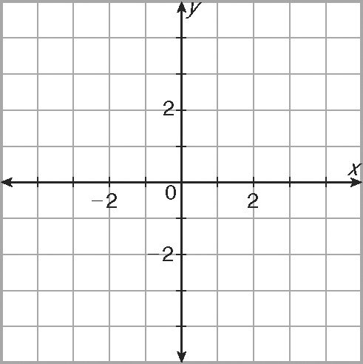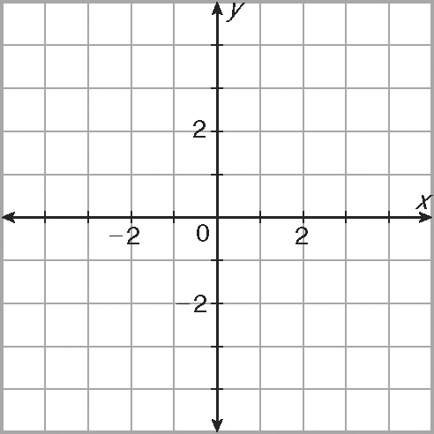
7. E(0, 3), F(3, 5), G(4, 0); 180° 8. U(1, −1), V(4, −2), W(3, −4); 90°
