`sd
Data Distributions
Standard: SWABAT Use statistics appropriate to the shape of the data distribution to compare center and spread (MCC912.S.ID.2)

Name: ___________________________________ Mr. Murphey’s Coordinate Algebra Support
Date: 11/12/2013 Block: 1 4



Inbox Task – Identify the least and greatest value in each set.

- 34, 62, 45, 35, 75, 23, 35, 65

- 1.6, 3.4, 2.6, 4.8, 1.3, 3.5, 4.0

- Use the data below to make a stem-and-leaf plot.
7, 8, 10, 18, 24, 15,
17, 9, 12, 20, 25,
18, 21, 12

Data Distributions
Find the mean, median, mode, and range of each data set.
1. 7, 19, 25, 9, 10
Order the numbers: _____, _____, _____, _____, _____
mean: median: ______
mode: _________ range: _____ – _____ = _____
2. 5, 3, 3, 5, 2, 5, 5
Order the numbers: _____, _____, _____, _____, _____, _____, _____
mean: _________ median: ______
mode: _________ range: _______
3. 8, 12, 17, 12, 9, 8
mean: _________ median: ______
mode: _________ range: _______
Identify the outlier in each data set, and determine how the outlier affects the mean, median, mode, and range of the data.
4. 7, 11, 29, 3, 10 5. 52, 39, 11, 44
_________________________________
_________________________________
6. Mr. Bernard drove 46, 4, 64, 50, and 56 miles on his last five trips. For each question, choose the mean, median, or mode, and give its value.
a. Which value describes Mr. Bernard’s average driving distance? __________________
b. Which value would Mr. Bernard tell his boss to convince him that he spends too much time on the road? Explain.

7. Use the data to make a box-and-whisker plot. 18, 22, 10, 22, 30, 8, 33, 15, 14
a. Order the data: __________________________
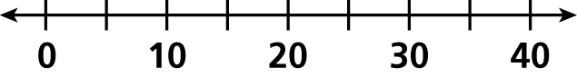
b. Min: _____, Q1_____, Med: _____,
Q3: _____, Max: _____
The quiz scores of two students are shown in the box-and-whisker plots.
8. Who has the higher median score? ________
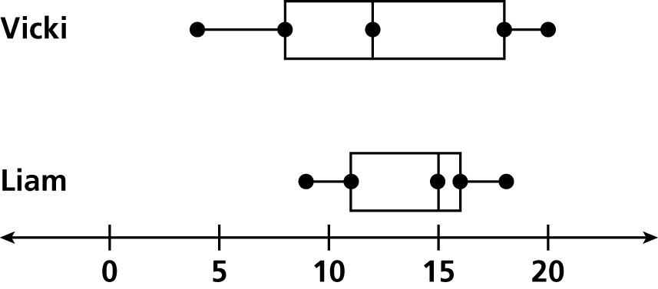
9. Who has the highest score? ________
10. Who has the most consistent scores? ________

Find the mean, median, mode, and range of each data set.
1. 22, 45, 30, 18, 22 2. 8, 10, 8, 14, 8, 15

3. 1.25, 0.5, 3.25, 0.75, 1.75 4. 95, 92, 96, 93, 94, 95, 93

Identify the outlier in each data set, and determine how the outlier affects the mean, median, mode, and range of the data.
5. 31, 35, 41, 40, 40, 98 6. 82, 24, 100, 96, 79, 93, 86

7. The amounts of Cathy’s last six clothing purchases were $109, $72, $99, $15, $99, and $89. For each question, choose the mean, median, or mode, and give its value.
a. Which value describes the average of Cathy’s purchases? __________________
b. Which value would Cathy tell her parents to convince them that she is not spending too much money on clothes? Explain.

c. Which value would Cathy tell her parents to convince them that she needs an increase in her allowance? Explain.

Use the data to make a box-and-whisker plot.
8. 71, 79, 56, 24, 35, 37, 81, 63, 75 9. 210, 195, 350, 250, 260, 300

The finishing times of two runners for several one-mile races, in minutes, are shown in the box-and-whisker plots.
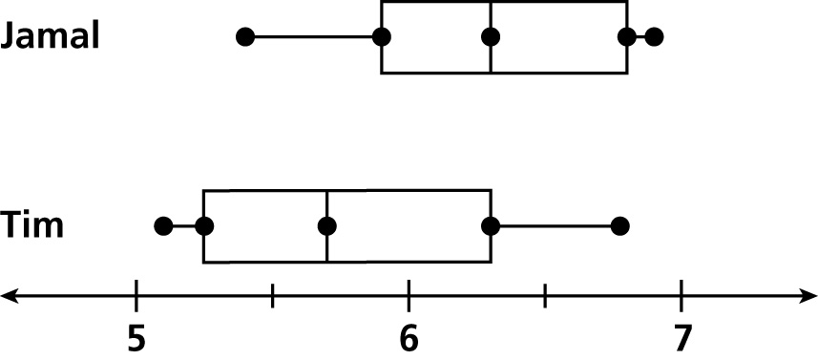
10. Who has the faster median time? __________

11. Who has the slowest time? _______________

12. Overall, who is the faster runner? Explain.

