Data Distributions
Consider the data set {2, 6, 4, 2, 1}.

The mean of the data set is the average of the data set. Add all the numbers and divide by the number of numbers.
The mean is 3.

The median of the data set is the middle number when the numbers are listed in order.
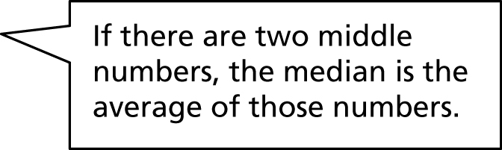
1, 2, 2, 4, 6
The median is 2.

The mode is the number that occurs most often.
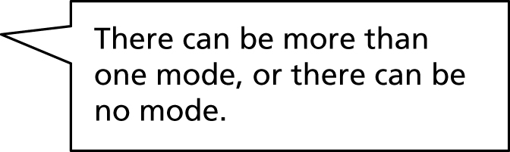
1, 2, 2, 4, 6
The mode is 2.

The range is the difference between the greatest and least numbers.
1, 2, 2, 4, 6
6 – 1 = 5
The range is 5.
Find the mean, median, mode, and range of each data set.
1. 8, 2, 3, 4, 3
mean: mode: ____________________________
median: ______________________________ range: ____________________________

2. 4, 5, 7, 4, 5, 8
mean:________________________________ mode: ____________________________
median: ______________________________ range: ____________________________

3. 12, 8, 16, 4
mean:________________________________ mode: ____________________________
median: ______________________________ range: ____________________________

Data Distributions (continued)
Consider the data set {3, 5, 6, 8, 8, 10, 11, 13, 14, 19, 20}.

To make a box-and-whisker plot, first identify the median, which divides the data into two halves. Then identify the first quartile, Q1, the median of the lower half, and the third quartile, Q3, the median of the upper half. Last, identify the minimum (lowest) and maximum (greatest) numbers.
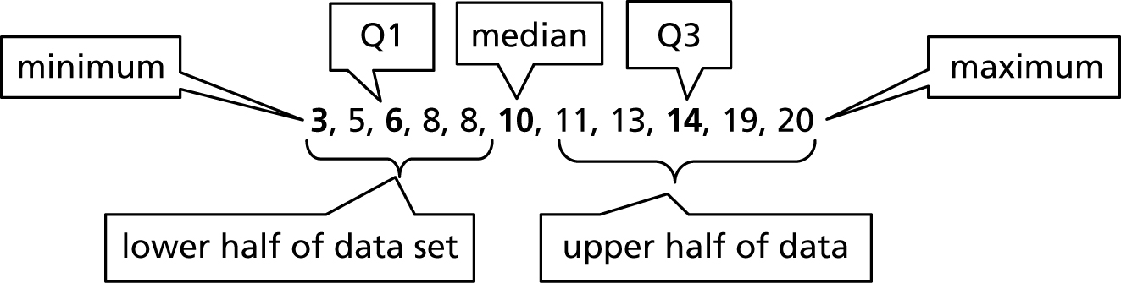

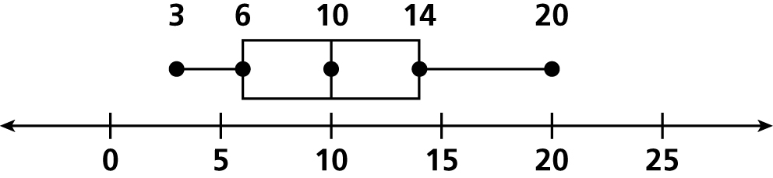
Plot the five numbers above a number line. Draw a box so
the sides go through Q1 and Q3. Draw a line through the
median. Connect the box to the minimum and maximum.

When there is an even number of numbers, the two middles numbers are included in the upper and lower halves of the data set.
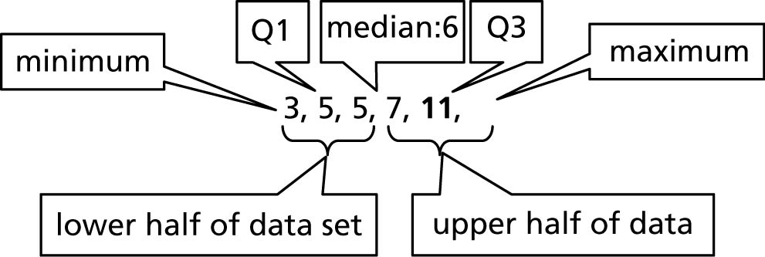

Consider the data set {9, 11, 18, 21, 18, 14, 5}.
4. Write the data in order: ____________________________
5. Minimum: _____, Q1: ____, Median: ____, Q3: ____, Maximum: ____
6. Draw the box-and-whisker plot.

Consider the data set {7, 5, 2, 14, 9, 15}.
7. Write the data in order: ____________________________
8. Minimum: _____, Q1: ____, Median: ____, Q3: ____, Maximum: ____
9. Draw the box-and-whisker plot.

