`sd
Scatter Plots and Trend Lines
Standard: SWABAT represent data on two variables on a scatter plot, and describe how the variables are related (MCC912.S.ID.6)

Name: ___________________________________ Mr. Murphey’s Coordinate Algebra Support
Date: 11/13/2013 Block: 1 4



Inbox Task

1. Find the mean, median, mode, and range of the data set. {7, 3, 5, 4, 5}

2. Identify the outlier in the data set {12, 15, 20, 44, 18, 20}, and determine how the outlier affects the mean, median, mode, and range of the data.

3. The data set {12, 23, 13, 14, 13} gives the times of Tara’s one-way ride to school (in minutes) for one week. For each question, choose the mean, median, or mode, and give its value.
A. Which value describes the time that occurred most often?
B. Which value best describes Tara’s ride time? Explain.

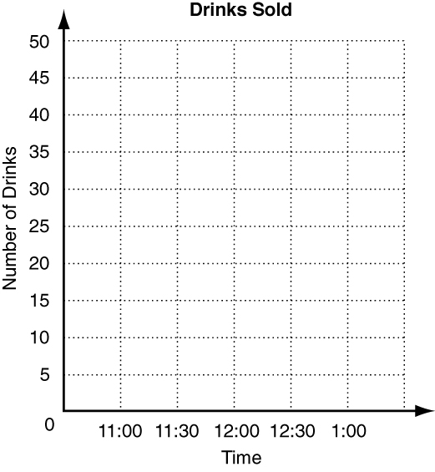
Scatter Plots and Trend Lines
1. The table shows the number of soft drinks sold at
a small restaurant from 11:00 am to 1:00 pm.
Graph a scatter plot using the given data.
Time of Day | 11:00 | 11:30 | 12:00 | 12:30 | 1:00
Number of Drinks | 20 | 29 | 34 | 49 | 44
Write positive, negative, or none to describe the correlation
illustrated by each scatter plot.
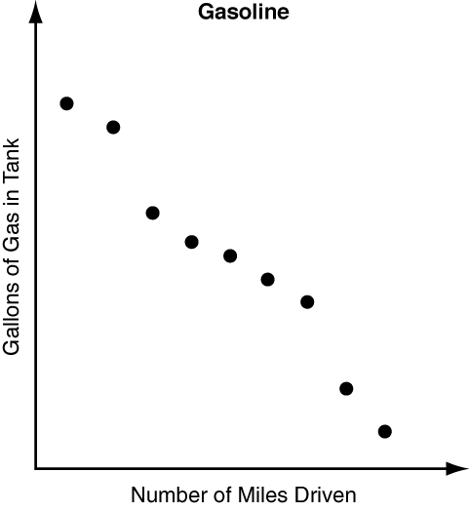
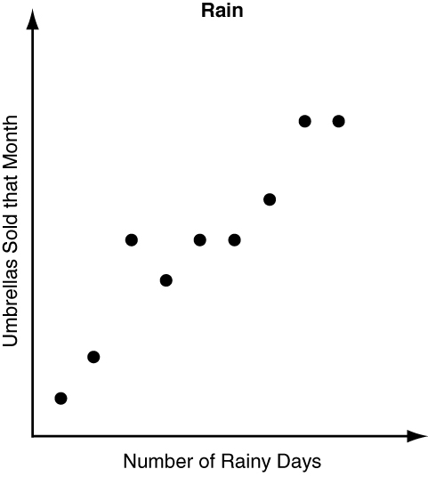
2. 3.

Identify the correlation you would expect to see between each pair of data sets. Explain.
4. the temperature during the day and the number of people in the pool

5. the height of an algebra student and the number of phone calls they make in one week

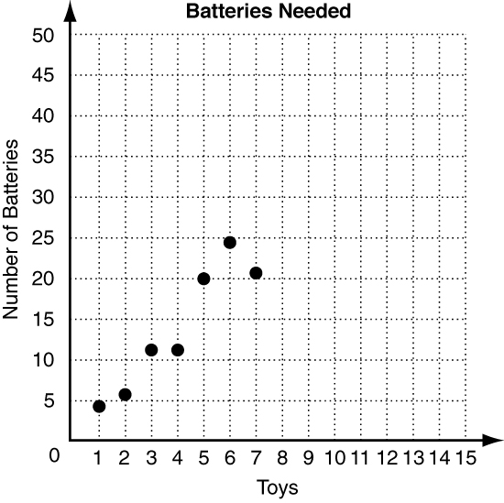
6. The scatter plot at right shows a relationship between the
number of batteries needed and the number of toys.
Predict how many batteries will be needed for 11 toys.
___________________________

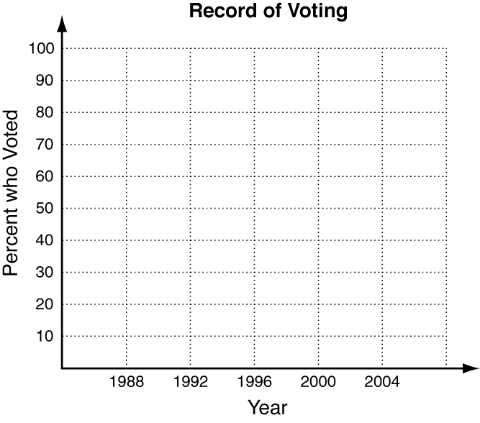
Graph a scatter plot using the given data.
7. The table shows the percent of people ages 18–24
who reported they voted in the presidential elections.
Graph a scatter plot using the given data.
Year | 1988 | 1992 | 1996 | 2000 | 2004
% of 18-24 year olds | 36 | 43 | 32 | 32 | 42
Write positive, negative, or none to describe the correlation
illustrated by each scatter plot.
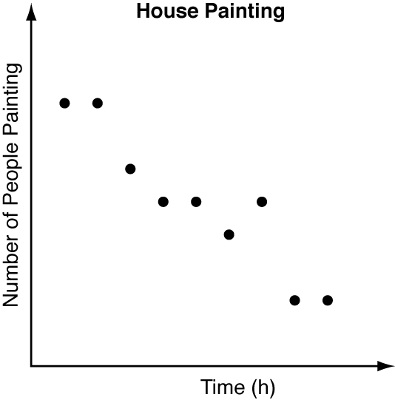
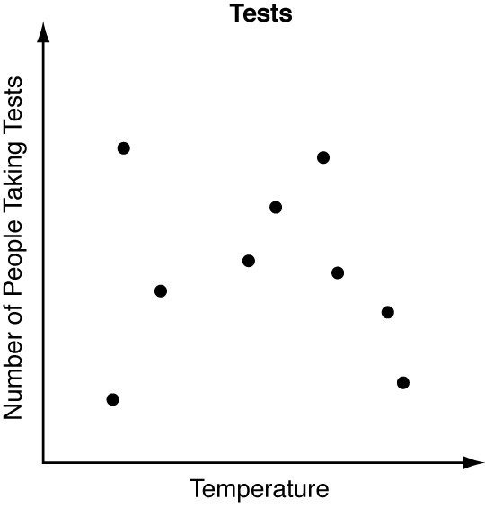
8. 9.

10. Identify the correlation you would expect to see between the number of pets a person has and the number of times they go to a pet store. Explain.

Neal kept track of the number of minutes it took him to assemble sandwiches at his restaurant. The information is in the table below.
Number of sandwiches | 1 | 2 | 4 | 6 | 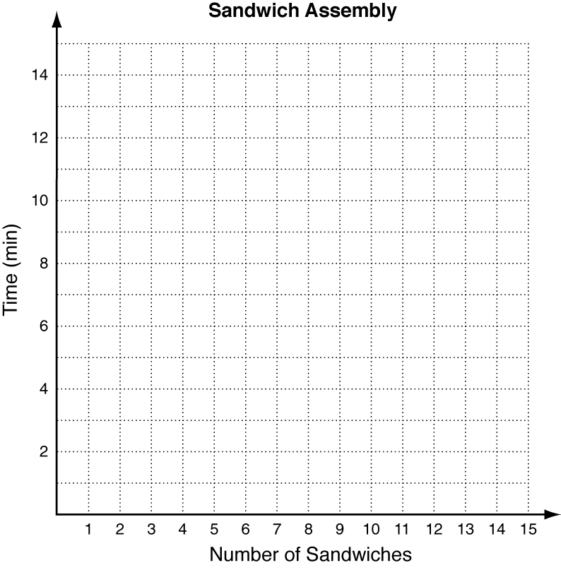  7
Minutes | 3 | 4 | 5 | 6 | 7
11. Graph a scatter plot of the data.
12. Draw a trend line.
13. Describe the correlation.

14. Based on the trend line you drew, predict the amount
of time it will take Neal to assemble 12 sandwiches.

