Scatter Plots and Trend Lines
Correlation is one way to describe the relationship between two sets of data.
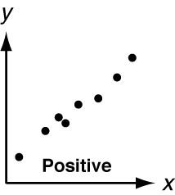
Positive Correlation
Data: As one set increases, the other set increases.
Graph: The graph goes up from left to right.

Negative Correlation
Data: As one set increases, the other set decreases.
Graph: The graph goes down from left to right.

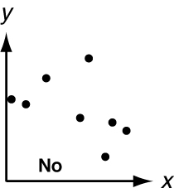
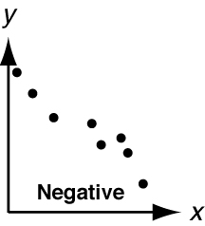
No Correlation
Data: There is no relationship between the sets.
Graph: The graph has no pattern.

Identify the correlation you would expect to see between the number
of grams of fat and the number of calories in different kinds of pizzas.
When you increase the amount of fat in a food, you also increase calories.
So you would expect to see a positive correlation.
Identify the correlation you would expect to see between
each pair of data sets. Explain.
1. the number of knots tied in a rope and the length of the rope

2. the height of a woman and her score on an algebra test

Describe the correlation illustrated by each scatter plot.
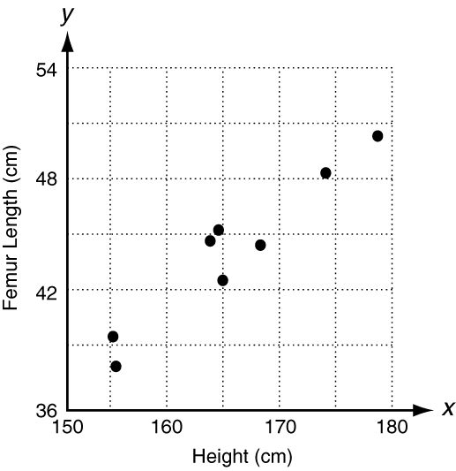
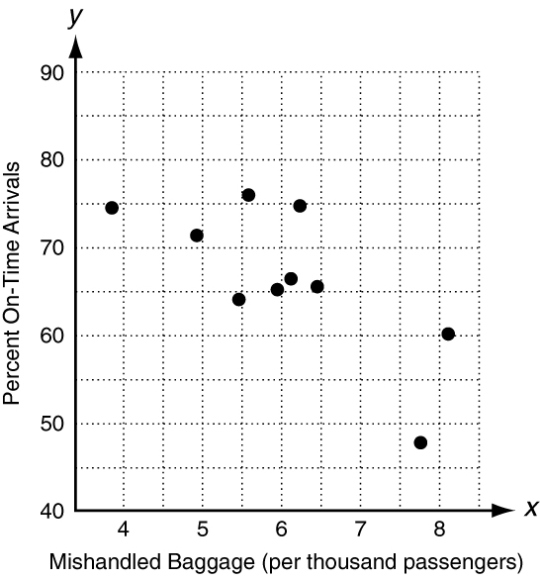
3. 4.

Scatter Plots and Trend Lines continued
By drawing a trend line over a graph of data, you can make predictions.
The scatter plot shows a relationship between a man’s height and
the length of his femur (thigh bone). Based on this relationship,
predict the length of a man’s femur if his height is 160 cm.
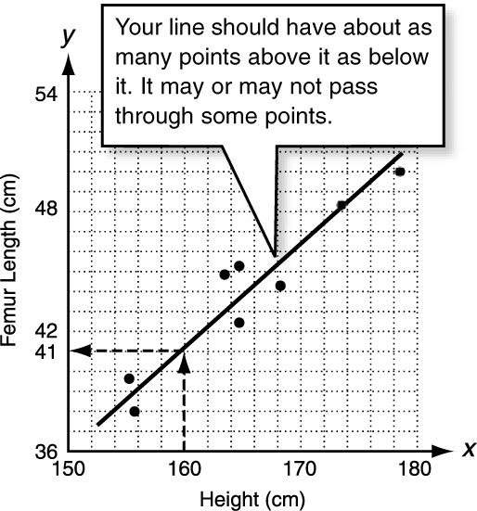
Step 1: Draw a trend line through the points.
Step 2: Go from 160 cm on the x-axis up to
the line.
Step 3: Go from the line left to the y-axis.
The point (160, 41) is on the line.

Femur
Height
A man that is 160 cm tall would have a
femur about 41 cm long.
To find an x-value, go right from the y-value,
and then down to the x-value. So, a man with a
42 cm femur would be about 162 cm tall.
The scatter plot shows a relationship between
engine size and city fuel economy for ten automobiles.
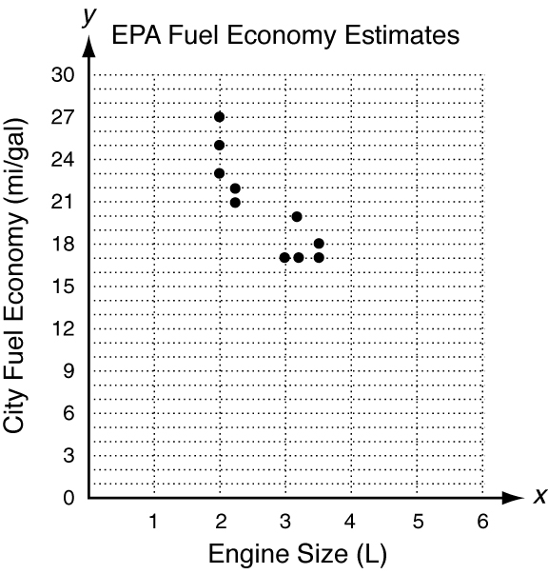
5. Draw a trend line on the graph.
6. Based on the relationship, predict
a. the city fuel economy of an automobile
with an engine size of 5 L.
_____________________________________
b. the city fuel economy of an automobile
with an engine size of 2.8 L.
_____________________________________
c. the engine size of an automobile
with a city fuel economy of 11 mi/gal.
_____________________________________
d. the engine size of an automobile
with a city fuel economy of 28 mi/gal.
_____________________________________

