`sd
Line of Best Fit
Standard: SWABAT Interpret the slope and the intercept of a linear model in the context of the data (MCC912.S.ID.7)

Name: ___________________________________ Mr. Murphey’s Coordinate Algebra Support
Date: 11/14/2013 Block: 1 4



Inbox Task – Identify the slope and the y-intercept.

- $y =-2x + 1$
- $y = \frac{2}{3} x - 4$

Identify the correlation (positive, negative, or none) that you would expect to see between each pair of data sets.

3. a person’s height and shoe size
4. the age of a car and its value

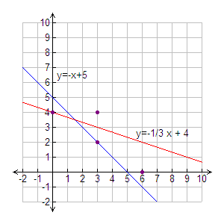
Line of Best Fit
x | 0 | 3 | 3 | 6
y | 4 | 2 | 4 | 0
1. The data in the table are graphed at the right along with two lines of fit.

a. Find the sum of the squares of the residuals for
y = −x + 5.___________________________
b. Find the sum of the squares of the residuals for ___________________________
c. Which line is a better fit for the data? ___________________________
2. Use the data in the table to answer the questions that follow.
x | 2 | 4 | 5 | 7 | 10
y | 4.3 | 4.8 | 5.1 | 5.75 | 6.4

a. Find an equation for a line of best fit. ___________________________
b. What is the correlation coefficient? ___________________________
c. How well does the line represent the data? ___________________________
d. Describe the correlation. ___________________________
3. Use the data in the table to answer the questions that follow.
x | 10 | 8 | 6 | 4 | 2
y | 3 | 3.2 | 3.5 | 3.8 | 4

a. Find an equation for a line of best fit. ___________________________
b. What is the correlation coefficient? ___________________________
c. How well does the line represent the data? ___________________________
d. Describe the correlation. ___________________________
4. The table shows the average number of hours of sleep per night that four students had during the week versus their grades on a test. The equation of the line of best fit is y ≈ 4.04x + 52.70, and r ≈ 0.97. Discuss correlation and causation for the data set.
Hours Slept | 6 | 6.5 | 7.2 | 8.1
Test Score | 76 | 80 | 82 | 85

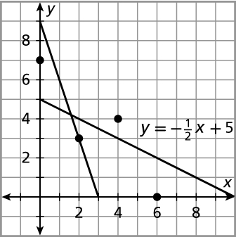
5. The data in the table are graphed at right along with two lines of fit.
x | 0 | 2 | 4 | 6
y | 7 | 3 | 4 | 0

a. Find the sum of the squares of the residuals for
y = −3x + 9.___________________________
b. Find the sum of the squares of the residuals for ___________________________
c. Which line is a better fit for the data? ___________________________
6. Use the data in the table to answer the questions that follow.
x | 5 | 6 | 6.5 | 7.5 | 9
y | 0 | −1 | 3 | −2 | 4

a. Find an equation for a line of best fit. ___________________________
b. What is the correlation coefficient? ___________________________
c. How well does the line represent the data? ___________________________
d. Describe the correlation. ___________________________
7. Use the data in the table to answer the questions that follow.
x | 10 | 8 | 6 | 4 | 2
y | 1 | 1.1 | 1.2 | 1.3 | 1.5
a. Find an equation for a line of best fit. ___________________________
b. What is the correlation coefficient? ___________________________
c. How well does the line represent the data? ___________________________
d. Describe the correlation. ___________________________
8. The table shows the number of pickles four students ate during the week versus their grades on a test. The equation of the least-squares line is y ≈ 2.11x + 79.28, and r ≈ 0.97. Discuss correlation and causation for the data set.

Pickles Eaten | 0 | 2 | 5 | 10
Test Score | 77 | 85 | 92 | 99

