Line of Best Fit
x | 1 | 2 | 3 | 4
y | 8 | 5 | 5 | 2
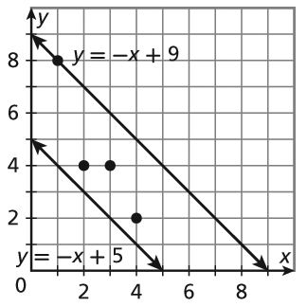
The data in the table are graphed along with two lines of fit. The line that is a better fit will have the lesser sum of the square of the residuals. A residual is the vertical distance between a data point and a line of fit.
Find the sum of the squares of the residuals for y = −x + 5.
Step 1 Use the equation to find the y-values when
x = 1, 2, 3, and 4.
x | −x + 5 = y
1 | −1 + 5 = 4
2 | −2 + 5 = 3
3 | −3 + 5 = 2
4 | −4 + 5 = 1

Step 2 Subtract each y-value in Step 1 from the corresponding
y-value in the original table to find the residuals.
8 − 4 = 4 5 − 3 = 2 5 − 2 = 3 2 − 1 = 1
Step 3 Add the squares of the residuals.
4² + 2² + 3² + 1² = 16 + 4 + 9 + 1 = 30
The sum of the squares of the residuals for y = −x + 5 is 30.
1. Find the sum of squares of the residuals for y = −x + 9.
a. Use the equation to find the y-values when x = 1, 2, 3, and 4.
x | 1 | 2 | 3 | 4
y
b. Subtract each y-value in Step 1 from the corresponding y-value in the original table to find the residuals.
8 − _____ = _____ 5 − _____ = _____ 5 − _____ = _____ 2 − _____ = _____
c. Add the squares of the residuals.
_____² + _____² + _____² + _____² = _____ + _____ + _____ + _____ = _____
The line for which the sum of the squares of the residuals is lesser is the better fit for the data.
2. _________________ is the better fit.

x | 1 | 3 | 3.5 | 5
y | 0 | 2 | 3 | 5
Use a graphing calculator to find the line of best fit and the correlation coefficient for the data at right.
Step 1 Press [STAT].
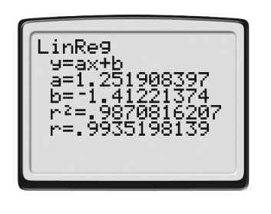
Step 2 Press 1 to select 1:Edit….
Step 3 Enter the x-values into list L1.
Step 4 Enter the y-values into list L2.
Step 5 Press [STAT].
Step 6 Use [right arrow key] to select CALC.
Step 7 Press 4 to select 4:LinReg(ax+b).
Step 8 Press ENTER.
Substitute the calculator’s values for a and b into y = ax + b to get the
equation for the line of best fit.
The equation of the line of best fit is y ≈ 1.25x − 1.41.
The correlation coefficient is r. When r is close to 1 or −1, there is a
very strong correlation. The closer r is to 0, the weaker the correlation.
For this example, r ≈ 0.99, so there is a strong positive correlation.
3. The table below shows the number of times four students run during the week versus how long it takes, in minutes, for each student to run one mile. Use your calculator to find the equation for the line of best fit. What is the correlation coefficient? Describe the correlation.

Number of times student runs per week | 0 | 2 | 4 | 5
Time to run one mile (min) | 14 | 8 | 7 | 6

a ≈ _________________

b ≈ _________________

The equation of the line of best fit is y ≈ _________________x + _________________.
r ≈ _________________, so there is a _________________ _________________ correlation.

