`sd
Review of Unit 4
Standard: SWABAT Interpret the slope and the intercept of a linear model in the context of the data (MCC912.S.ID.7)

Name: ___________________________________ Mr. Murphey’s Coordinate Algebra Support
Date: 11/15/2013 Block: 1 4



Inbox Task – Find the mean, median, mode, and range of each data set.

- 95, 92, 96, 93, 94, 95, 93

2. Use the data to make a box-and-whisker plot.
71, 79, 56, 24, 35, 37, 81, 63, 75

Unit 4 Review
1. The table shows the number of fish in
a small pond over four years. Draw a scatter plot and trend line.
Year | ’02 | ’03 | ’04 | ’05
Number of Fish | 32 | 37 | 41 | 50
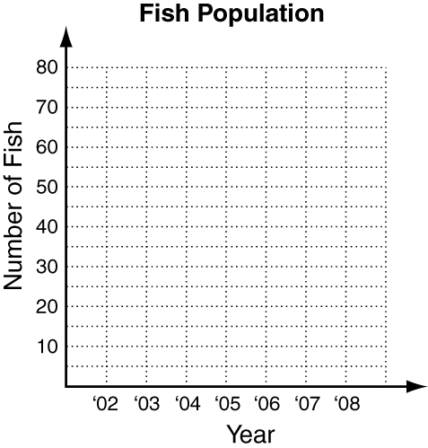
Based on the trend line, predict how many fish will be in the pond in 2007.

2. An artisan crochets blankets
for a craft fair. The table shows
the relationship between how many
hours the artisan spent on a blanket
and the price charged for the blanket.
Hours | 8 | 24 | 16 | 8 | 20
Price  (dollars) | 80 | 200 | 120 | 65 | 180
Find an equation for a line of best fit.

3. The table shows the number of employees in a company over five years. Draw a scatter plot and trend line.
Year | ’01 | ’02 | ’03 | ’04 | ’05
Employees | 15 | 20 | 23 | 30 | 34
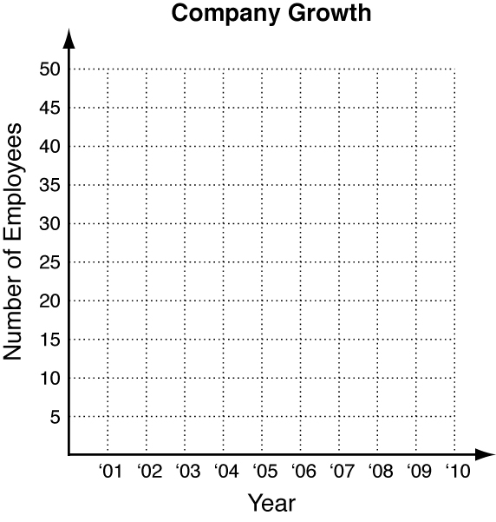
Based on the trend line, predict how many employees the company will have in 2008.

4. An artisan builds birdhouses
out of pine for a craft fair. The
table shows the relationship between
the number of hours the artisan
spends on a birdhouse, and how
much she charges for it.
Hours | 2 | 2 | 6 | 4 | 8
Price  (dollars) | 35 | 45 | 70 | 65 | 75
Find an equation for a line of best fit.

5. Use this bar graph to identify how many more candies are green than yellow.
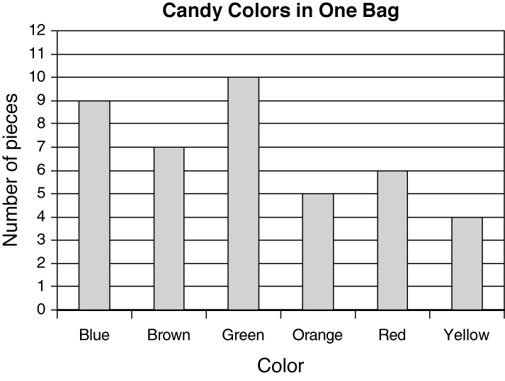

The low temperatures for Nashville, TN, for October 1–15, 2005, are given below. Use this data for questions 6–9.
Low Temperatures (ºF)
56 66 67 63 64 60 52 52
54 56 58 54 55 55 49
6. Complete this frequency table.
Temperature (ºF) | Frequency
45–49
50–54
55–59
60–64
65–69
7. Use your frequency table in question 6
to make a histogram.

8. Find the mean, median, and mode.
mean: _________________
median: ________________
mode: _________________
9. Use the data to make a box-and-
whisker plot.

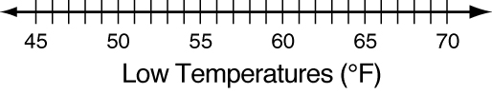
10. Men and Women at a shoe store were
polled to see if they prefer comfort
or fashion. The results of the poll
are shown in the two-way table.
 | Comfort | Fashion
Men | 20 | 3
Women | 13 | 24
How many people were polled?

11. Use the two-way table from Question 17.
How many people prefer fashion?

12. Make a marginal and relative frequency table
 | Comfort | Fashion | Total
Men | 20 | 3
Women | 13 | 24
Total
13. Given that the person is a man what is the probability that they prefer comfort?

14. Use the two-way table from Question 17.
Did more people prefer comfort or
fashion?

