Linear Equation Review
Standard: SWABAT create equations and inequalities in one variable and use them to solve problems. Include linear. (MCC912.A.CED.1)

Name: ___________________________________ Mr. Murphey’s Coordinate Algebra
Date: 4/24/2014 Block: 1 4



Inbox Task – Complete #1-5 on the board on pg. 176 YOU MUST SHOW WORK
Using Intercepts
Use intercepts to graph the line described by each equation.
1. 3x + 2y = −6 2. x − 4y = 4
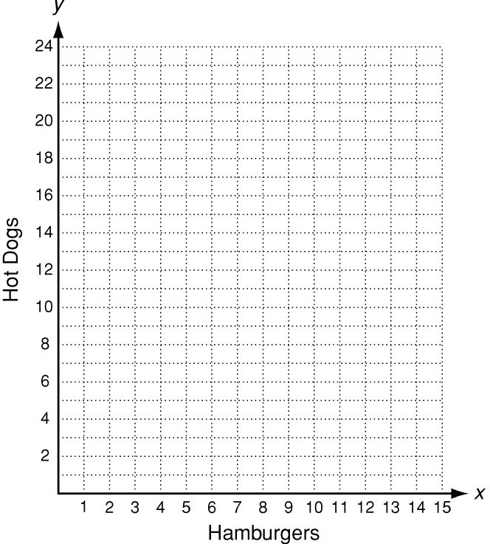
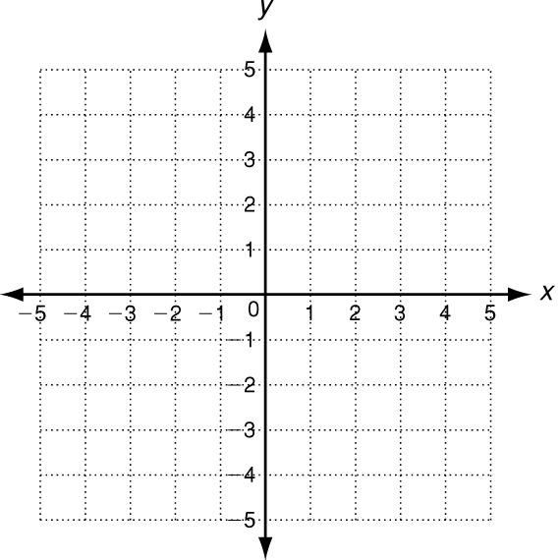
3. At a fair, hamburgers sell for $3.00 each and hot dogs sell for
$1.50 each. The equation 3x + 1.5y = 30 describes the number
of hamburgers and hot dogs a family can buy with $30.
a. Find the intercepts and graph the function.

b. What does each intercept represent?

Write the correct answer.

4. Naima has $40 to spend on refreshments for herself and her friends at the movie theater. The equation 5x + 2y = 40 describes the number of large popcorns x and small drinks y she can buy.
Graph this function and find its intercepts.

_______________________________________
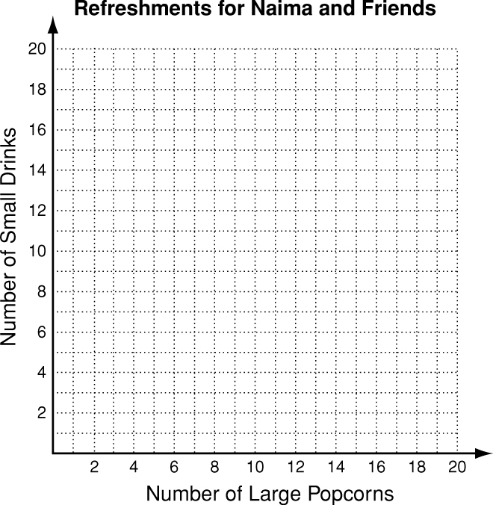
5. Turner is reading a 400-page book. He reads 4 pages every 5 minutes.The number of pages Turner has left to read after x minutes is represented by the function f( x) = 400 − $\frac{4}{5}x$ Graph this function and find its intercepts.
_______________________________________
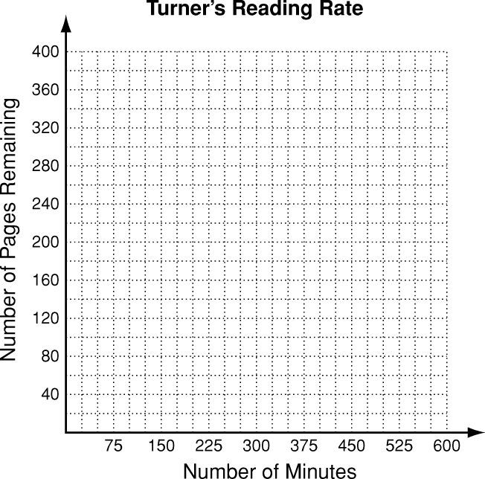

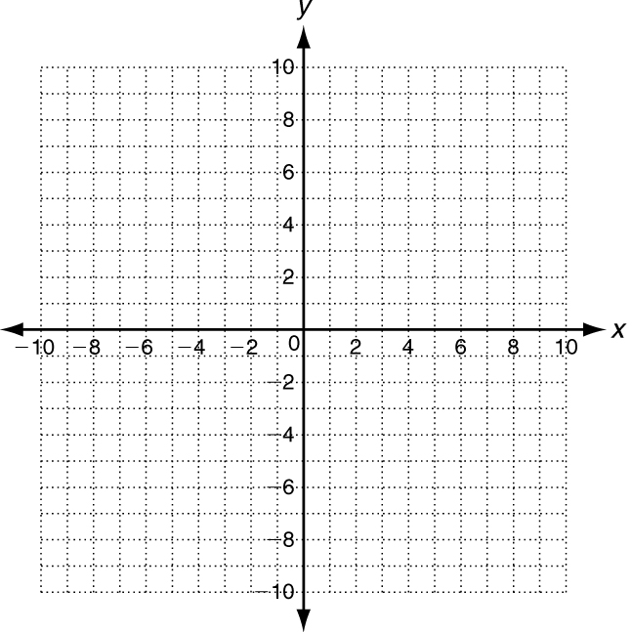
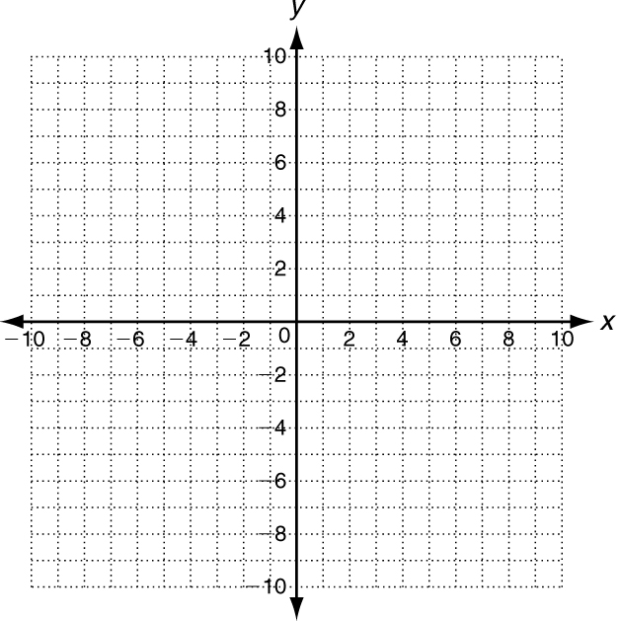
6. 7.

Solution: _________________ Solution: _________________

8.Solve using any method To sell an item in an online auction, WebAuctions charges a$5 listing fee plus 10% of the final selling price. AuctionsOnline charges a $3 listing fee plus 15% of the final selling price. For what final selling price do both companies charge the same
amount? What will that amount be? ____________________________________________________

Solve for the indicated variable.
9. 4c = d for c 10. n − 6m = 8 for n 11. 2p + 5r = q for p

12. −10 = xy + z for x 13. = c for b 14. = k for j

Answer each of the following.
15. The formula c = 5p + 215 relates c, the total cost
in dollars of hosting a birthday party at a skating
rink, to p, the number of people attending.
a. Solve the formula c = 5p + 215 for p.
b. If Allie’s parents are willing to spend $300 for
a party, how many people can attend?
16. The formula for the area of a triangle is A = bh,
where b represents the length of the base and h
represents the height.
a. Solve the formula A = bh for b.
b. If a triangle has an area of 192 mm², and the
height measures 12 mm, what is the measure
of the base?

