Linear Equation Review
Standard: SWABAT create equations and inequalities in one variable and use them to solve problems. Include linear. (MCC912.A.CED.1)

Name: ___________________________________ Mr. Murphey’s Coordinate Algebra
Date: 4/25/2014 Block: 1 4



Inbox Task – Complete #1-5 on the board on pg. 176 YOU MUST SHOW WORK

Solving Systems of Linear Inequalities
Graph the system of linear inequalities. a. Give two ordered pairs that are solutions and two that aren’t
1. 2. 3.
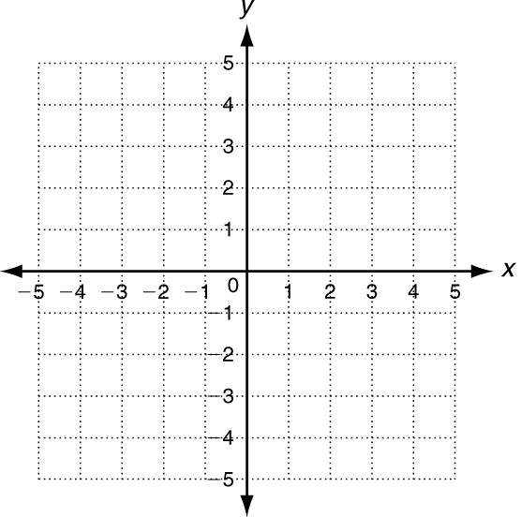

a. _________________ a. _________________ a. _________________
b. _________________ b. _________________ b. _________________

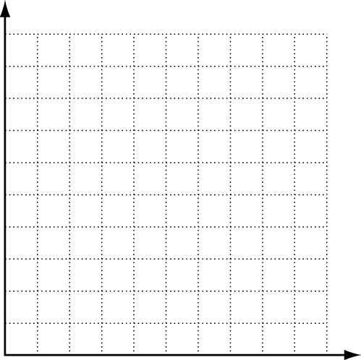
4. Dennis works at a frozen yogurt store in the summer. He
needs to order boxes of small cups and boxes of large cups.
The storage room can hold up to 10 more boxes of cups.
Each box of small cups costs $100 and each box of large
cups costs $150. A maximum of $1200 is budgeted for cups.
a. Write a system of linear equations.

b. Graph the solutions of the system.
c. Describe all the possible combinations of boxes of cups that Dennis can order.
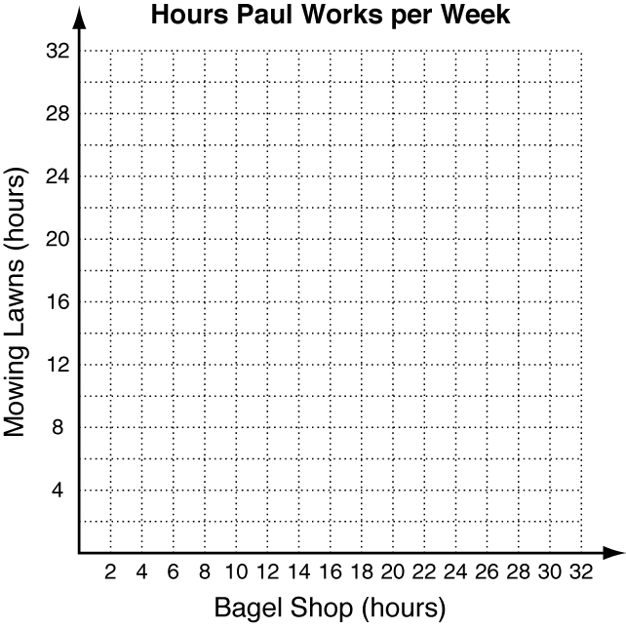
d. List two possible combinations. ______________________________________________________
______________________________________________________
Write the correct answer.
- Paul earns $7 per hour at the bagel shop and $12 per hour mowing lawns.
Paul needs to earn at least $120 per week, but he must work less than 30
hours per week. Write and graph the system of linear inequalities that
describes this situation.

Solving Systems by Elimination Write the correct answer.

6. The Lees spent $31 on movie tickets for 2 adults and 3 children. The Macias spent $26 on movie tickets for 2 adults and 2 children. What are the prices for adult and child movie tickets?

7. Last month Stephanie spent $57 on 4 allergy shots and 1 office visit. This month she spent $9 after 1 office visit and a refund for 2 allergy shots from her insurance company. How much does an office visit cost? an allergy shot?

Use the chart below to answer questions 8–9. Select the best answer. The chart shows the price per pound for dried fruit.
Dried Fruit Price List
Pineapple | Apple | Mango | Papaya
$7.50/lb | $7.00/lb | $8.00/lb | $7.25/lb

8. A customer bought 5 pounds of mango and papaya for $37.75. How many pounds of each fruit did the customer buy?
A 2 lbs mango and 3 lbs papaya
B 3 lbs mango and 2 lbs papaya
C 1 lb mango and 4 lbs papaya
D 4 lbs mango and 1 lb papaya

9. A store employee made two gift baskets of dried fruit, each costing $100. The first basket had 12 pounds of fruit x and 2 pounds of fruit y. The second basket had 4 pounds of fruit x and 9 pounds of fruit y. Which two fruits did the employee use in the baskets?
F pineapple and apple
G apple and mango
H mango and papaya
J papaya and pineapple

Comparing Functions

10. George and Julie each deposit money into their savings accounts monthly. Compare the accounts by finding slopes and y-intercepts.
George's Account
Month | 0 | 1 | 2 | 3
Balance ($) | 125 | 175 | 225 | 275

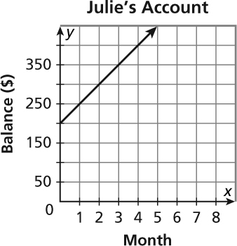

11. Miguel tracked the weekly spread of two strains of flu virus. His data are shown below. Compare the number of cases of flu by finding and interpreting average rates of change from week 0 to week 4.
Strain 1
Week | 0 | 1 | 2 | 3 | 4 | 5
Cases | 15 | 25 | 40 | 60 | 85 | 115
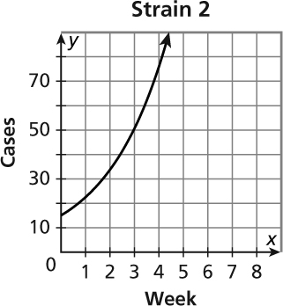

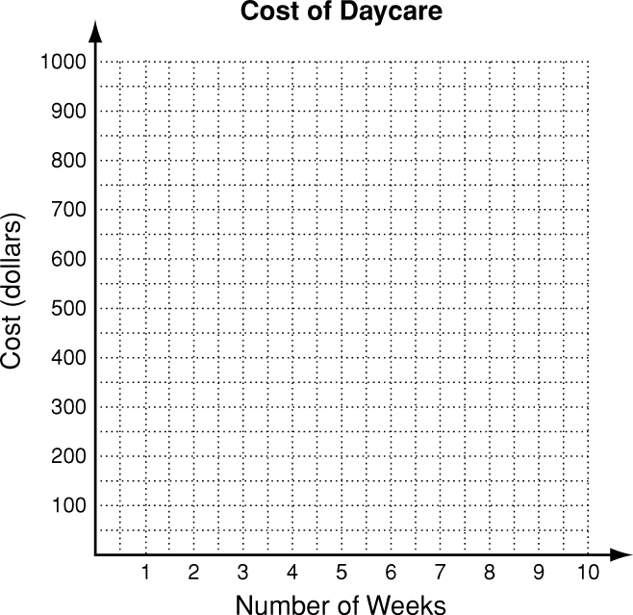
Identifying Linear Functions Write the correct answer.
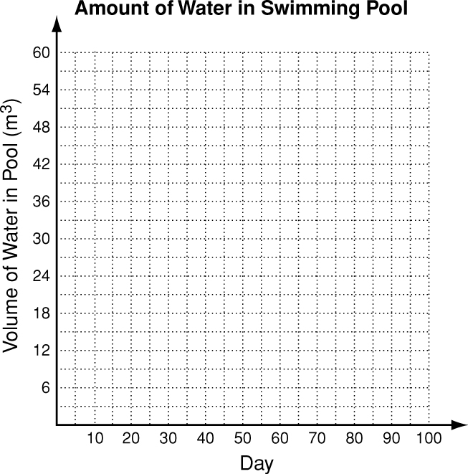
12. A daycare center charges a $75 enrollment fee
plus $100 per week. What is the function gives the
cost of daycare f(x) for x weeks. Graph this
function and give its domain and range.

13. A family swimming pool holds 60 m³ of water.
The function f(x) = 60 − 0.18x gives the cubic
meters of water in the pool, taking into account
water lost to evaporation over x days. Graph this
function and give its domain and range.

