`sd
Reflections
Standard: SWABAT given a figure and a rotation, reflection, or translation, draw the transformed figure (MCC912.G.CO.4)

Name: ___________________________________ Mr. Murphey’s Coordinate Algebra
Date: 11/20/2013 Block: 2



Inbox Task – Given that ∆ABC ≅ ∆DEF, identify a segment or angle congruent to each of the following..

- 
- 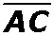
- 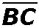

Reflections
Fill in the blanks to complete each definition.
1. A reflection is a transformation across a line, called the line of reflection, so that
the line of reflection is the ______________________ of each segment joining
each point and its image.
2. An ______________________ is a transformation that does not change the shape or size of a figure.

Tell whether each transformation appears to be a reflection.
3. 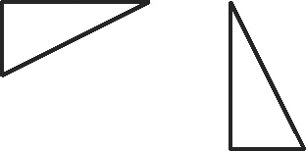 _________ 4. 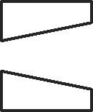 _________
5. 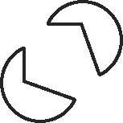 _________ 6. 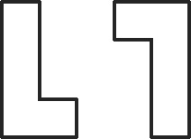 _________
Draw the reflection of each figure across the line. To do this, draw a dashed segment from each vertex perpendicular to the line. Use a ruler to make the dashed segments on either side of the line equal.
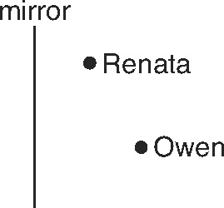
7. 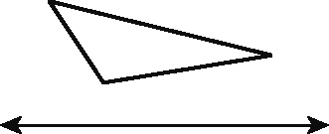 8. 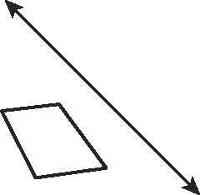
9. Renata and Owen stand in front of a mirror at the positions shown in the figure. Owen looks into the mirror so he can see Renata in the mirror. Plot the reflection of Renata’s position and label it R′. Label with an X the point on the mirror where Owen should look in order to see Renata.

Reflect the figure with the given vertices across the given line. Plot and label the vertices of the image one at a time. Remember that for reflections across the x-axis, (x, y) → (x, −y), and for reflections across the y-axis, (x, y) → (−x, y).
10. A(−2, 2), B(3, 3), C(2, 1); x-axis 11. P(2, 3), Q(4, 0), R(1, −4), S(0, −2); y-axis
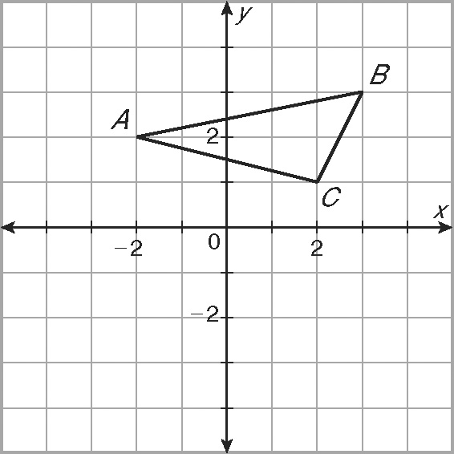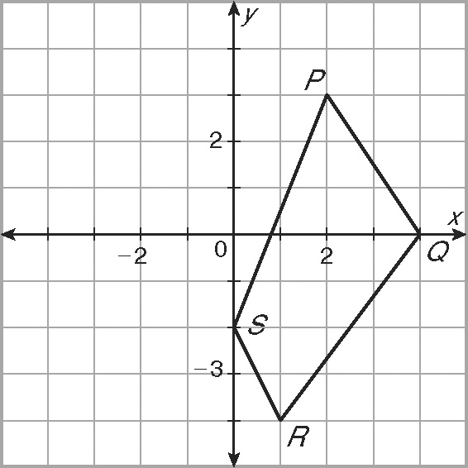
Tell whether each transformation appears to be a reflection.
1. 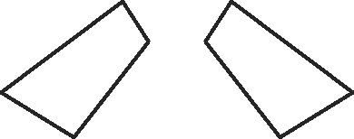 _________ 2. 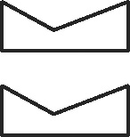 _________

3. 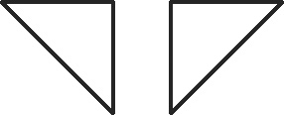 _________ 4. 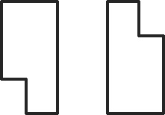 _________

Draw the reflection of each figure across the line.
5. 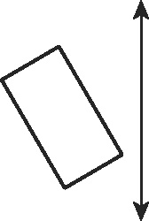 6. 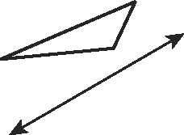
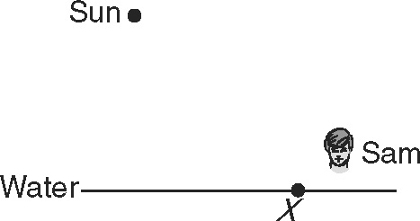
7. Sam is about to dive into a still pool, but some sunlight is
reflected off the surface of the water into his eyes. On the
figure, plot the exact point on the water’s surface where the
sunlight is reflected at Sam.

Reflect the figure with the given vertices across the given line.
8. A(4, 4), B(3, −1), C(1, −2); y-axis 9. D(−4, −1), E(−2, 3), F(−1, 1); y = x
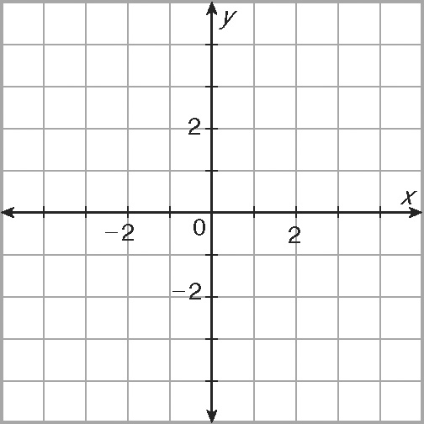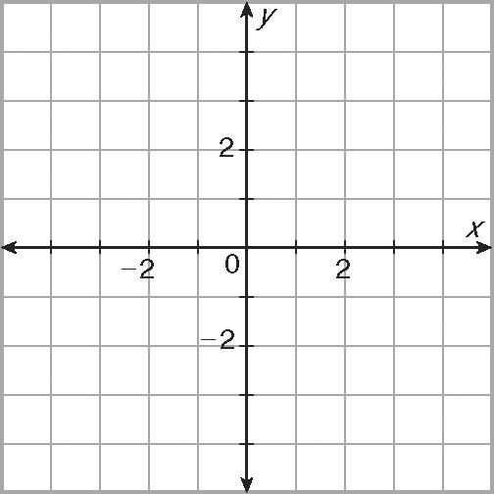

10. P(1, 3), Q(−2, 3), R(−2, 1), S(1, 0); 11. J(3, −4), K(1, −1), L(−1, −1),
x-axis M(−2, −4); y = x
