`sd
Translations
Standard: SWABAT given a figure and a rotation, reflection, or translation, draw the transformed figure (MCC912.G.CO.4)

Name: ___________________________________ Mr. Murphey’s Coordinate Algebra Support
Date: 11/21/2013 Block: 1 4



Inbox Task –Find the coordinates of the image of ∆ABC with vertices A(3, 4), B(–1, 4),and C(5, –2), after each reflection.

- across the x-axis

- across the y-axis
- across the line y = x

Translations
Fill in the blanks to complete the definition.
1. A translation is a transformation along a vector such that each segment joining a point and its image has the same _____________________ as the vector and is _____________________ to the vector.
Tell whether each transformation appears to be a translation.
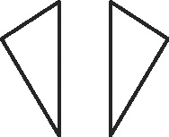

2. ________ 3. ________

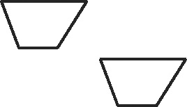

4. ________ 5. ________

Draw the translation of each figure along the given vector. To do this, draw a dashed line from each vertex parallel to the given vector. Use a ruler to measure the vector’s length. Plot the new vertices that same length along the parallels.
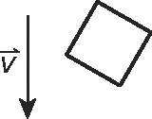
6. 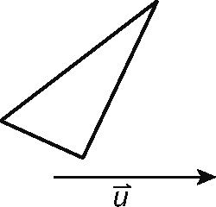 7.

Translate the figure with the given vertices along the given vector. For each vertex, find the new coordinates by adding the horizontal and vertical components of the vector to the old coordinates.
8. D(2, 4), E(4, 1), F(4, −2); ⟨−2, −2⟩ 9. J(−3, −1), K(−2, −3), L(1, −3), M(2, −1); ⟨1, 4⟩

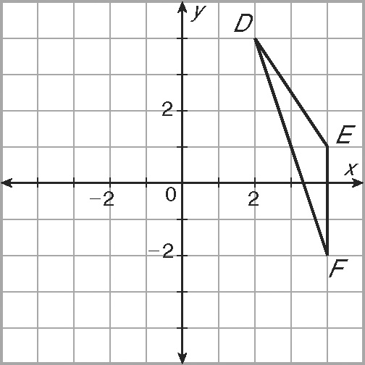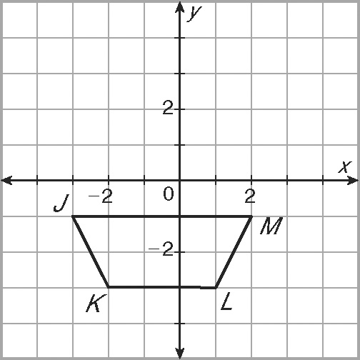
10. Leigh and Derek are tossing a flying disc. Leigh stands at (2, 5) and throws the
disc to Derek at (11, 0). Find the translation vector from Leigh to Derek.

Tell whether each transformation appears to be a translation.
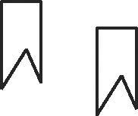
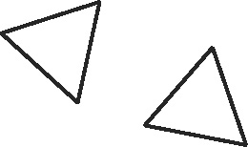
1. _________ 2. _________

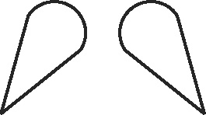
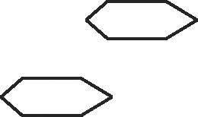
3. _________ 4. _________

Draw the translation of each figure along the given vector.
5. 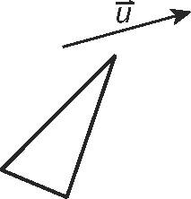 6. 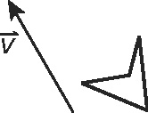

Translate the figure with the given vertices along the given vector.
7. A(−1, 3), B(1, 1), C(4, 4); ⟨0, −5⟩ 8. P(−1, 2), Q(0, 3), R(1, 2), S(0, 1); ⟨1, 0⟩
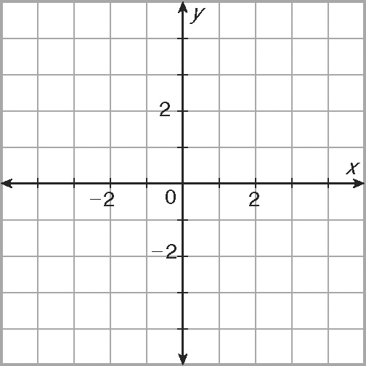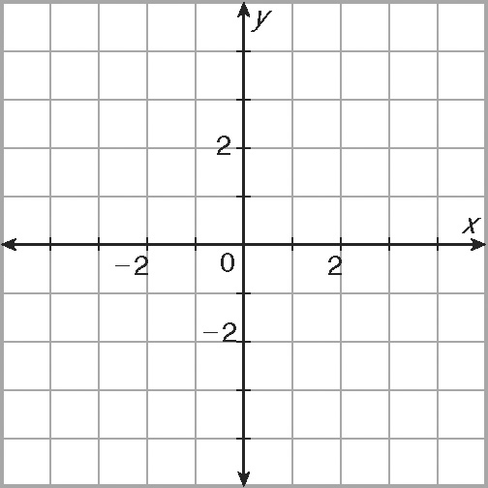

9. L(3, 2), M(1, −3), N(−2, −2); ⟨−2, 3⟩ 10. D(2, −2), E(2, −4), F(1, −4),
G(−2, −2); ⟨2, 5⟩
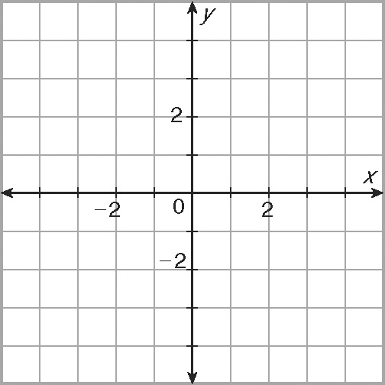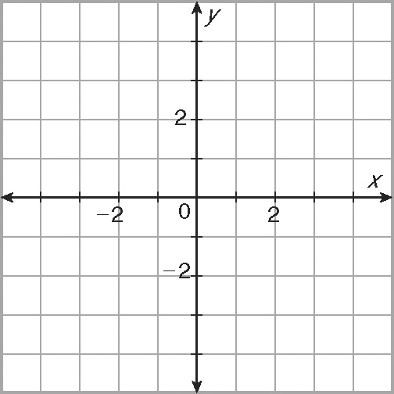

11. A builder is trying to level out some ground with a front-end loader. He picks up some
excess dirt at (9, 16) and then maneuvers through the job site along the vectors
⟨−6, 0⟩, ⟨2, 5⟩, and ⟨8, 10⟩ to get to the spot to unload the dirt. Find the coordinates
of the unloading point. Find a single vector from the loading point to the unloading point.

