Problem Solving
Standard: SWABAT create equations and inequalities in one variable and use them to solve problems. Include linear. (MCC912.A.CED.1)

Name: ___________________________________ Mr. Murphey’s Coordinate Algebra
Date: 4/29/2014 Block: 1 4



Inbox Task – Complete #13-16 On Unit 3 of Review Packet

Problem Solving
Write the correct answer.

1. The table shows the cost per pound of Granny Smith apples.
Weight (lb) | 1 | 2 | 3 | 4
Cost ($) | 1.49 | 2.98 | 4.47 | 5.96
Describe the rate(s) of change shown by the data.

3. The table shows the distance of a courier from her destination.
Time (p.m.) | 2:15 | 2:30 | 2:45 | 3:00
Distance (mi) | 5.4 | 5.4 | 5.0 | 0.5
What is the rate of change from
2:15 p.m. to 2:30 p.m.? What does
this rate of change mean?

2. The table shows Gabe’s height on his birthday for five years. Find the rate
of change during each time interval.
Age | 9 | 11 | 12 | 13 | 15
Height (in.) | 58 | 59.5 | 61.5 | 65 | 69

When did the greatest rate of change occur? ________________________
When was the rate of change the least?

During which two time periods were
the rates of change the same?

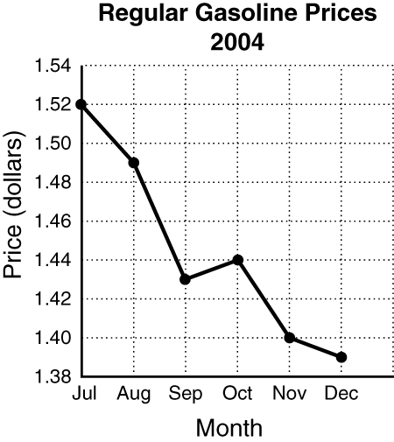
The graph below tracks regular gasoline prices from July 2004 to December 2004. Use the graph to answer questions 5–7. Select the best answer.

4. What is the slope of the line from November to December?
A −4 C −0.04
B −1 D −0.01
5. During which time interval did the cost decrease at the greatest rate?
F Jul to Aug H Sep to Oct
G Aug to Sep J Oct to Nov
6. During which time interval was the slope positive?
A Jul to Aug C Sep to Oct
B Aug to Sep D Oct to Nov
7. What was the rate of change from October to December?
F −0.05 H 0.025
G −0.025 J 0.05

8. Gerry collected data and made a table of marginal relative frequencies on the number of students who participate in chorus and the number who participate in band.
Chorus
 |  | Yes | No | Total
Band | Yes | 0.38 | 0.29 | 0.67
Band | No | 0.09 | 0.24 | 0.33
Band | Total | 0.47 | 0.53 | 1.0
- If you are given that a student is in chorus, what is the probability that the student also is in band? Round your answer to the nearest hundredth.

b. If you are given that a student is not in band, what is the probability that the student is in chorus? Round your answer to the nearest hundredth.

Select the best answer.

9. What is the probability if a student is not in chorus, then that student is in band?
A 0.29 B 0.38
C 0.43 D 0.55

Write the correct answer.
1. The table shows the height of a
baseball for different times after it was thrown. Graph the data. Which kind of model best describes the data?
Height of Baseball
Time (s) | 0 | 1 | 2 | 3 | 4
Height (ft) | 5 | 53 | 69 | 53 | 5

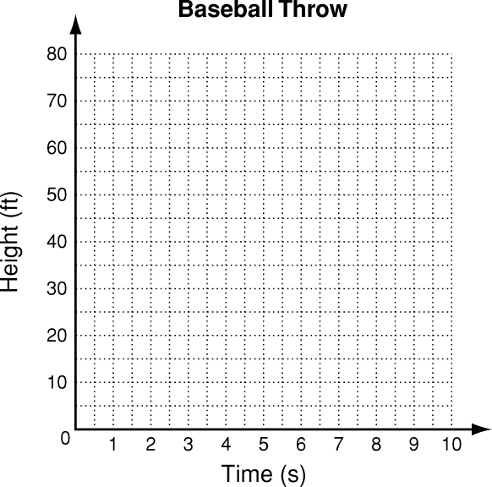

2. The table shows the cost of peaches. Look for a pattern and determine which kind of model best describes the data. Then write a function that models the data.
Cost of Peaches
Pounds | 1 | 2 | 3 | 4
Cost ($) | 1.29 | 2.58 | 3.87 | 5.16

_____________________________________
_____________________________________ _____________________________________ 3. The table shows the number of computers in a school for four years.
3. The table shows the number of computers in a school for four years.
Number of Computers
Year | ’00 | ’01 | ’02 | ’03
Computers | 14 | 28 | 56 | 112

Write a function to model the data.
Then use the function to predict how many computers the school will have in 2006 if the pattern continues.
_____________________________________
The chart shows the ticket sales for movies on two different screens at one theater over four days. Select the best answer.
4. Which kind of model best describes the ticket sales for the movie on screen 1?
A linear C exponential
B quadratic D none of these
5. Which function describes the data for screen 1?
F y = 40x² H y = 400x
G y = 40x + 400 J y = 400(40)^{x}
6. Which kind of model best describes the ticket sales for the movie on screen 2?
A linear C exponential
B quadratic D none of these
 | Screen1 | Screen 2
Day 1 | 400 | 3000
Day 2 | 440 | 2400
Day 3 | 480 | 1920
Day 4 | 520 | 1536

The table and graph below show functions used to model the population in millions of the United States. Use the table or graph to select the best answers for 3 and 4.
Year (2000 = 0) | Population (millions)
0 | 282
2 | 288
4 | 293
6 | 298
8 | 304
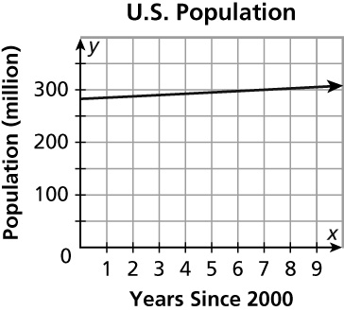

3. What is the rate of change in the table from the year 2000 to the year 2008?
A 1.75 million C 22 million
B 2.75 million D73.25 mil

