`sd
Symmetry
Standard: SWABAT Given a figure, describe the rotations and reflections that carry it onto itself (MCC912.G.CO.3)

Name: ___________________________________ Mr. Murphey’s Coordinate Algebra Support
Date: 12/3/2013 Block: 1 4

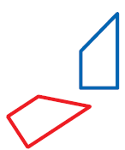
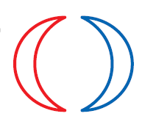

Inbox Task - Identify each transformation

Rotate ∆ABC with the given vertices by the given angle.

- A(3, –4), B(5, 1), C(–4, 0); 180°
- A(1, –5), B(7, –1), C(3, 6); 90°

Symmetry
Tell whether each figure has line symmetry. If so, draw all lines of symmetry.
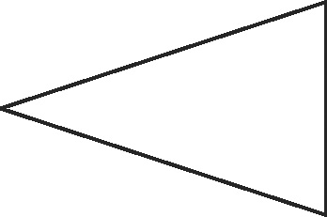
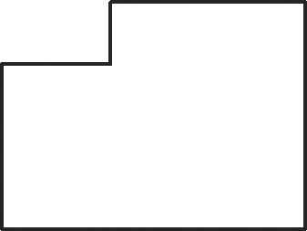
1. 2.
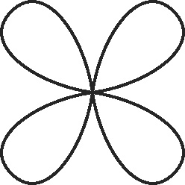
Tell whether each figure has rotational symmetry. If so, give the angle of rotational symmetry and the order of the symmetry.

3. 4.

Tell whether each figure has plane symmetry, symmetry about an axis, both, or neither.
5. square pyramid 6. prism
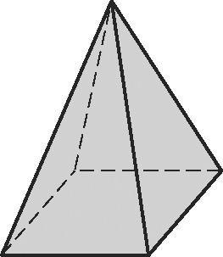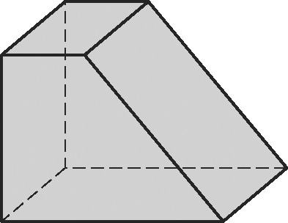
7. triangular pyramid 8. cylinder
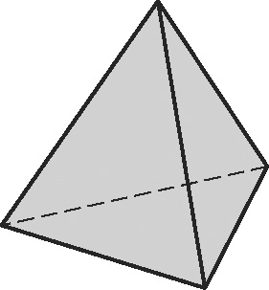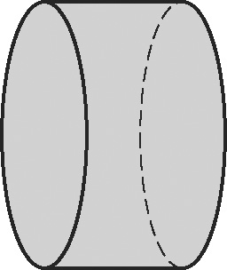
Fill in the blanks to complete each definition.
1. The number of times a figure coincides with itself as it rotates through 360° is
called the ______________________ of the rotational symmetry.
2. A three-dimensional figure has ______________________ if a plane can divide
the figure into two congruent reflected halves.
3. The ______________________ divides a figure into two congruent halves.
4. The angle of rotational symmetry is the ______________________ angle through
which a figure can be rotated to coincide with itself.
5. A three-dimensional figure has symmetry about an axis if there is a line about which
the figure can be rotated so that the image ______________________ with itself.

Tell whether each figure has line symmetry. If so, draw all lines of symmetry.
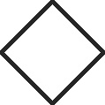
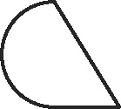
6. 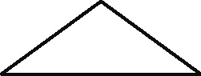 _________ 7. _________ 8. _________

Tell whether each figure has rotational symmetry. If so, give the angle of rotational symmetry and the order of the symmetry.
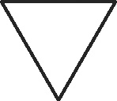
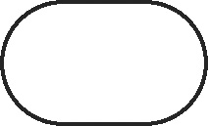
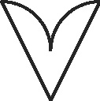
9. 10. 11.

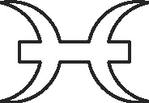
12. This figure shows the zodiac symbol for Pisces. Draw all lines of
symmetry. Give the angle and the order of any rotational symmetry.

Tell whether each figure has plane symmetry, symmetry about an axis, both, or neither.
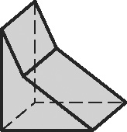
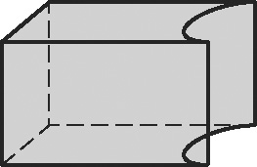
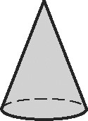
13. 14. 15.

Tell whether each figure has line symmetry. If so, draw all lines of symmetry.
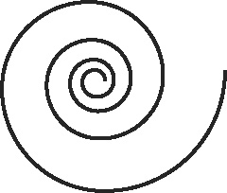
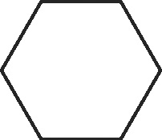
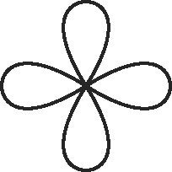
16. 17. 18.

19. Anna, Bob, and Otto write their names in capital letters. Draw all lines of symmetry for each whole name if possible.

Tell whether each figure has rotational symmetry. If so, give the angle of rotational symmetry and the order of the symmetry.
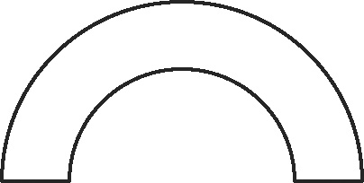
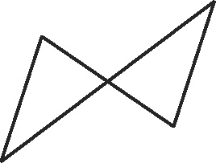
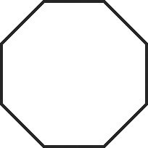
20. 21. 22.

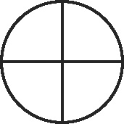
23. This figure shows the Roman symbol for Earth. Draw all lines
of symmetry. Give the angle and order of any rotational symmetry.

Tell whether each figure has plane symmetry, symmetry about an axis, both, or neither.
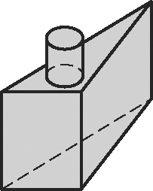
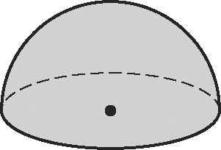
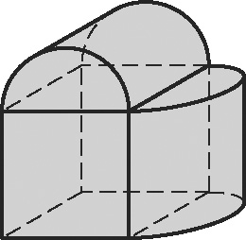
24. 25. 26.

