`sd
Tessellations
Standard: SWABAT Given a figure, describe the rotations and reflections that carry it onto itself (MCC912.G.CO.3)

Name: ___________________________________ Mr. Murphey’s Coordinate Algebra Support
Date: 12/4/2013 Block: 1 4


Inbox Task - Find the sum of the interior angle measures of each polygon.$180(n-2)$

- Quadrilateral
- Octagon

Rotate ∆ABC with the given vertices by the given angle.$\frac{180(n-2)}{n}$

- Square

- Pentagon
- Hexagon

- Octogon

Tessellations
Fill in the blanks to complete each definition.
1. A _____________________ is a repeating pattern that completely covers a
plane with no gaps or overlaps.
2. A regular tessellation is formed by congruent _____________________.
3. A pattern with _____________________ coincides with its image after
a glide reflection.
4. A _____________________ tessellation is formed by two or more different
regular polygons, with the same number of each polygon occurring in the same
order at every vertex.

Tell whether each pattern has translation symmetry, glide reflection symmetry,
or both.

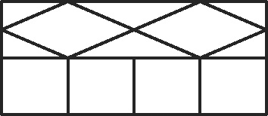
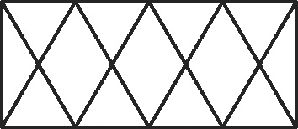
5. 6. 7.

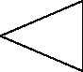
8. Trace the triangle on a blank sheet of paper and cut it out. Trace around
the cut-out triangle several times to create a tessellation on this page.

Classify each tessellation as regular, semiregular, or neither.


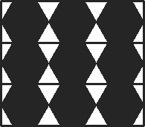
9. 10. 11.

Determine whether the given regular polygon(s) can be used to form a tessellation. Remember that the angles at any vertex have to be able to add up to 360° to
make a tessellation.
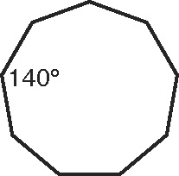
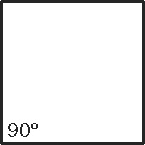
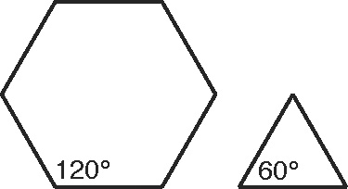
12. 13. 14.

Tell whether each pattern has translation symmetry, glide reflection symmetry, or both.
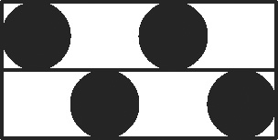

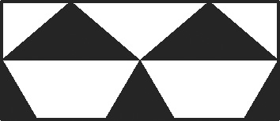
15. 16. 17.

Use the given figure to create a tessellation.
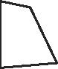
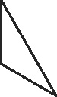
18. 19.
Classify each tessellation as regular, semiregular, or neither.
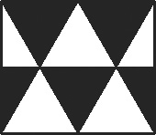
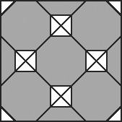
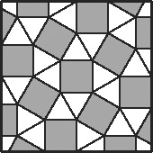
20. 21. 22.

Determine whether the given regular polygon(s) can be used to form a tessellation. If so, draw the tessellation.
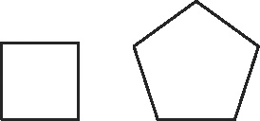
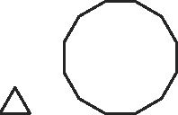
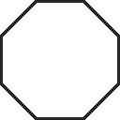
23. 24. 25.

