Tessellations
A pattern has translation symmetry if it can be translated along a vector so
that the image coincides with the preimage. A pattern with glide reflection
symmetry coincides with its image after a glide reflection.
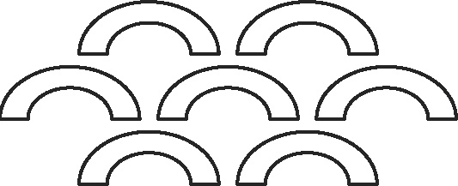
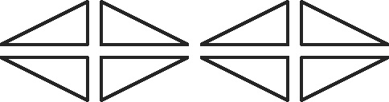

Translation Symmetry Translation Symmetry and
Glide Reflection Symmetry
A tessellation is a repeating pattern that completely covers a plane with
no gaps or overlaps.

Tessellation Not a Tessellation
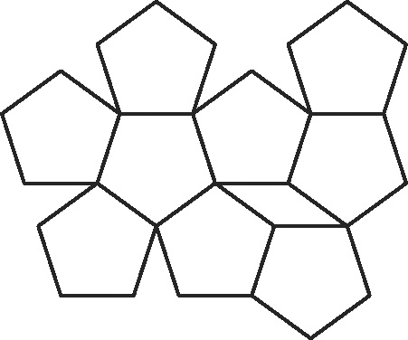
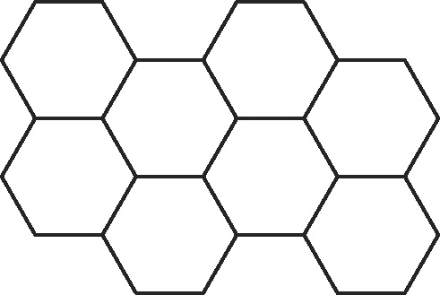

Identify the symmetry in each pattern.
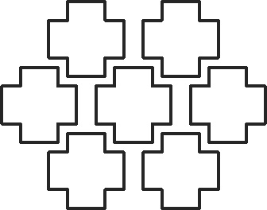
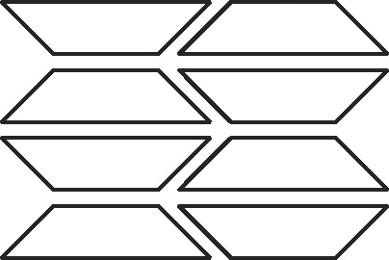
1. 2.

Copy the given figure and use it to create a tessellation.
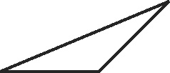
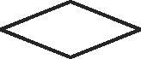
3. 4.
Tessellations continued
A regular tessellation is formed by congruent regular polygons. A semiregular
tessellation is formed by two or more different regular polygons.
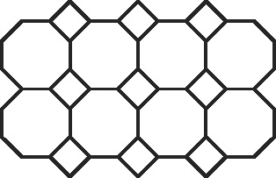


Regular Tessellation Semiregular Tessellation

In a tessellation, the measures of the angles that meet at each vertex
must have a sum of 360°.
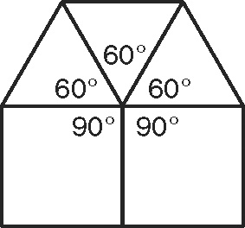
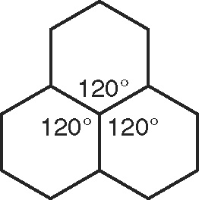
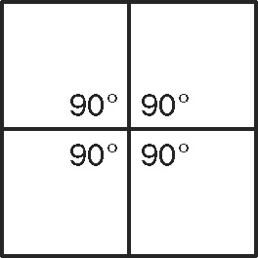

90° + 90° + 90° + 90° = 360° 120° + 120° + 120° = 360° 3(60°) + 2(90°) = 360°
Classify each tessellation as regular, semiregular, or neither.
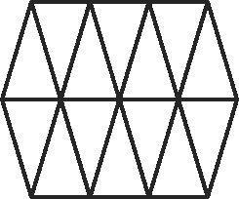
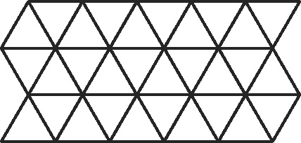
5. 6.

Determine whether the given regular polygon(s) can be used to form a tessellation. If so, draw the tessellation.
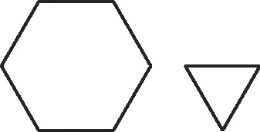
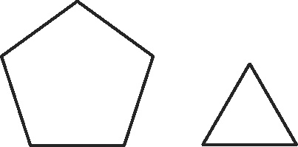
7. 8.

