z`sd
Distance Formula
Standard: SWABAT use coordinates to compute perimeters of polygons and areas using the distance formula. (MCC912.G.GPE.7)

Name: ___________________________________ Mr. Murphey’s Coordinate Algebra Support
Date: 12/11/2013 Block: 1 4



Inbox Task – find the midpoint of the following
- (–2, 3) and (1, 0)

- (–2, 5) and (4, 3)

Find the slope between two points.
- (–2, 3) and (1, 0)

- Y is the midpoint of XZ . X has coordinates (2, 4), and Y has coordinates (5, 1). Find Z.

Distance Formula
What is the Pythagorean Theorem?
d
a
b
c

(x₁, y₁)

Find the formula for distance (d) between two points (x₁,y₁) and (x₂,y₂) using the Pythagorean Theorem.
The Distance Formula
The distance (d) between any two points (x₁,y₁) and (x₂,y₂) is $d =\sqrt{{(x_{2}-x_{1})}^{2}+{(y_{2}-y_{1})}^{2}}$.

Example: Find the distance between the (-3, 2) and (7, 2).
You Try: Find the distance between (0, 4) and (8, -2).

Find the distances between the two points

- R(-1,1) and S(2,5)

- N(0,6) and T(8,0)

- P(-2,8) and Q(7,-4)

- V(1,3) and W(5,5)

Find the distances.
5. Use the Distance Formula to find the distance, to the
nearest tenth, between K(−7, −4) and L(−2, 0). _______________
6. Use the Pythagorean Theorem to find the distance, to
the nearest tenth, between F(9, 5) and G(–2, 2). _______________
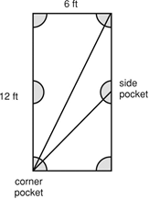
Use the figure for Exercises 7 and 8.
Snooker is a kind of pool or billiards played on a 6-foot-by-12-foot table. The side pockets are halfway down the rails (long sides).
7. Find the distance, to the nearest tenth of a foot, diagonally across the table from corner pocket to corner pocket.
8. Find the distance, to the nearest tenth of an inch, diagonally
across the table from corner pocket to side pocket.

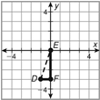
Use the figure for Exercises 9–12
Manuel is out for a jog. The thick lines on the grid are jogging paths. He is on his way home and is at D. His home is at E. Each unit on the grid is 1 mile.
9. Name the coordinates of D. _______________
10. Find how many miles Manuel will jog if he goes straight to the x-axis. _______________
11. Find how many miles Manuel will jog if he stays on the jogging paths all the way home. _______________
12. Find how many miles Manuel will jog if he goes straight to the y-axis. _______________

11. Suppose points A (1, 2), B (3, 6), and C (6, 4) are three vertices of a parallelogram.
- Give the coordinates of a point that could be the fourth vertex. Sketch the parallelogram in a coordinate plane.
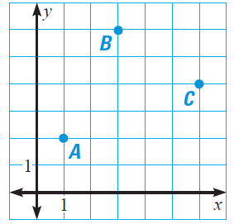

- Explain how to check to make sure the figure you drew in part a is a parallelogram.

- How many different parallelograms can be formed using A, B, and C as vertices? Sketch each parallelogram and label the coordinates of fourth vertex.

PLOT each set of points on a single graph and find the missing point.
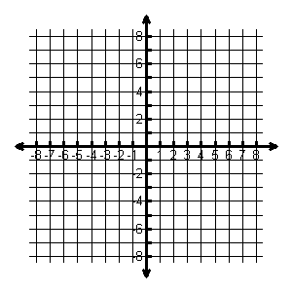
1. Square (-6, 6) (-6, -6) (6, -6) _____ 2. Rectangle (1, 1) (8, 1) (1, 6) ______ 3. Parallelogram (-5, 3) (5, 3) (8, 6) ____

